

**PROJECT REPORT**

# VTC-Freelancer

|  |  |
| --- | --- |
| **Sem:** | Sem 2 |
| **Class:** | WD02 |
| **Group:** | Group 1 |
| **Instructors:** | TRẦN VĂN LÂM |
| **Member:** | NDE18055 – LÊ CHÍ DŨNG  NDE18048 – ĐOÀN NGỌC THẠCH  NDE18030 – NGUYỄN THANH TÙNG  NDE18090 – NGUYỄN ANH LINH  NDE18020 – ĐẶNG VĂN CƯỜNG |

# Category

VTC-Freelancer 1

Category 2

I. Project introduction 3

1. The system instends to do(Proposed System) 3

2. Purpose of the project 3

3. The scope of the project to be applied 3

4. System name 3

5. Implementation (software, hardware) 3

6. Used for development 3

7. Identify customer requirements 4

II. Analyze system requirements 5

1. Use Case 6

• Use case diagram 6

• Use case description 20

2. Activity diagram 49

3. Sequence Diagram: 78

III. Detailed design 103

1. Design the theme. 103

2. Class Diagram 121

3. Database diagram 122

a) Entity Relationship Diagram 122

b) Database detail 123

IV. Testing 136

V. Assign work to each team member 144

VI. Installation Instructions 165

1. Deployment Diagram 165

2. Installation steps 165

Appendix 167

1. References 167

2. Some other issues 167

Document format 167

# Project introduction

1. The system instends to do(Proposed System)

* VTC-Freelancer

1. Purpose of the project

* VTC – Freelancer is one of the world's largest networking and buying venues between buyers and sellers. Whether it's an individual or a business ... It's an intermediary site, very convenient and easy to use.

1. The scope of the project to be applied

* Use for freelancers

1. System name

* VTC- FREELANCER.

1. Implementation (software, hardware)

* Hardware: Computer systems (PC,Laptop)
* Software:
* Operating system : Windown
* Server : Mysql Server

1. Used for development

* Programming language : C#.
* Database : Mysql
* Technology: ASP .net core 3.0
* Reporting tools : Microsoft Word
* Development tools : Visual Studio Code, Violet UML, Mysql

Workbench, Lucidchart, draw.io.

1. Identify customer requirements

* User is buyer (is the person who has the problem to solve the problem)
* Buyer cant login
* Buyer cant post request
* Buyer cant management order
* Buyer cant managerment request
* Buyer cant login
* Buyer cant sign up
* Buyer cant sing up to seller
* User is Seller (is the one who solves the problems)
* Seller cant apply order
* Seller cant mangement order
* Seller cant management service
* Seller cant create service
* Seller cant create offer
* Seller cant management offer
* User is Admin(is the system manager)
* Admin cant management user.
* Admin cant management service.
* Admin cant management addcategory.
* Admin cant management trouble.
* Admin cant management order.

# Analyze system requirements

* VTC – Freelancer is the largest online freelancer market in the world. This is a place to trade between individuals, businesses and freelancers. Here all the services you need start from $ 5. Basically, you can sell and buy services for just $ 5. Where you can sell any service as long as someone needs it. Specifically:
* Logo design, infographic.
* Design t-shirt pattern.
* Advertising Banner Design.
* Increase youtube view, increase website traffic.
* Edit html, css or fix wordpress error.
* Making promotional videos.
* The services I have listed above are only a small part of many of VTC – Freelancer services. There are strange services that you do not think of. You should remember, if there is demand, the battery will have supply.
* At first glance, everything like VTC – Freelancer is a provider of all the aforementioned services. But not, VTC – Freelancer is just a platform, they are intermediaries. Those service orders are entirely for freelancers who are working on them.
* VTC – Freelancer is one of the world's largest networking and buying venues between buyers and sellers. Whether it's an individual or a business ... It's an intermediary site, very convenient and easy to use.

1. Use Case

* 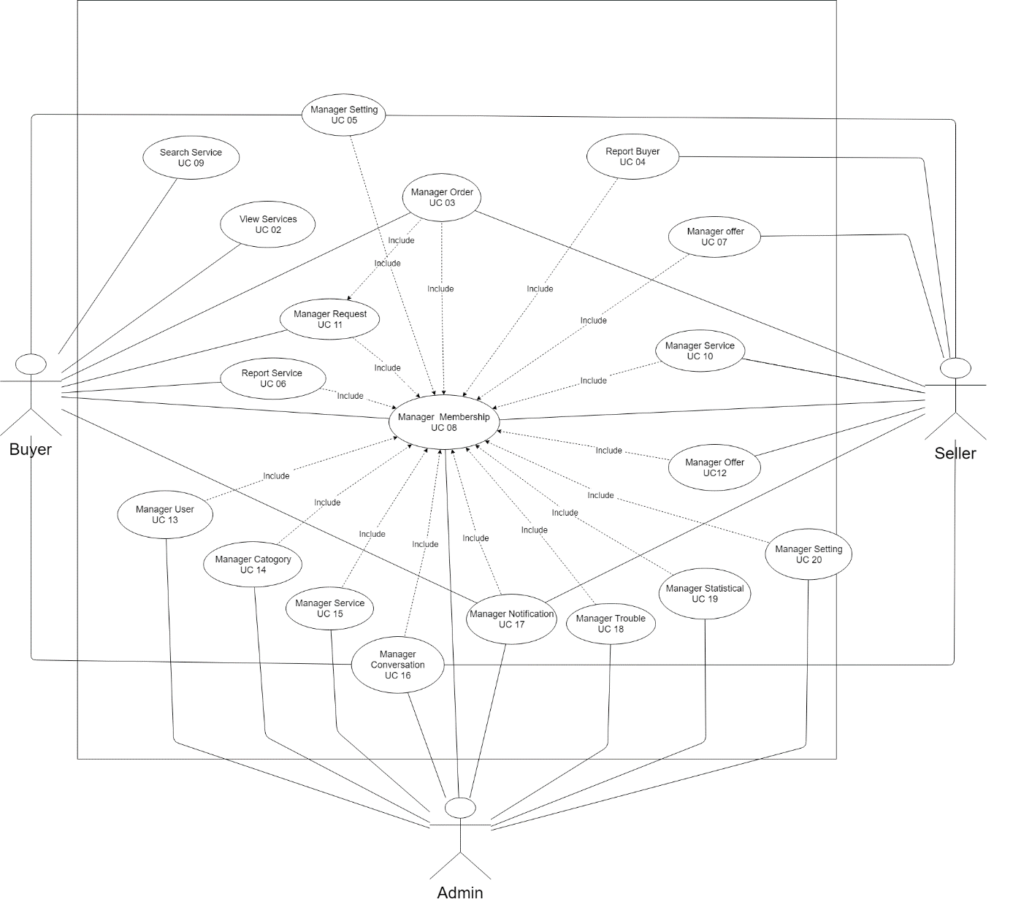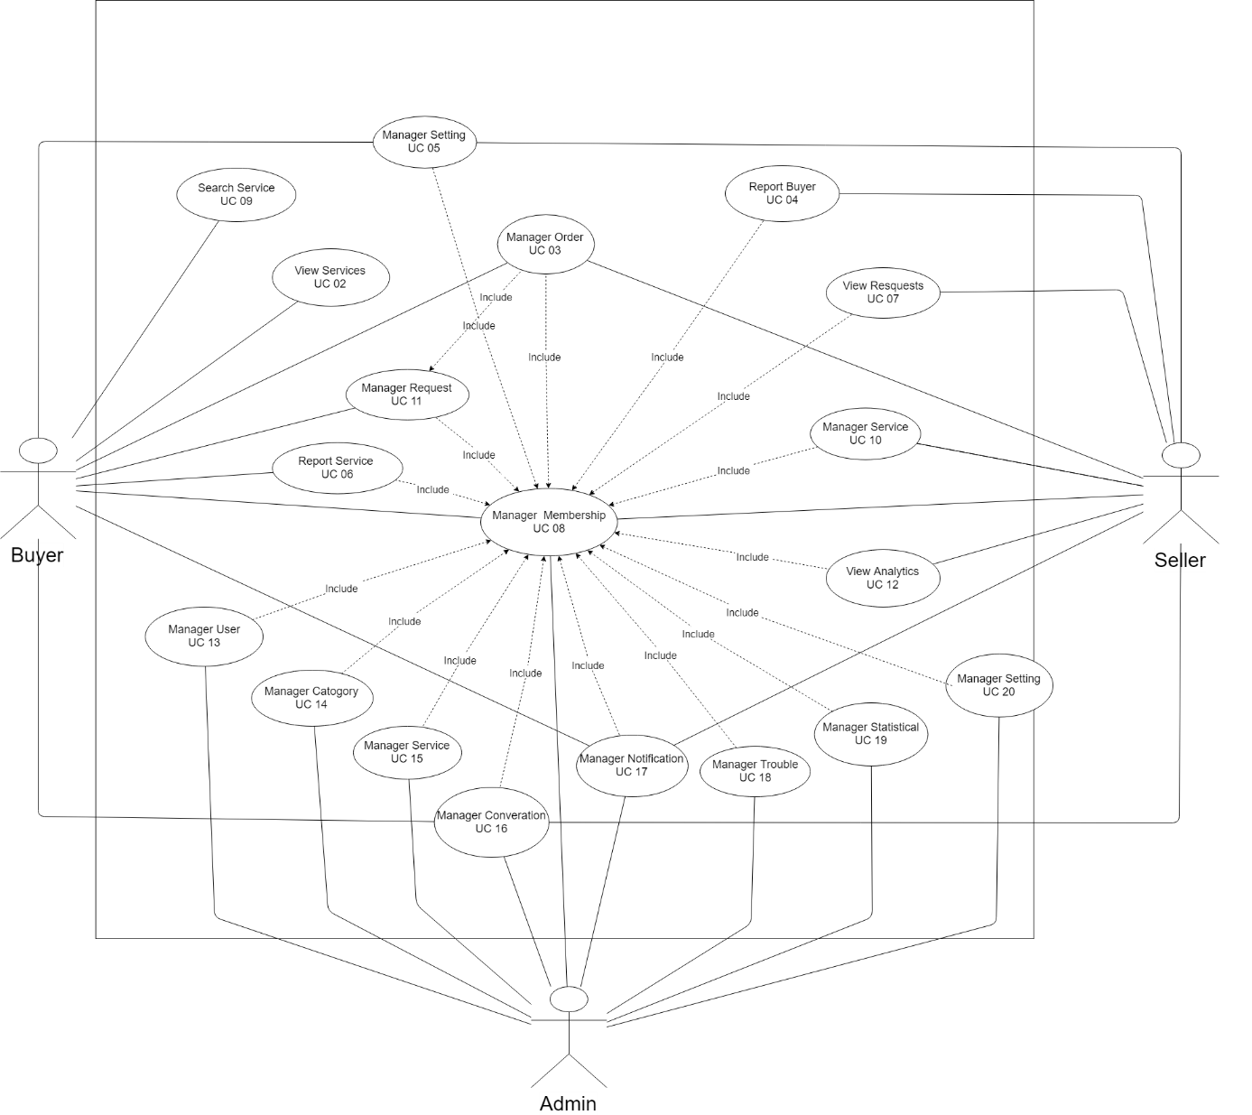Use case diagram

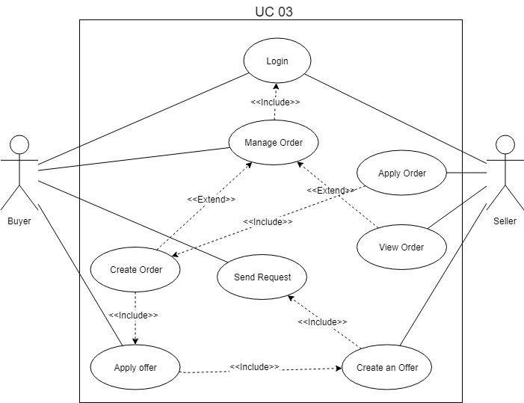

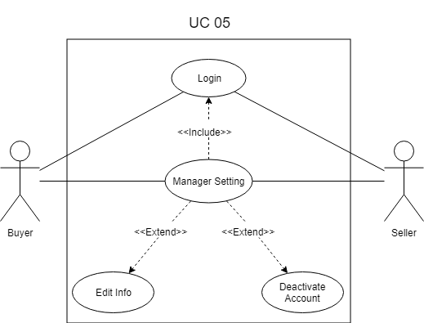

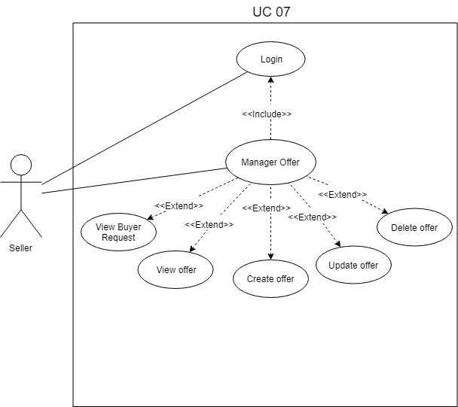

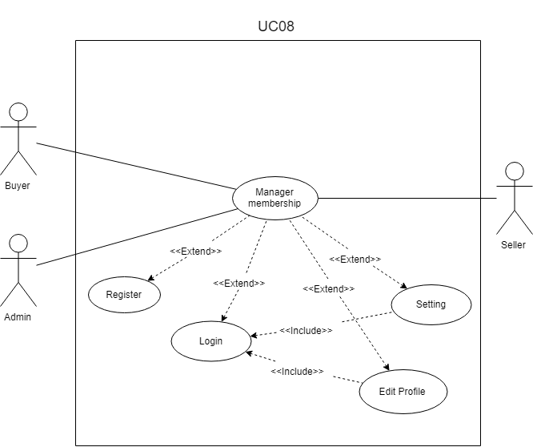

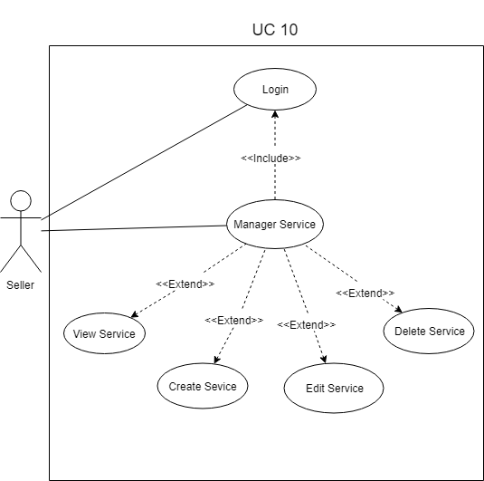

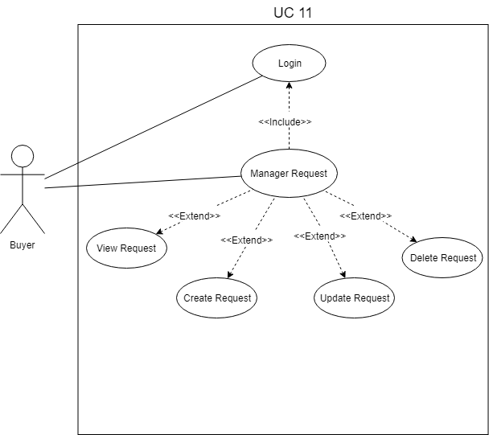

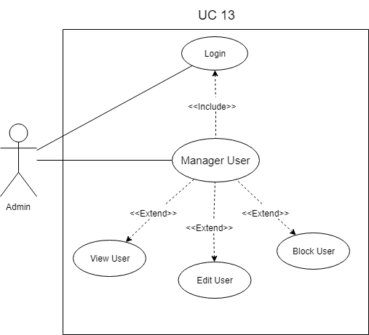

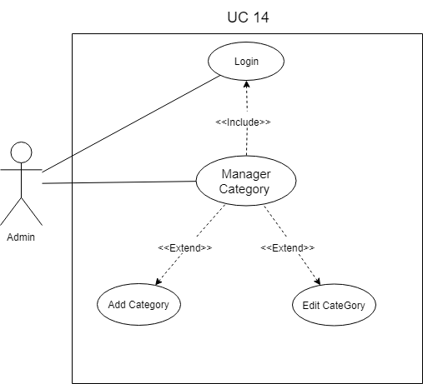

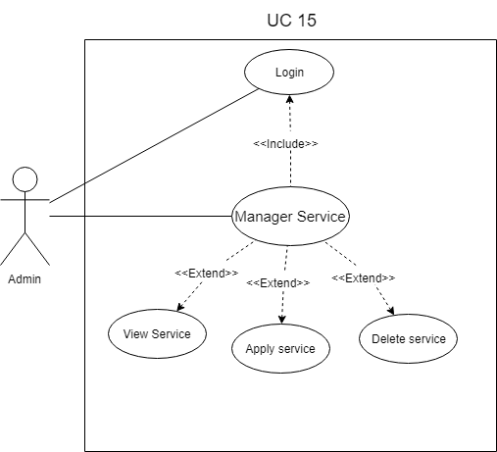

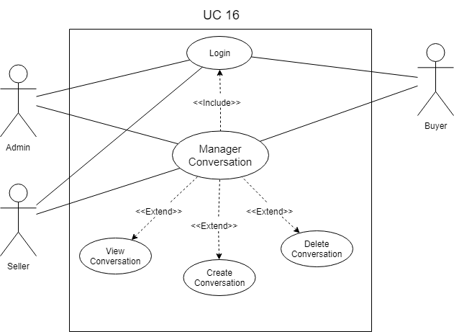

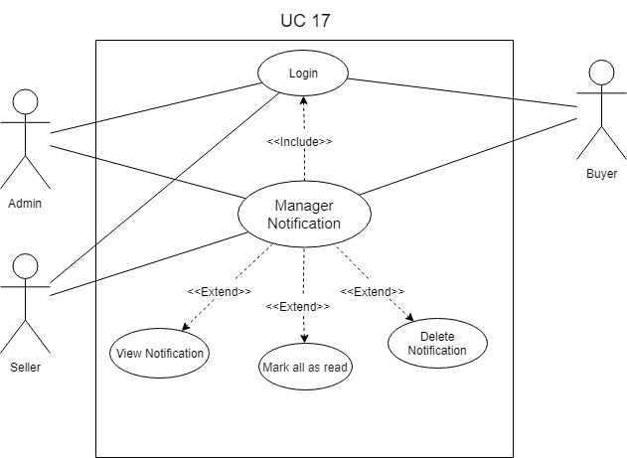

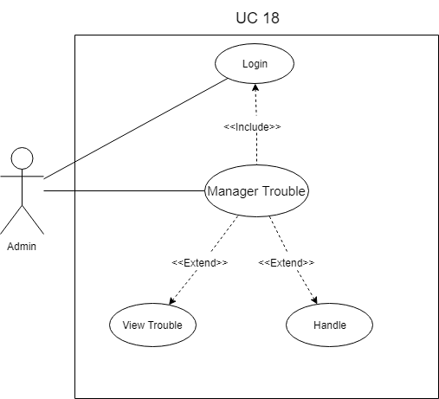

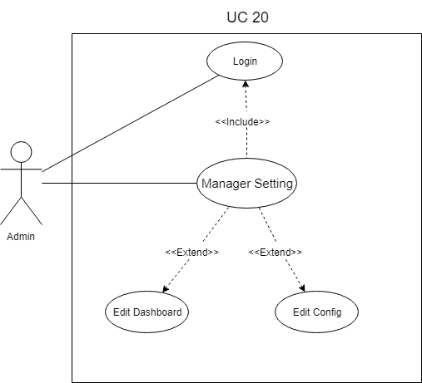

* Use case description
* Description view service.

|  |  |
| --- | --- |
| **Title** | **Content** |
| **Use Case Name** | View service |
| **Use Case ID** | UC02 |
| **Description** | Buyer want to see all services. |
| **Actor** | The Buyer accesses the web page VTC-Freelance. |
| **Trigger** | Buyer want to see all services. |
| **Preconditions** | Must have service for display. |
| **Postconditions** | Buyer acceess the web page to be albe to view the service. |
| **Main Course** | 1. Buyer access web page VTC-Freelancer. 2. Display all services. |
| **Alternate Courses** | AC1: No service   1. Notice: “No service!”. |
| **Exceptions** | EX1: Server connection error  1. Notice “Server connection error”. |

* Description use case create order.

|  |  |
| --- | --- |
| **Title** | **Content** |
| **Use Case Name** | Create order (Manager order) |
| **Use Case ID** | UC03 |
| **Description** | Buyer chooses one service to order. |
| **Actor** | Buyer chooses one service. |
| **Trigger** | Buyer want to rent one any service. |
| **Preconditions** | There must be a service for the buyer to order and buyer must login. |
| **Postconditions** | Buyer choose one any service to order. |
| **Main Course** | Buyer order by service.   1. Buyer access web page VTC-Freelancer. 2. Buyer login. 3. Display all services. 4. Choose any service. 5. Display service detail. 6. Choose package and order. 7. Choose quantity and the form of payment.    1. Choose form payment.    2. Enter information card.  * The card not valid will notice : “ Card not valid”.  1. Order.   Buyer order by offer.   1. Choose any offer of seller 2. Choose order 3. Choose the form of payment.   3.1 Choose form payment.  3.2 Enter information card.   * The card not valid will notice : “ Card not valid”. |
| **Alternate Courses** | AC1: No service   1. Notice: “No service!”.   AC2: Order error   1. Notice: “Order error”. 2. Come back step 5.   AC3: Payments faild   1. Notice: “Payments faild”. 2. Comeback step 6. |
| **Exceptions** | EX1: Server connection error  1. Notice “Server connection error”. |

* Description use case apply order.

|  |  |
| --- | --- |
| **Title** | **Content** |
| **Use Case Name** | Apply order (Manager order) |
| **Use Case ID** | UC03 |
| **Description** | Seller apply order of buyer requirements. |
| **Actor** | Seller apply order. |
| **Trigger** | Must have buyer order sent to seller. |
| **Preconditions** | The seller must have buyer order for the seller to apply order and The seller must login. |
| **Postconditions** | The seller apply order of buyer sent. |
| **Main Course** | 1. Seller access web page VTC-Freelancer. 2. Seller login. 3. Choose manager order. 4. Display order not process. 5. Apply order. |
| **Alternate Courses** | AC1: Apply order error   1. Notice: “Apply order error”. 2. Come back step 4. |
| **Exceptions** | EX1: Server connection error  1. Notice “Server connection error”. |

* Description use case report buyer

|  |  |
| --- | --- |
| **Title** | **Content** |
| **Use Case Name** | Report buyer |
| **Use Case ID** | UC04 |
| **Description** | Seller report buyer. |
| **Actor** | Seller report buyer. |
| **Trigger** | Seller want report buyer. |
| **Preconditions** | Want report buyer then seller must login. |
| **Postconditions** | Seller report buyer. |
| **Main Course** | 1. Seller access web page VTC-Freelancer. 2. Seller login. 3. Choose any buyer. 4. Display profile buyer. 5. Choose report.   4.1 Choose title report.  4.2 Enter content report.   1. Report. |
| **Alternate Courses** | AC1: Report error   1. Notice: “Report error”. 2. Come back step 4. |
| **Exceptions** | EX1: Server connection error  1. Notice “Server connection error”. |

* Description use case edit information.

|  |  |
| --- | --- |
| **Title** | **Content** |
| **Use Case Name** | Edit infomation |
| **Use Case ID** | UC05 |
| **Description** | Seller or buyer want update infomation. |
| **Actor** | Seller or buyer update infomantion. |
| **Trigger** | Seller or buyer want update infomation. |
| **Preconditions** | Seller or buyer must login. |
| **Postconditions** | The seller or buyer update infomation. |
| **Main Course** | 1. Seller access web page VTC-Freelancer. 2. Seller login. 3. Choose manager setting. 4. Choose Infomation. 5. Display infomation.   4.1 Choose infomation need update.  4.2 Choose save.   1. Update success. |
| **Alternate Courses** | AC1: Update error   1. Notice: “Update error”. 2. Come back step 5. |
| **Exceptions** | EX1: Server connection error  1. Notice “Server connection error”. |

* Description use case deactivate account.

|  |  |
| --- | --- |
| **Title** | **Content** |
| **Use Case Name** | Deactivate account |
| **Use Case ID** | UC05 |
| **Description** | Seller or buyer want deactivate account. |
| **Actor** | Seller or buyer deactivate account. |
| **Trigger** | Seller or buyer want deactivate account. |
| **Preconditions** | Seller must login. |
| **Postconditions** | The seller or buyer deactivate account. |
| **Main Course** | 1. Seller access web page VTC-Freelancer. 2. Seller login. 3. Choose manager setting. 4. Choose deactive account.   4.1 Choose reason.  4.2 Enter content why deactivate account.   1. Choose deactive account. 2. Automatically logout and come back home page. |
| **Alternate Courses** | AC1: Deactivate error   1. Notice: “Deactivate error”. 2. Come back step 4. |
| **Exceptions** | EX1: Server connection error  1. Notice “Server connection error”. |

* Description use case report service.

|  |  |
| --- | --- |
| **Title** | **Content** |
| **Use Case Name** | Report service |
| **Use Case ID** | UC06 |
| **Description** | Buyer want report any service. |
| **Actor** | Buyer report service. |
| **Trigger** | Buyer want report any service. |
| **Preconditions** | Buyer must login. |
| **Postconditions** | Buyer choose service to report. |
| **Main Course** | 1. Buyer access web page VTC-Freelancer. 2. Buyer login. 3. Choose any service. 4. Display detail service. 5. Choose report service.   5.1 Choose title  5.2 Enter content report.   1. Sent report. |
| **Alternate Courses** | AC1: Report error.   1. Notice: “Report error”. 2. Come back step 4. |
| **Exceptions** | EX1: Server connection error  1. Notice “Server connection error”. |

* Description use case create offer.

|  |  |
| --- | --- |
| **Title** | **Content** |
| **Use Case Name** | Create offer. |
| **Use Case ID** | UC07 |
| **Description** | Seller want create offer. |
| **Actor** | Seller create offer. |
| **Trigger** | Seller want create offer. |
| **Preconditions** | Seller must login. |
| **Postconditions** | Seller choose request for create offer. |
| **Main Course** | 1. Seller access web page VTC-Freelancer. 2. Seller login. 3. Swich to seller. 4. Choose buyer request. 5. .Display request of buyer. 6. Choose offer.   6.1 Enter information.  6.2 Create offer.   1. Create offer. |
| **Alternate Courses** | AC1: Offer error.   1. Notice: “Create offer error”. 2. Come back step 5. |
| **Exceptions** | EX1: Server connection error  1. Notice “Server connection error”. |

* Description use case update offer.

|  |  |
| --- | --- |
| **Title** | **Content** |
| **Use Case Name** | Update offer. |
| **Use Case ID** | UC07 |
| **Description** | Seller want update offer. |
| **Actor** | Seller update offer. |
| **Trigger** | Seller want update offer. |
| **Preconditions** | Seller must login and have an offer. |
| **Postconditions** | Seller choose offer for update offer. |
| **Main Course** | 1. Seller access web page VTC-Freelancer. 2. Seller login. 3. Swich to seller. 4. Choose buyer request. 5. Choose display offer. 6. Choose offer.   6.1 Choose update.  6.2 Update offer.   1. Update offer. |
| **Alternate Courses** | AC1: Offer error.   1. Notice: “Update offer error”. 2. Come back step 5. |
| **Exceptions** | EX1: Server connection error  1. Notice “Server connection error”. |

* Description use case delete offer.

|  |  |
| --- | --- |
| **Title** | **Content** |
| **Use Case Name** | Delete offer. |
| **Use Case ID** | UC07 |
| **Description** | Seller want delete offer. |
| **Actor** | Seller delete offer. |
| **Trigger** | Seller want delete offer. |
| **Preconditions** | S Seller must login and have an offer. |
| **Postconditions** | Seller choose offer for delete offer. |
| **Main Course** | 1. Seller access web page VTC-Freelancer. 2. Seller login. 3. Swich to seller. 4. Choose buyer request. 5. Choose display offer. 6. Choose offer. 7. Delete offer.   6.1 Are you sure delete offer. If choose Yes : Delete offer. If choose No : Come back step 5. |
| **Alternate Courses** | AC1: Offer error.   1. Notice: “Delete offer error”. 2. Come back step 5. |
| **Exceptions** | EX1: Server connection error  1. Notice “Server connection error”. |

* Description use case register.

|  |  |
| --- | --- |
| **Title** | **Content** |
| **Use Case Name** | Register. |
| **Use Case ID** | UC08 |
| **Description** | Buyer want register account. |
| **Actor** | Buyer register accoutnt. |
| **Trigger** | Buyer want register account. |
| **Preconditions** | Buyer enter full information. |
| **Postconditions** | Buyer choose register. |
| **Main Course** | 1. Buyer access web page VTC-Freelancer. 2. Buyer choose register. 3. Display page register.   3.1 Enter full information.  3.2 Choose register.   1. Display page login. |
| **Alternate Courses** | AC1: Register Faild.   1. Notice: “Register account faild”. 2. Come back step 3. |
| **Exceptions** | EX1: Server connection error  1. Notice “Server connection error”. |

* Description use case register seller.

|  |  |
| --- | --- |
| **Title** | **Content** |
| **Use Case Name** | Register seller. |
| **Use Case ID** | UC08 |
| **Description** | Buyer want register seller. |
| **Actor** | Buyer register seller. |
| **Trigger** | Buyer want register seller. |
| **Preconditions** | Buyer must login. |
| **Postconditions** | Buyer choose become to seller. |
| **Main Course** | 1. Buyer access web page VTC-Freelancer. 2. Buyer login. 3. Display home page. 4. Choose become to seller. 5. Display page register seller.   5.1 Choose category and enter information.  5.2 Choose register.   1. Display dashboard seller. |
| **Alternate Courses** | AC1: Register Faild.   1. Notice: “Register seller faild”. 2. Come back step 3. |
| **Exceptions** | EX1: Server connection error  1. Notice “Server connection error”. |

* Description use case login.

|  |  |
| --- | --- |
| **Title** | **Content** |
| **Use Case Name** | Login. |
| **Use Case ID** | UC08 |
| **Description** | User want login. |
| **Actor** | User login. |
| **Trigger** | User want login. |
| **Preconditions** | User must account. |
| **Postconditions** | User access web vtc-freelancer choose login. |
| **Main Course** | 1. User access web page VTC-Freelancer. 2. Choose login. 3. Enter username or email and password. 4. Login. |
| **Alternate Courses** | AC1: Enter the wrong account or password.   1. Notice: “Enter the wrong account or password”. 2. Come back step 3. |
| **Exceptions** | EX1: Server connection error  1. Notice “Server connection error”. |

* Description use case search service.

|  |  |
| --- | --- |
| **Title** | **Content** |
| **Use Case Name** | Search service. |
| **Use Case ID** | UC09 |
| **Description** | Buyer want find service. |
| **Actor** | Buyer search service. |
| **Trigger** | Buyer want search service. |
| **Preconditions** | Must have a service. |
| **Postconditions** | User access web vtc-freelancer enter need to find services. |
| **Main Course** | 1. User access web page VTC-Freelancer. 2. Display home page. 3. Enter service need to find. 4. Search service. |
| **Alternate Courses** | AC1: No service found.   1. Notice: “No service found”. 2. Come back step 3. |
| **Exceptions** | EX1: Server connection error  1. Notice “Server connection error”. |

* Description use case create service.

|  |  |
| --- | --- |
| **Title** | **Content** |
| **Use Case Name** | Create service. |
| **Use Case ID** | UC10 |
| **Description** | Seller want create service. |
| **Actor** | Seller create service. |
| **Trigger** | Seller want create service. |
| **Preconditions** | Buyer must login and is seller. |
| **Postconditions** | Seller choose create service. |
| **Main Course** | 1. Buyer access web page VTC-Freelancer. 2. Buyer login. 3. Choose switch to seller. 4. Choose manager gigs. 5. Choose create gig.   5.1 Step 1 enter title choose category input tags.  5.2 Step 2 enter package of gig.  5.3 Step 3 enter description of gig.  5.4 Step 4 enter image for gig.   1. Create gig. |
| **Alternate Courses** | AC1: Create service faild.   1. Notice: “Create service faild”. 2. Come back step 4. |
| **Exceptions** | EX1: Server connection error  1. Notice “Server connection error”. |

* Description use case update service.

|  |  |
| --- | --- |
| **Title** | **Content** |
| **Use Case Name** | Update service. |
| **Use Case ID** | UC10 |
| **Description** | Seller want update service. |
| **Actor** | Seller update service. |
| **Trigger** | Seller want update service. |
| **Preconditions** | Buyer must login and is seller, seller must have an service. |
| **Postconditions** | Seller choose update service. |
| **Main Course** | 1. Buyer access web page VTC-Freelancer. 2. Buyer login. 3. Choose switch to seller. 4. Choose manager gigs. 5. Display list gig. 6. Choose gig need update.   6.1 Step 1 enter title choose category input tags.  6.2 Step 2 enter package of gig.  6.3 Step 3 enter description of gig.  6.4 Step 4 enter image for gig.   1. Update gig. |
| **Alternate Courses** | AC1: Update service faild.   1. Notice: “Update service faild”. 2. Come back step 4. |
| **Exceptions** | EX1: Server connection error  1. Notice “Server connection error”. |

* Description use case delete service.

|  |  |
| --- | --- |
| **Title** | **Content** |
| **Use Case Name** | Delete service. |
| **Use Case ID** | UC10 |
| **Description** | Seller want delete service. |
| **Actor** | Seller delete service. |
| **Trigger** | Seller want delete service. |
| **Preconditions** | Buyer must login and is seller, seller must have an service. |
| **Postconditions** | Seller choose delete service. |
| **Main Course** | 1. Buyer access web page VTC-Freelancer. 2. Buyer login. 3. Choose switch to seller. 4. Choose manager gigs. 5. Display list gig. 6. Choose gig need delete.   6.1 Display “Are you sure delete gig”. If choose Yes : gig delete. If choose No : Come back step 5. |
| **Alternate Courses** | AC1: Delete service faild.   1. Notice: “Delete service faild”. 2. Come back step 4. |
| **Exceptions** | EX1: Server connection error  1. Notice “Server connection error”. |

* Description use case create request.

|  |  |
| --- | --- |
| **Title** | **Content** |
| **Use Case Name** | Create request. |
| **Use Case ID** | UC11 |
| **Description** | Buyer want post request. |
| **Actor** | Buyer post request. |
| **Trigger** | Buyer want post request. |
| **Preconditions** | Buyer must login. |
| **Postconditions** | Buyer choose post request. |
| **Main Course** | 1. Buyer access web page VTC-Freelancer. 2. Buyer login. 3. Buyer choose post request. 4. Enter information for request. 5. Post request. |
| **Alternate Courses** | AC1: Post request faild.   1. Notice: “Post request faild”. 2. Come back step 3. |
| **Exceptions** | EX1: Server connection error  1. Notice “Server connection error”. |

* Description use case update request.

|  |  |
| --- | --- |
| **Title** | **Content** |
| **Use Case Name** | Update service. |
| **Use Case ID** | UC11 |
| **Description** | Buyer want update request. |
| **Actor** | Buyer update request. |
| **Trigger** | Buyer want update request. |
| **Preconditions** | Buyer must login and have an request. |
| **Postconditions** | Seller choose any request for update. |
| **Main Course** | 1. Buyer access web page VTC-Freelancer. 2. Buyer login. 3. Choose manager request. 4. Display list request. 5. Chooose request update. 6. Update request. |
| **Alternate Courses** | AC1: Update request faild.   1. Notice: “Update request faild”. 2. Come back step 4. |
| **Exceptions** | EX1: Server connection error  1. Notice “Server connection error”. |

* Description use case statistical.

|  |  |
| --- | --- |
| **Title** | **Content** |
| **Use Case Name** | Statistical. |
| **Use Case ID** | UC12 |
| **Description** | Seller want see statistical. |
| **Actor** | Seller see statistical. |
| **Trigger** | Seller want see statistical. |
| **Preconditions** | Buyer must login and is seller. |
| **Postconditions** | Seller choose statistical. |
| **Main Course** | 1. Buyer access web page VTC-Freelancer. 2. Buyer login. 3. Choose switch is seller. 4. Display seller 5. Choose statistical. 6. View statistical. |
| **Alternate Courses** |  |
| **Exceptions** | EX1: Server connection error  1. Notice “Server connection error”. |

* Description use case edit user.

|  |  |
| --- | --- |
| **Title** | **Content** |
| **Use Case Name** | Edit user. |
| **Use Case ID** | UC13 |
| **Description** | Admin want edit user. |
| **Actor** | Seller see statistical. |
| **Trigger** | Admin want edit user. |
| **Preconditions** | Admin must login. |
| **Postconditions** | Admin choose user for edit. |
| **Main Course** | 1. Admin access web page VTC-Freelancer. 2. Admin login. 3. Display Admin. 4. Choose manager user. 5. Display list use. 6. Choose user for edit. 7. Edit user . |
| **Alternate Courses** | AC1: Edit user faild.   1. Notice: “Edit user faild. ”. 2. Come back step 5 |
| **Exceptions** | EX1: Server connection error  1. Notice “Server connection error”. |

* Description use case block user.

|  |  |
| --- | --- |
| **Title** | **Content** |
| **Use Case Name** | Block user. |
| **Use Case ID** | UC13 |
| **Description** | Admin want block user. |
| **Actor** | Admin block user. |
| **Trigger** | Admin want block user. |
| **Preconditions** | Admin must login. |
| **Postconditions** | Admin choose user for edit. |
| **Main Course** | 1. Admin access web page VTC-Freelancer. 2. Admin login. 3. Display Admin. 4. Choose manager user. 5. Display list use. 6. Choose user forblock. 7. Block user. |
| **Alternate Courses** | AC1: Block user faild.   1. Notice: “Block user faild. ”. 2. Come back step 5 |
| **Exceptions** | EX1: Server connection error  1. Notice “Server connection error”. |

* Description use case add category.

|  |  |
| --- | --- |
| **Title** | **Content** |
| **Use Case Name** | Add category. |
| **Use Case ID** | UC14 |
| **Description** | Admin want add category. |
| **Actor** | Admin add category. |
| **Trigger** | Admin want block user. |
| **Preconditions** | Admin must login. |
| **Postconditions** | Admin choose manager category for add category. |
| **Main Course** | 1. Admin access web page VTC-Freelancer. 2. Admin login. 3. Display Admin. 4. Choose manager category. 5. Choose add category. 6. Enter category. 7. Add category. |
| **Alternate Courses** | AC1: Add category faild.   1. Notice: “: Add category faild.”. 2. Come back step 5 |
| **Exceptions** | EX1: Server connection error  1. Notice “Server connection error”. |

* Description use case edit category.

|  |  |
| --- | --- |
| **Title** | **Content** |
| **Use Case Name** | Edit category. |
| **Use Case ID** | UC14 |
| **Description** | Admin want edit category. |
| **Actor** | Admin edit category. |
| **Trigger** | Admin want block user. |
| **Preconditions** | Admin must login. |
| **Postconditions** | Admin choose manager category for add category. |
| **Main Course** | 1. Admin access web page VTC-Freelancer. 2. Admin login. 3. Display Admin. 4. Choose manager category. 5. Display category. 6. Choose category edit. 7. Enter category. 8. Edit category. |
| **Alternate Courses** | AC1: Edit category faild.   1. Notice: “:Edit category faild.”. 2. Come back step 5 |
| **Exceptions** | EX1: Server connection error  1. Notice “Server connection error”. |

* Description use case block service.

|  |  |
| --- | --- |
| **Title** | **Content** |
| **Use Case Name** | Block service. |
| **Use Case ID** | UC15 |
| **Description** | Admin want apply service. |
| **Actor** | Admin apply service. |
| **Trigger** | Admin want apply service. |
| **Preconditions** | Admin must login. |
| **Postconditions** | Admin choose manager service. |
| **Main Course** | 1. Admin access web page VTC-Freelancer. 2. Admin login. 3. Display Admin. 4. Choose manager service. 5. Display service. 6. Choose any service. 7. Block service. |
| **Alternate Courses** | AC1: Block service faild.   1. Notice: “: Block service faild.”. 2. Come back step 5 |
| **Exceptions** | EX1: Server connection error  1. Notice “Server connection error”. |

* Description use case delete service.

|  |  |
| --- | --- |
| **Title** | **Content** |
| **Use Case Name** | Delete service. |
| **Use Case ID** | UC15 |
| **Description** | Admin want delete service. |
| **Actor** | Admin edit category. |
| **Trigger** | Admin want delete service. |
| **Preconditions** | Admin must login |
| **Postconditions** | Admin choose manager service. |
| **Main Course** | 1. Admin access web page VTC-Freelancer. 2. Admin login. 3. Display Admin. 4. Choose manager service. 5. Display service. 6. Choose any service. 7. Delete service. |
| **Alternate Courses** | AC1: Delete service faild.   1. Notice: “:Delete service faild.”. 2. Come back step 5 |
| **Exceptions** | EX1: Server connection error  1. Notice “Server connection error”. |

* Description use case handle trouple.

|  |  |
| --- | --- |
| **Title** | **Content** |
| **Use Case Name** | Handle trouple. |
| **Use Case ID** | UC18 |
| **Description** | Admin want handle service. |
| **Actor** | Admin hendle serivce. |
| **Trigger** | Admin want handle serivice. |
| **Preconditions** | Admin must login. |
| **Postconditions** | Admin choose manager trouble. |
| **Main Course** | 1. Admin access web page VTC-Freelancer. 2. Admin login. 3. Display Admin. 4. Choose manager trouble. 5. Display trouble. 6. Choose trouble. 7. Enter content. 8. Handle. |
| **Alternate Courses** | AC1: Handle faild.   1. Notice: “: Handle faild.”. 2. Come back step 5 |
| **Exceptions** | EX1: Server connection error  1. Notice “Server connection error”. |

## Activity diagram

* Create order

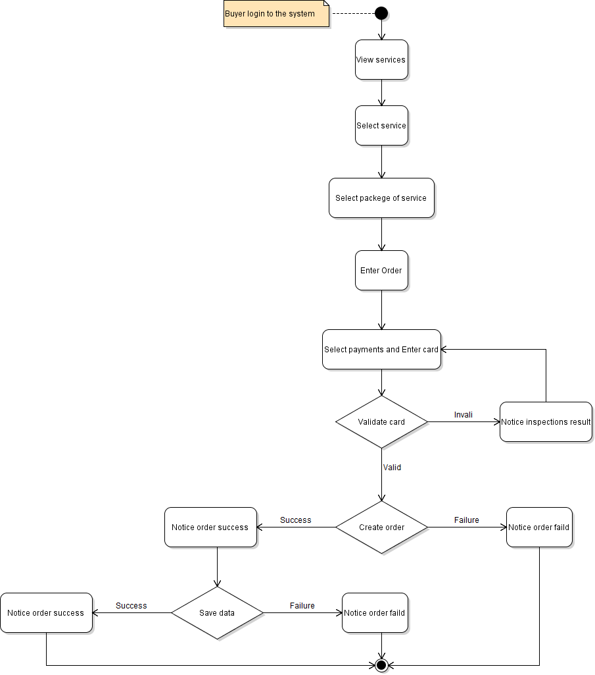

* Apply order

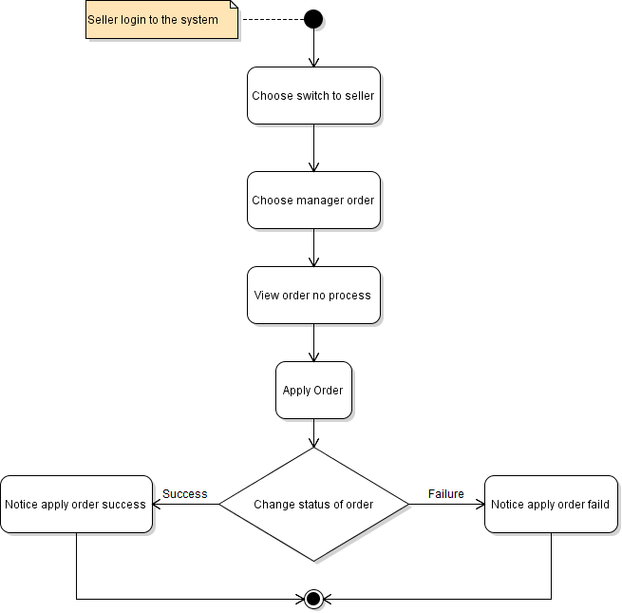

* Report buyer

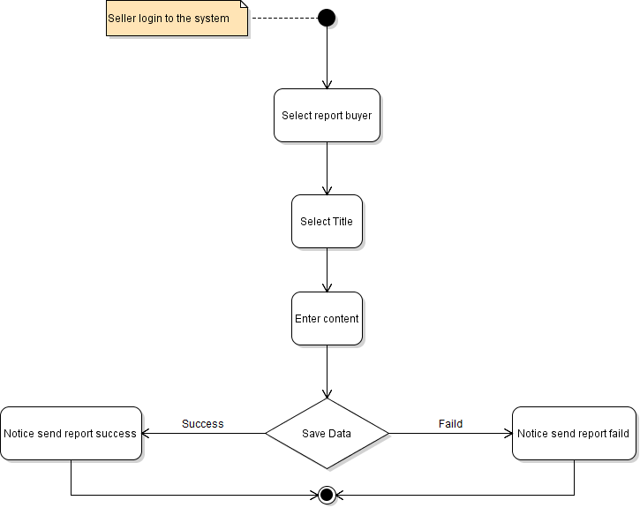

* Deactivate Account

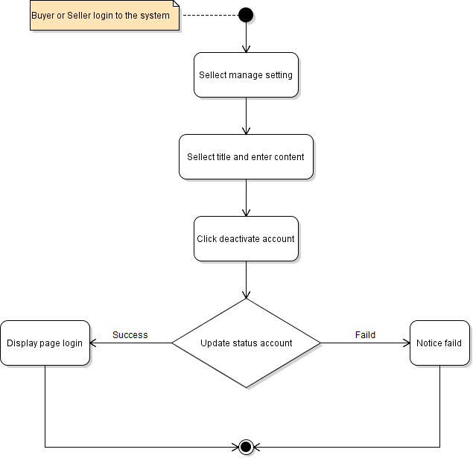

* Edit info

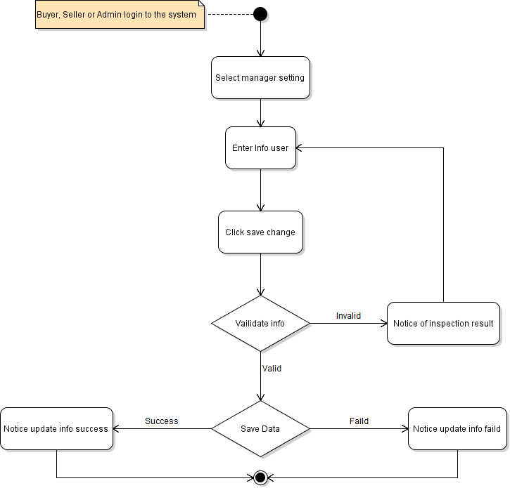

* Report service

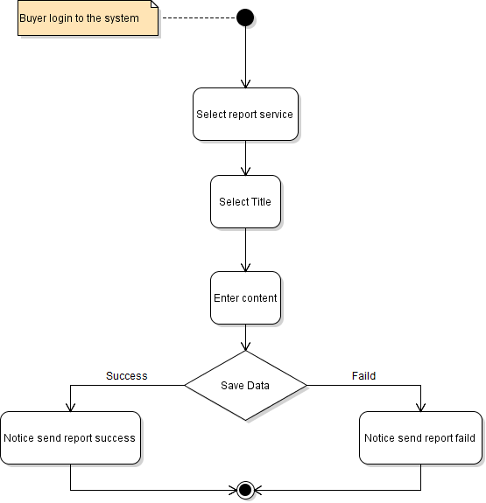

* Edit profile

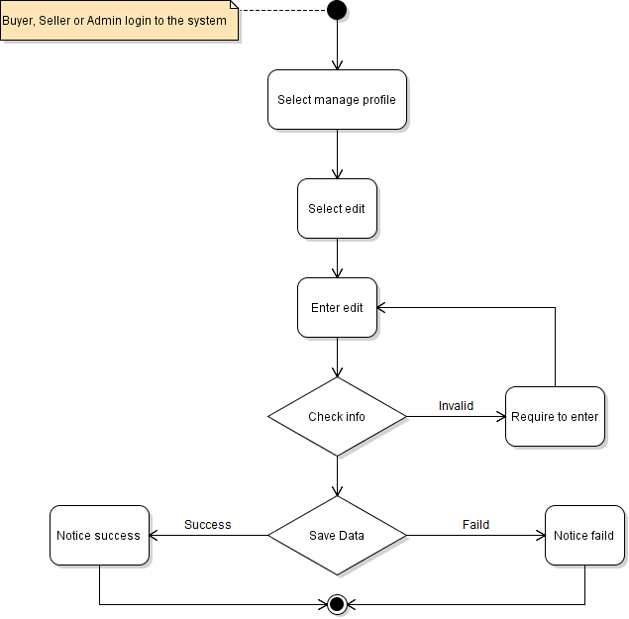

* Login

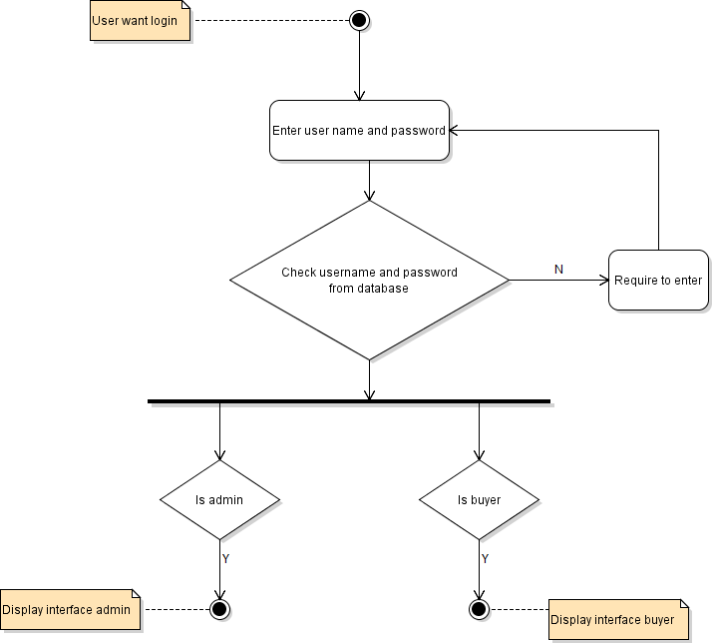

* Register

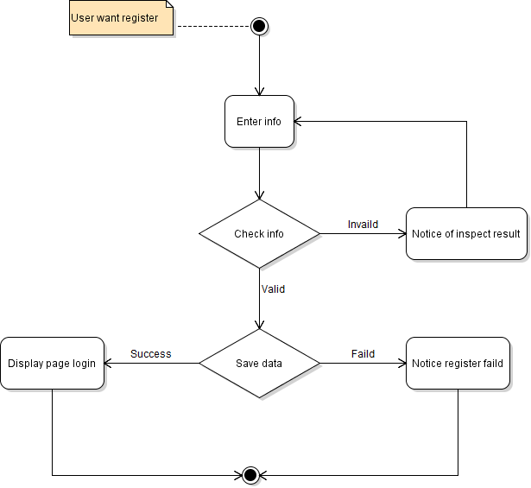

* Register seller

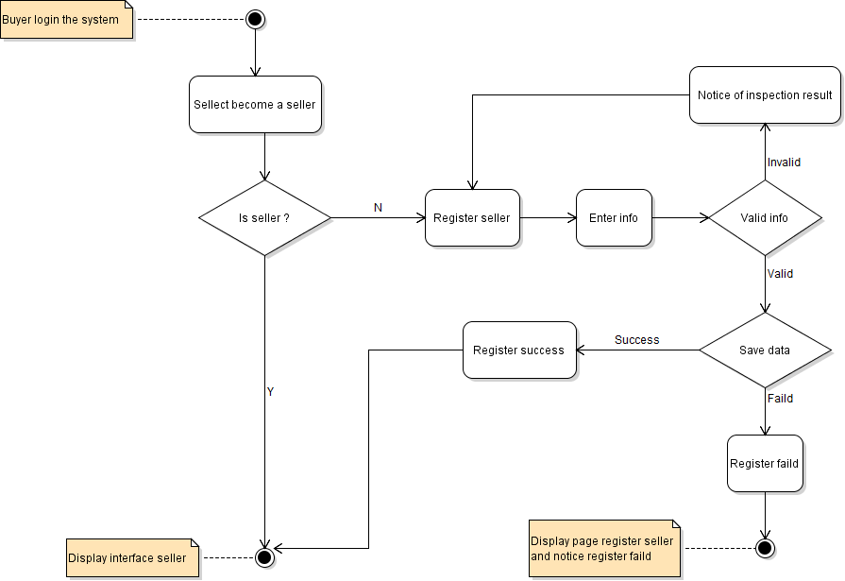

* Search service

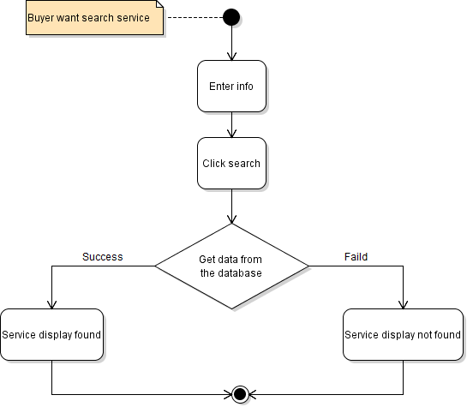

* Create service

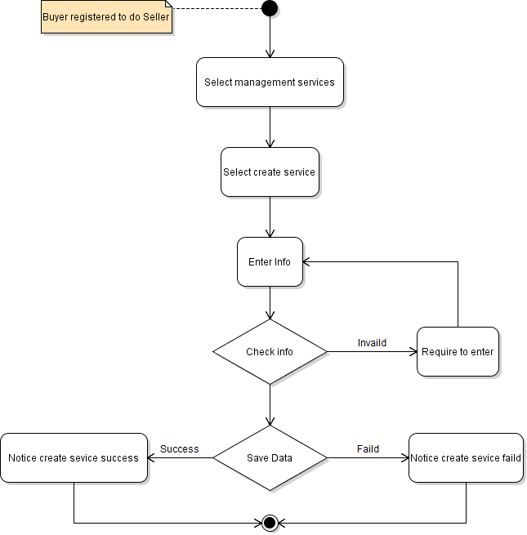

* Delete service

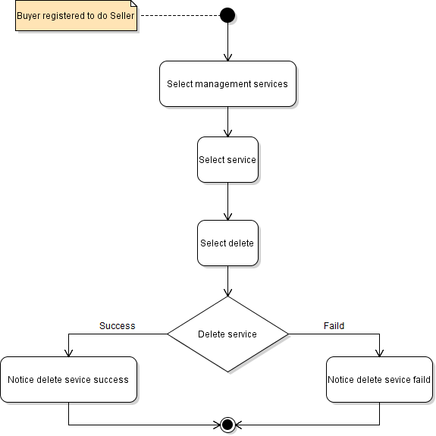

* Update service

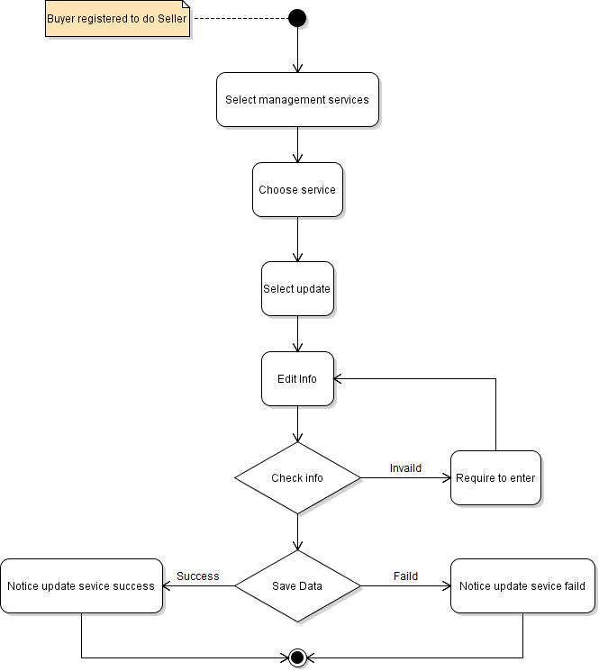

* Delete request

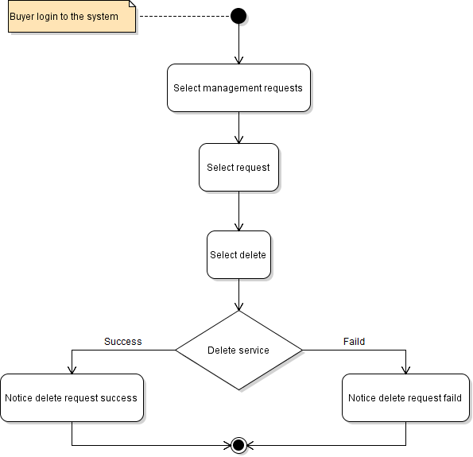

* Post request

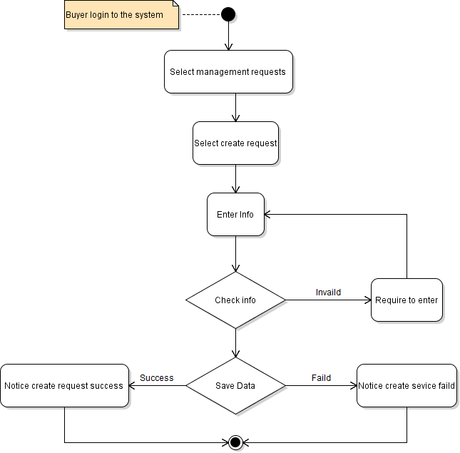

* Update request

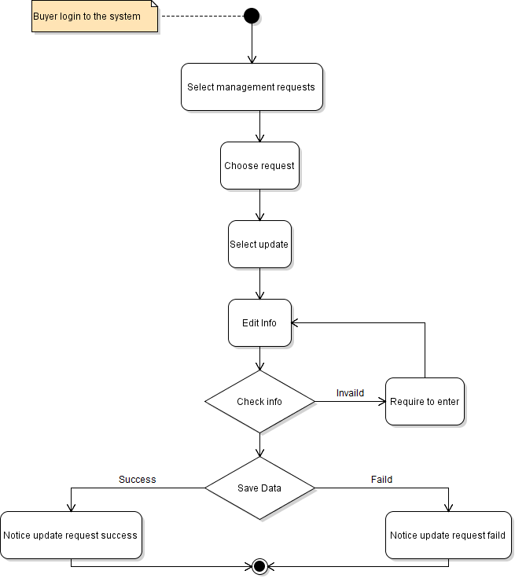

* Create offer

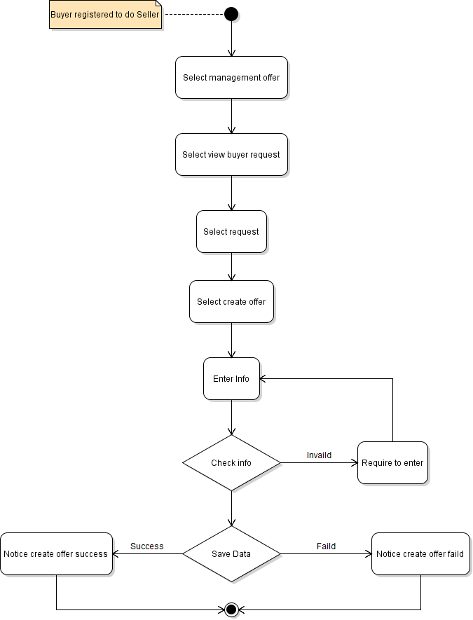

* Delete offer

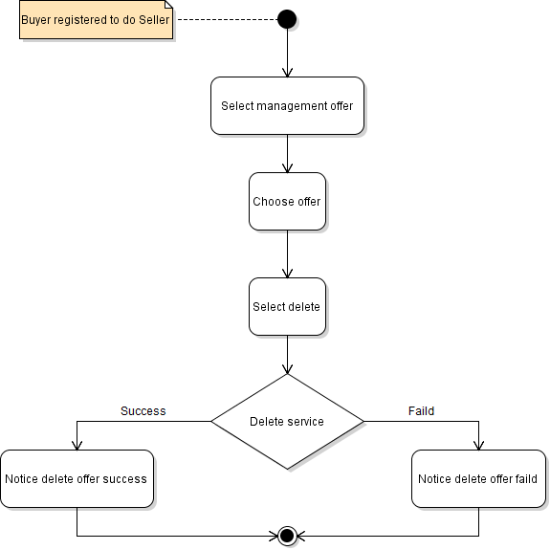

* Update offer

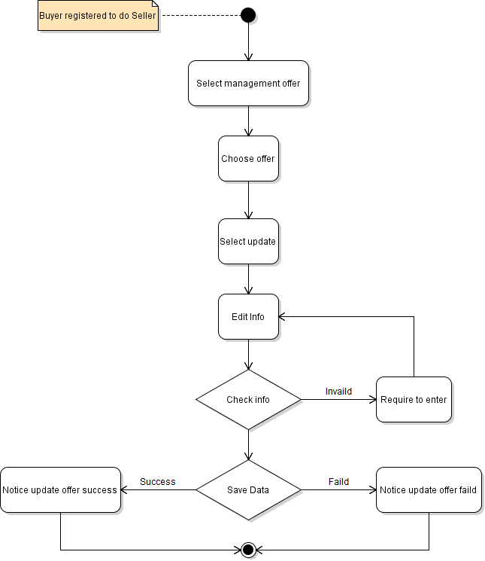

* Edit user

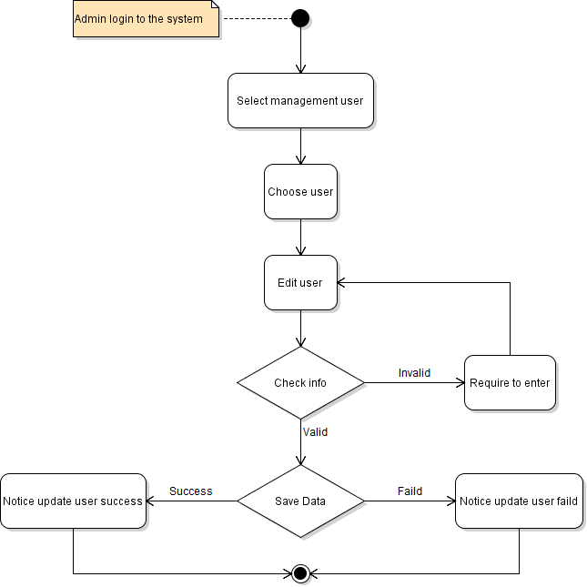

* Block user

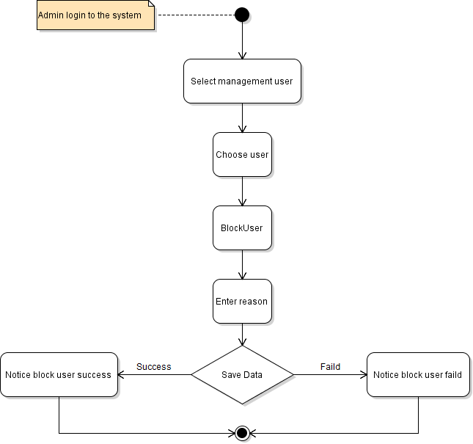

* Add category

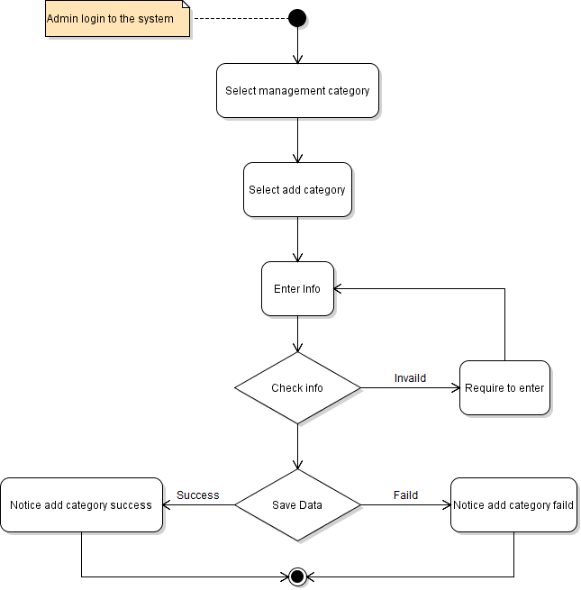

* Update category

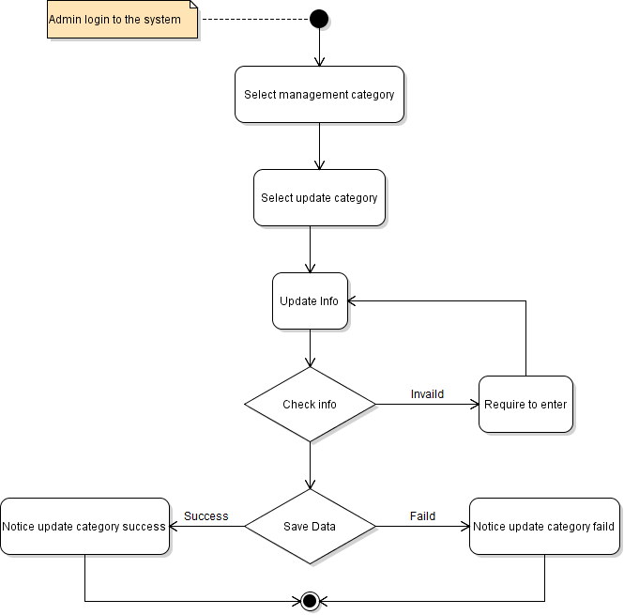

* Block or unblock service

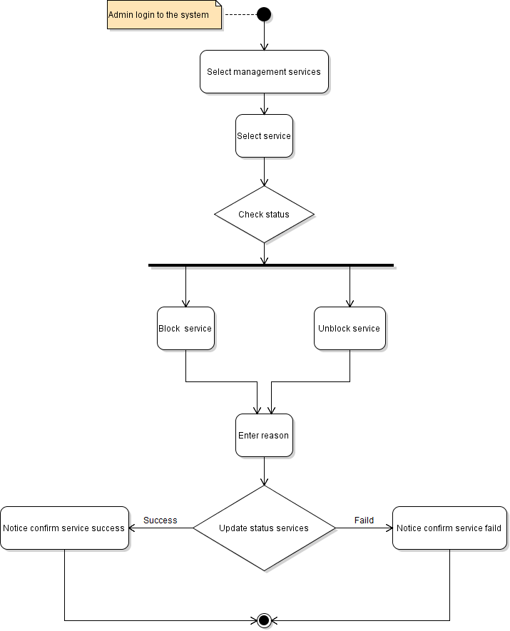

* Delete service

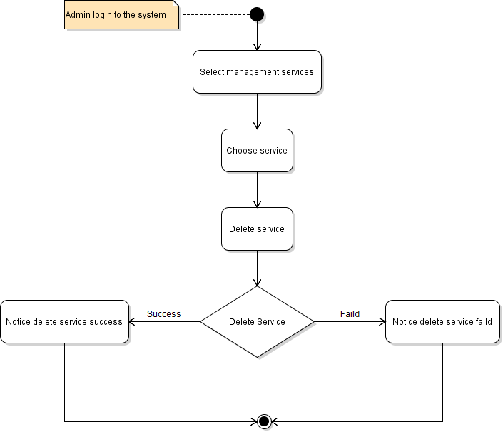

* Message

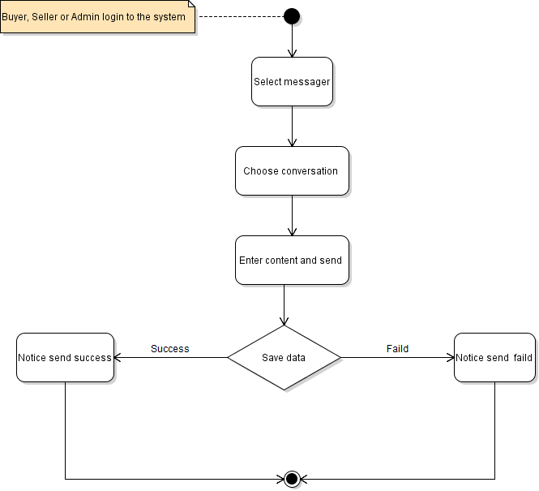

* Mask as read notification

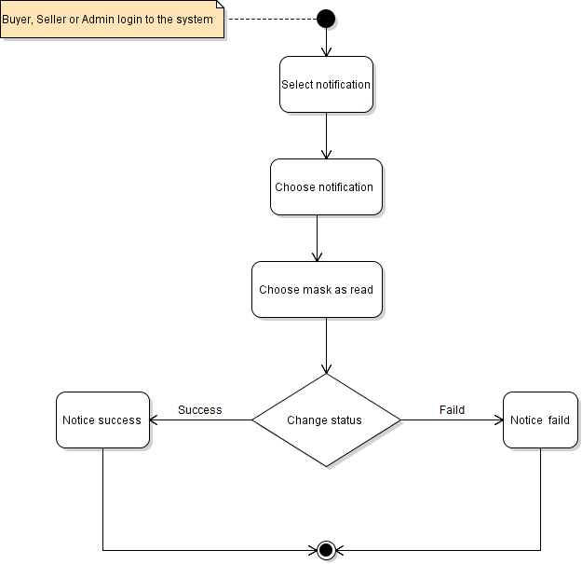

* Handle trouble

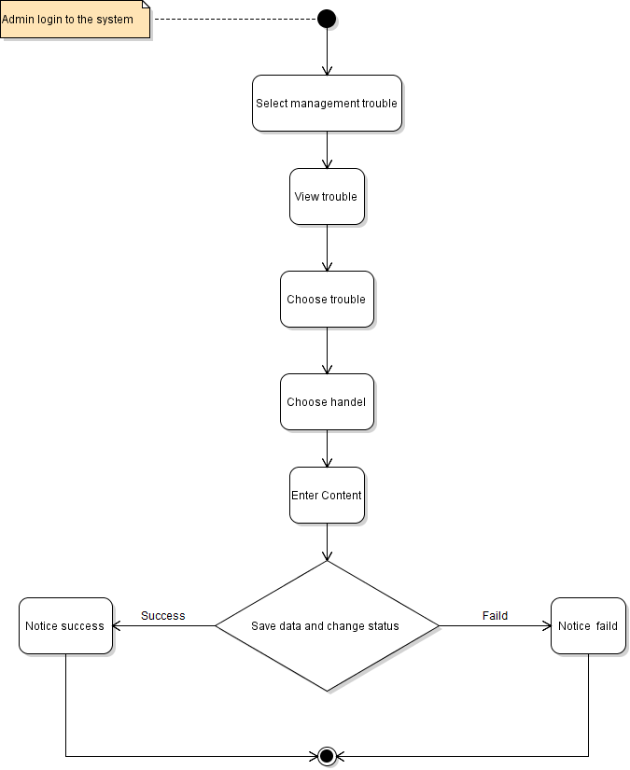

1. Sequence Diagram:

* Add category

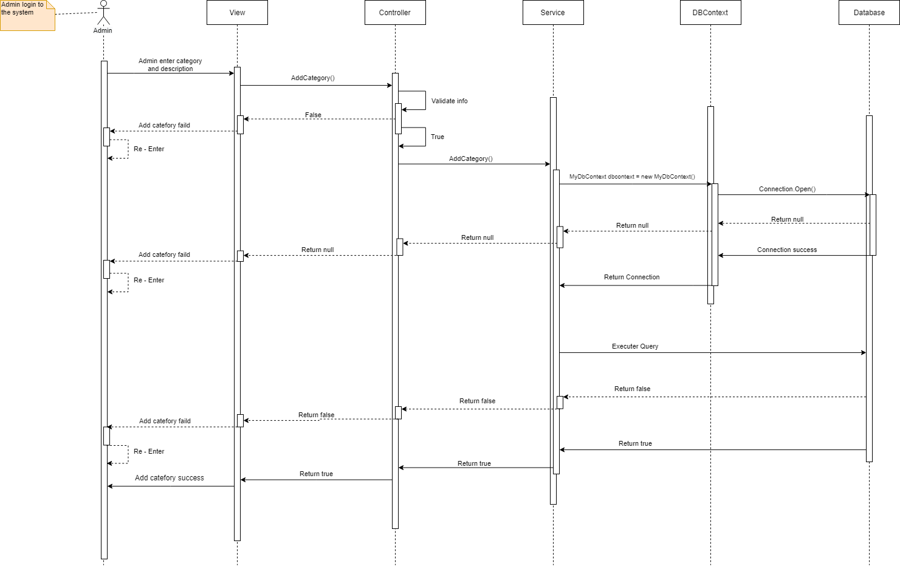

* Apply order

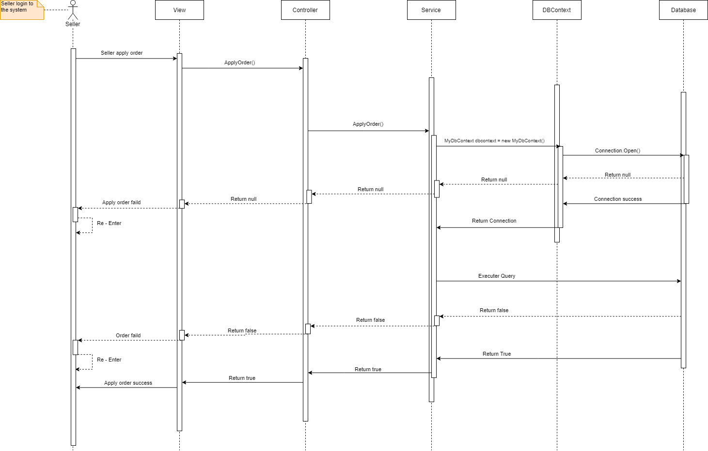

* Block user

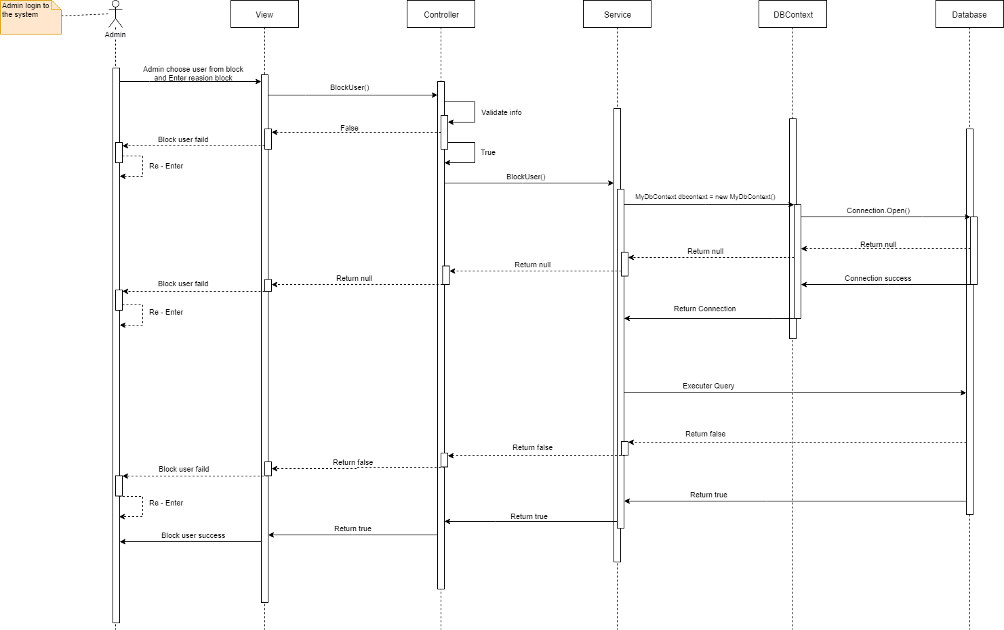

* Create offer

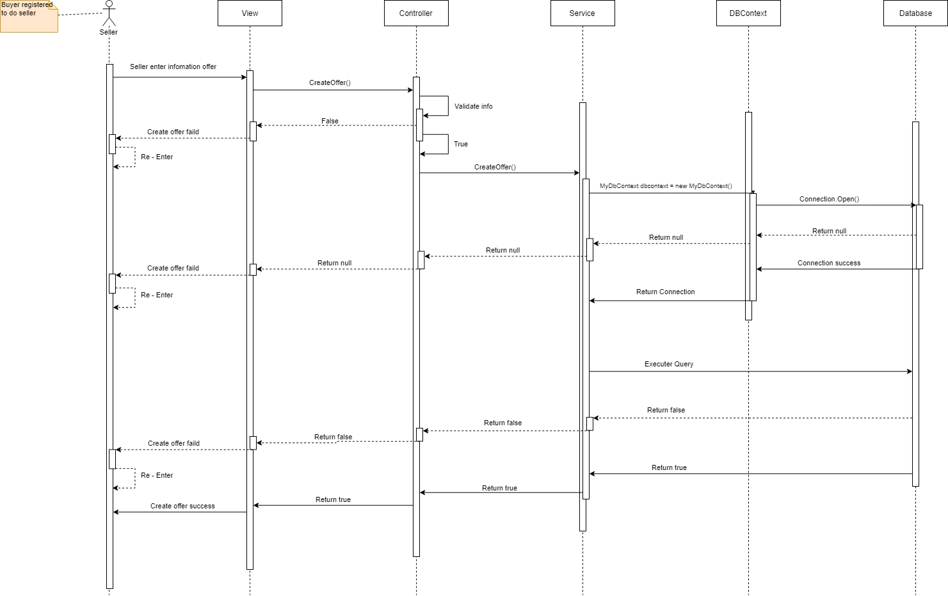

* Create order

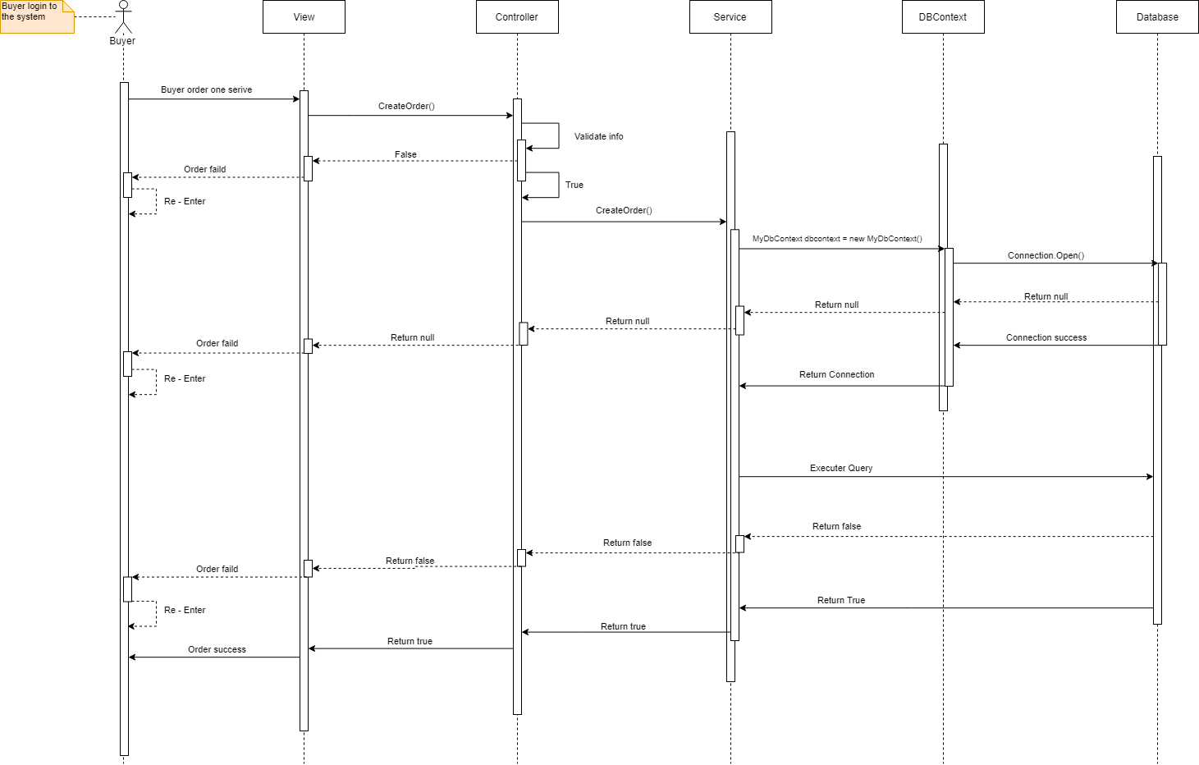

* Create service

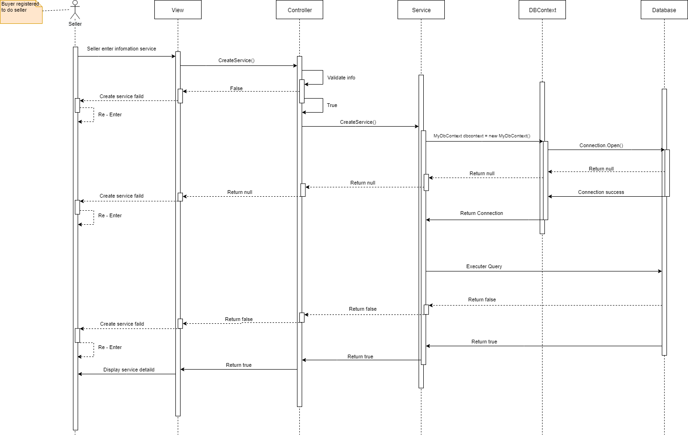

* Deactivate account

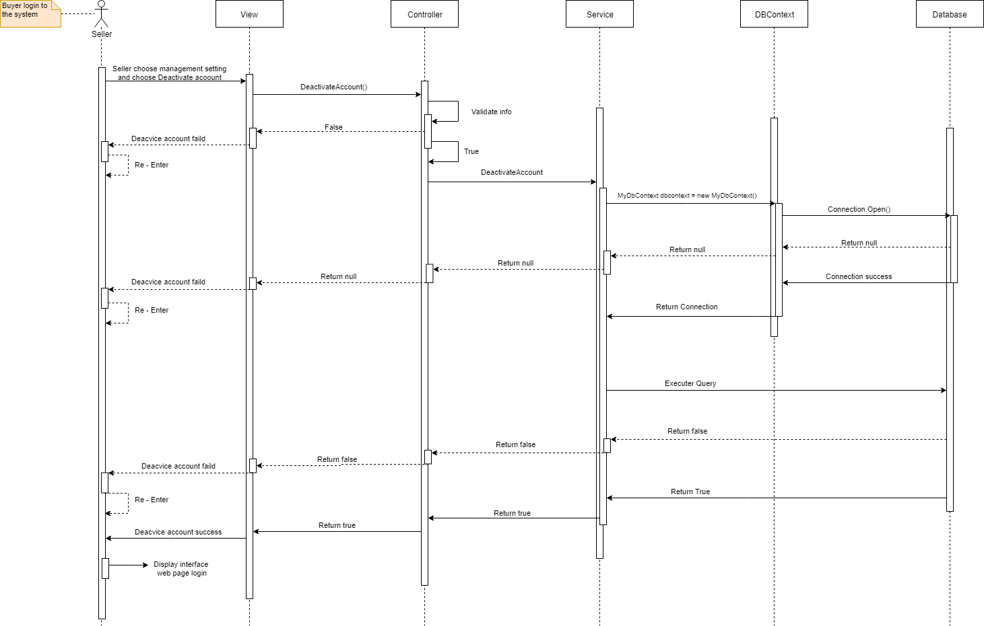

* Delete offer

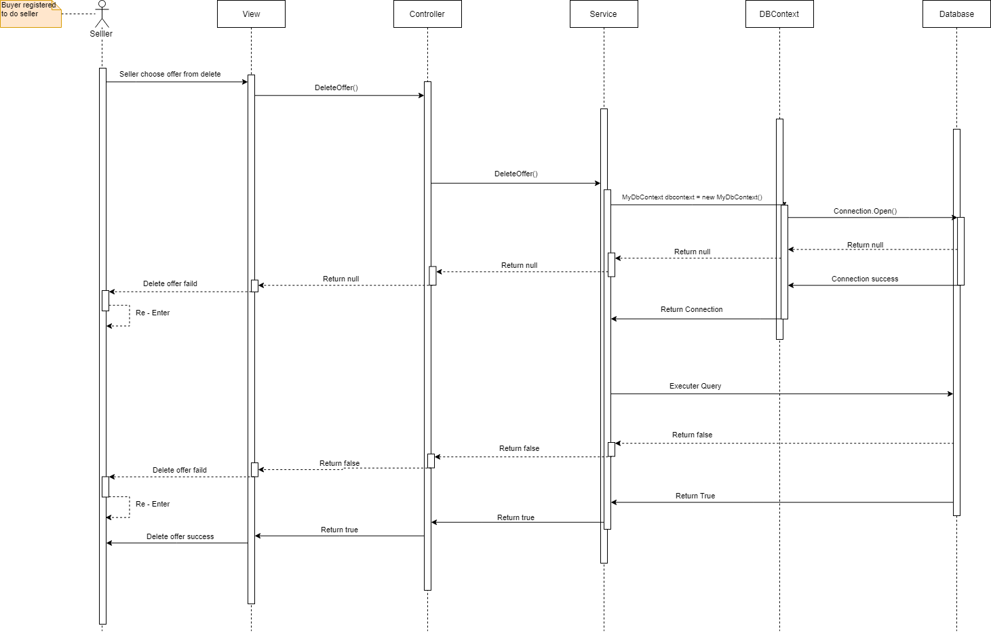

* Delete request

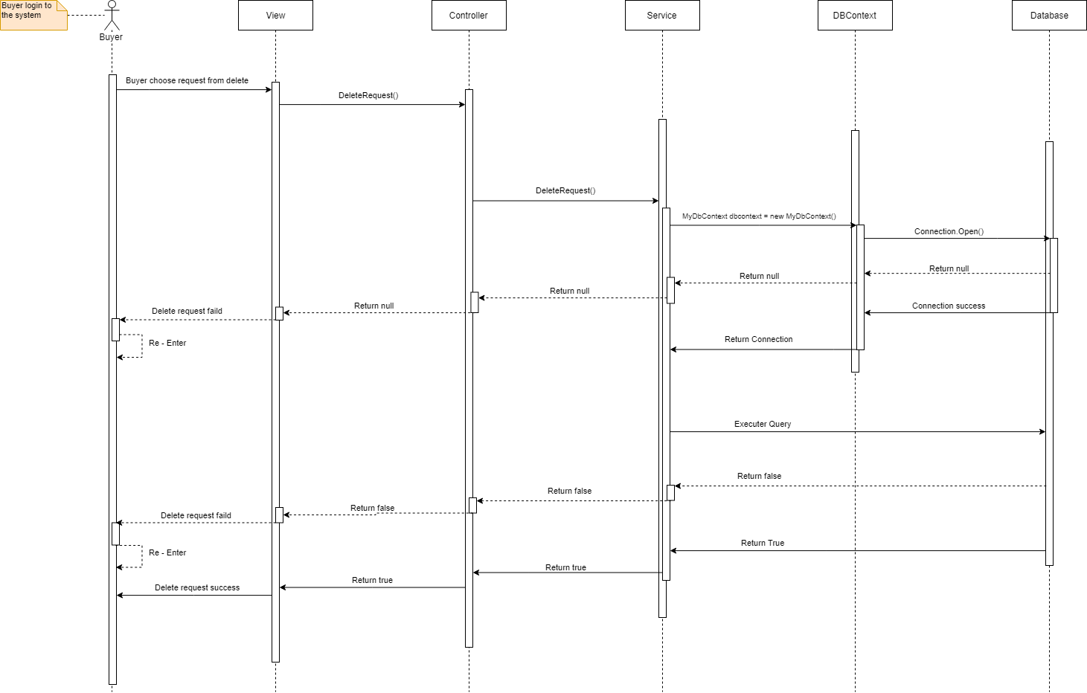

* Delete service

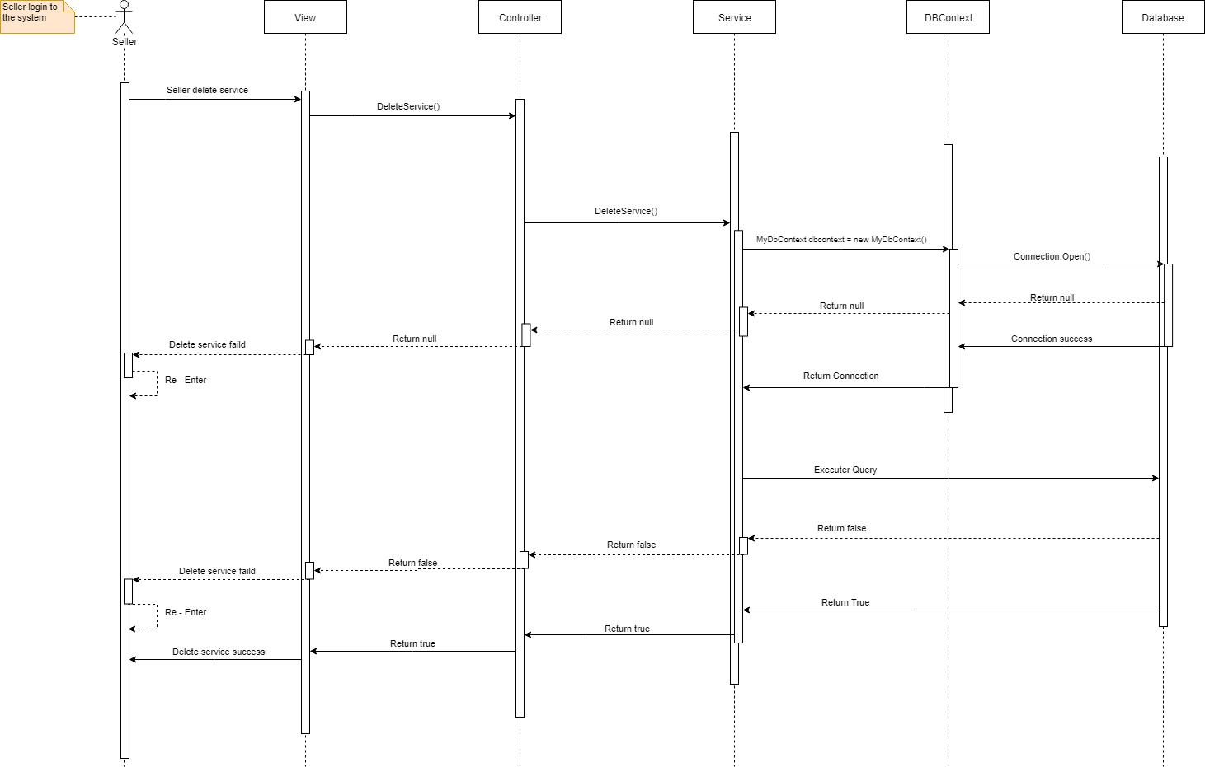

* Edit information

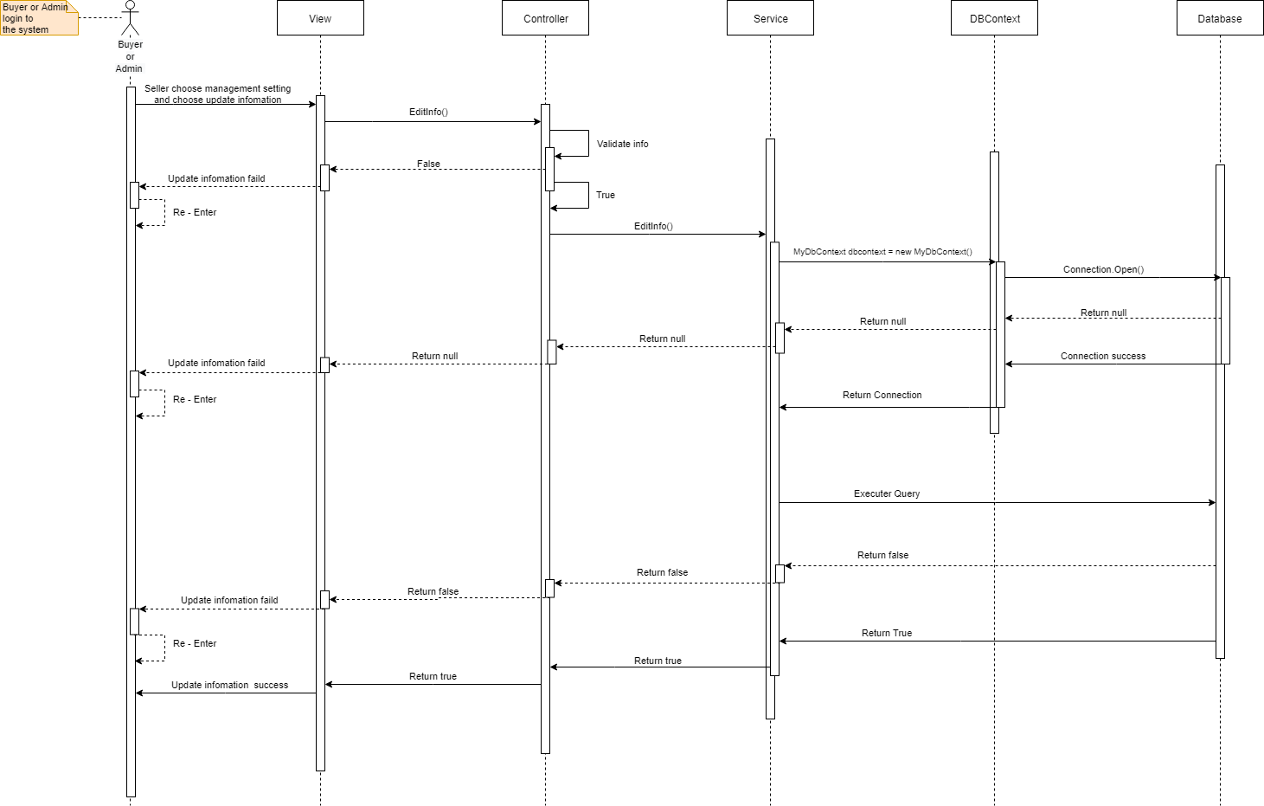

* Edit profile

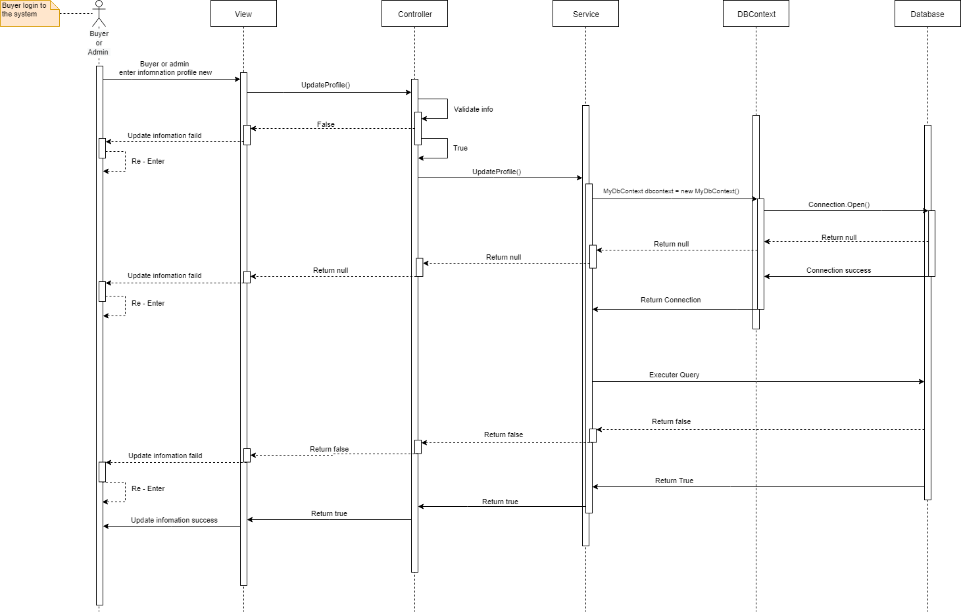

* Edit user

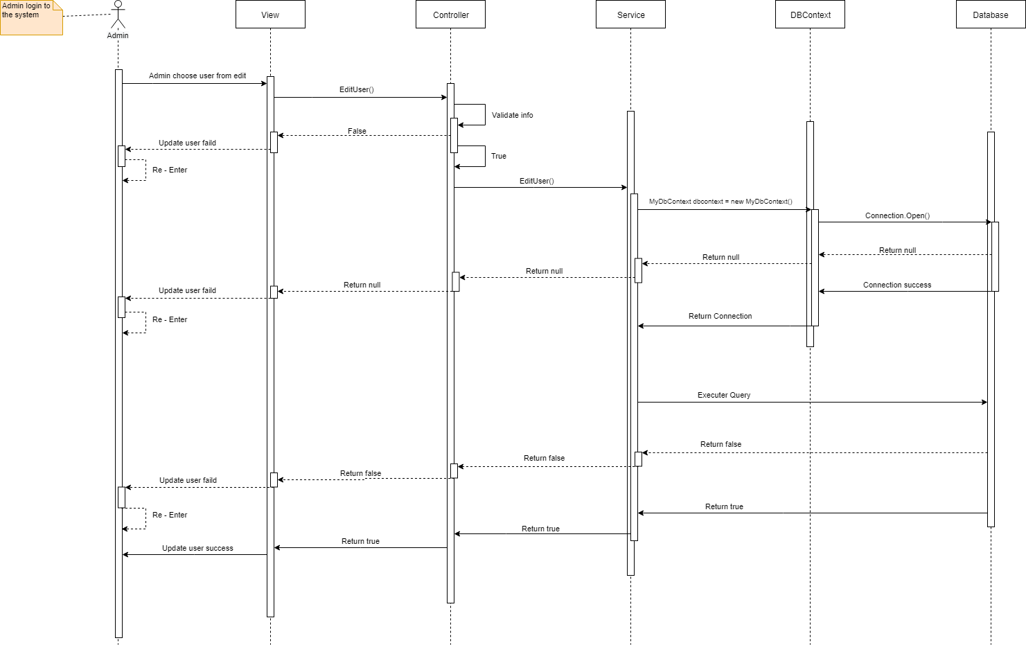

* Login

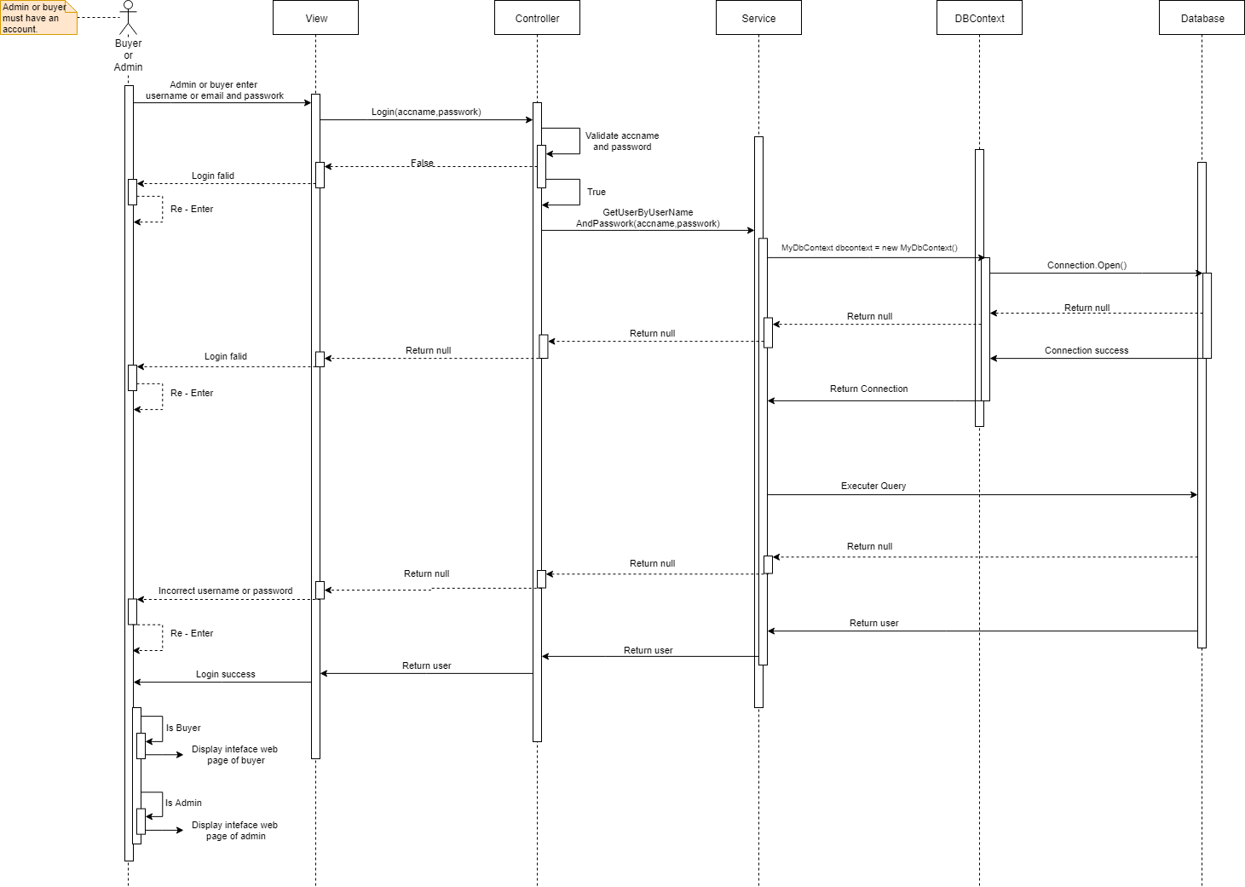

* Post request

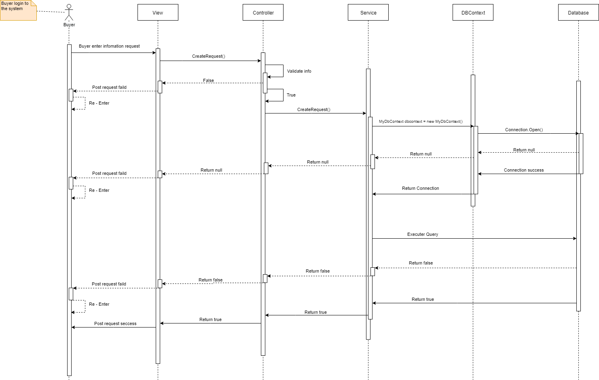

* Register

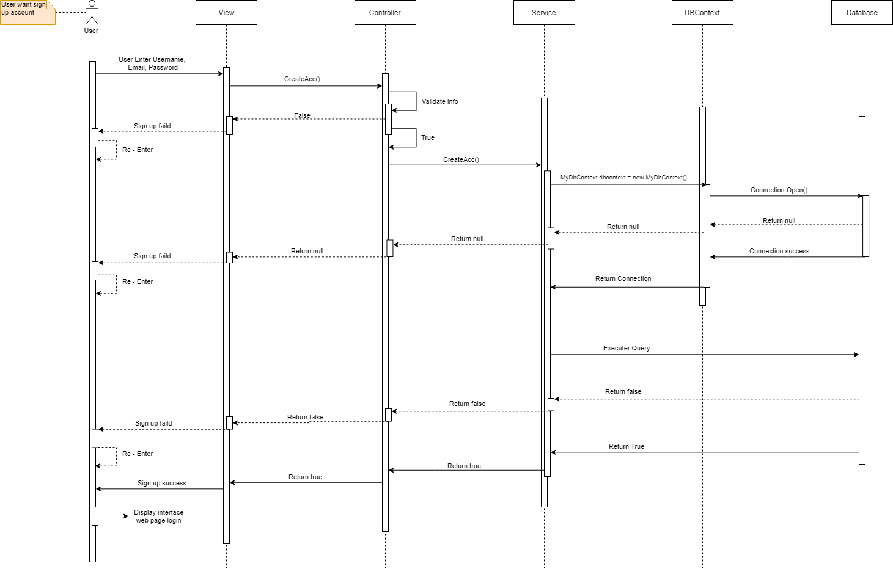

* Register seller

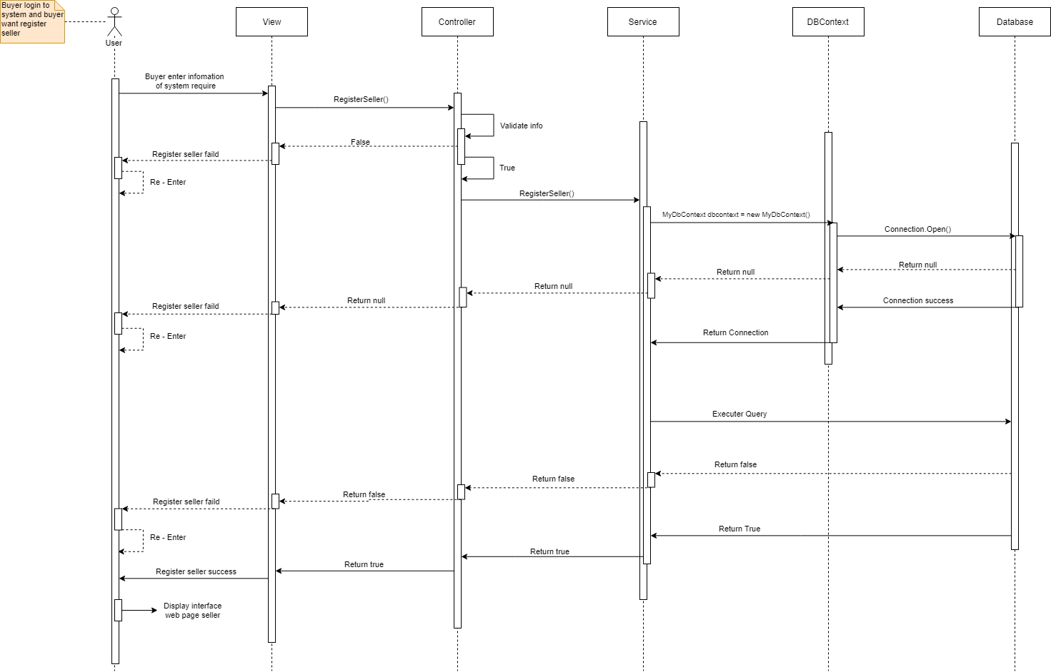

* Report buyer

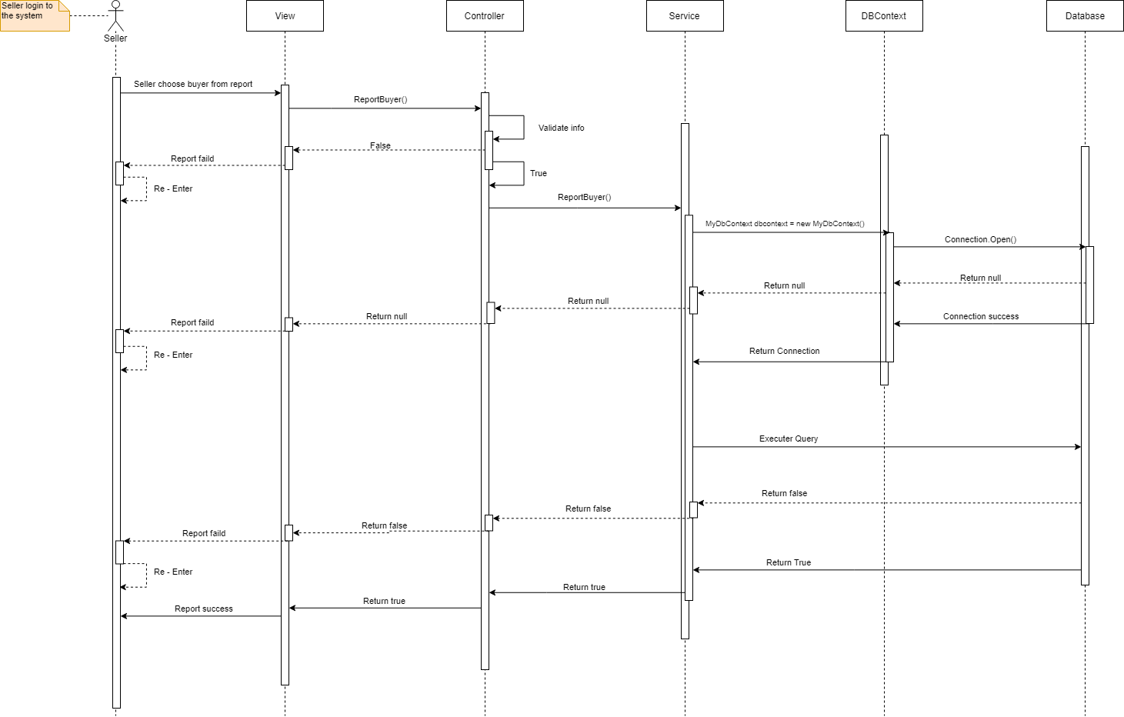

* Report service

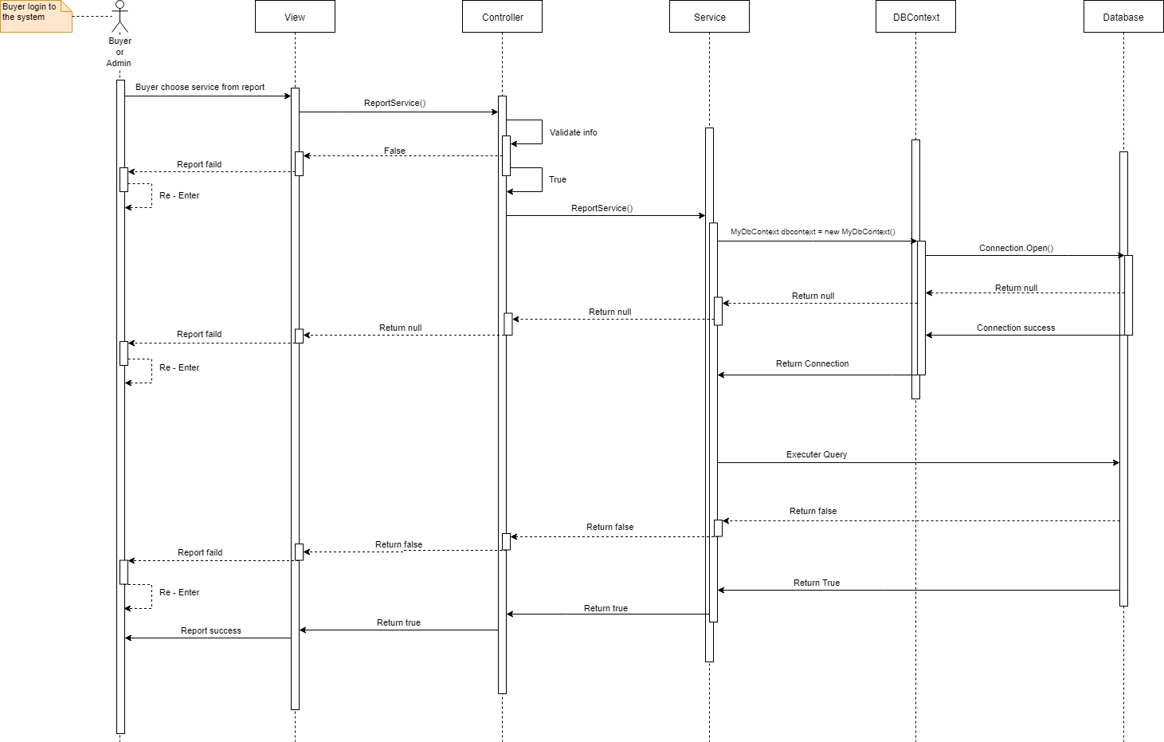

* Search service

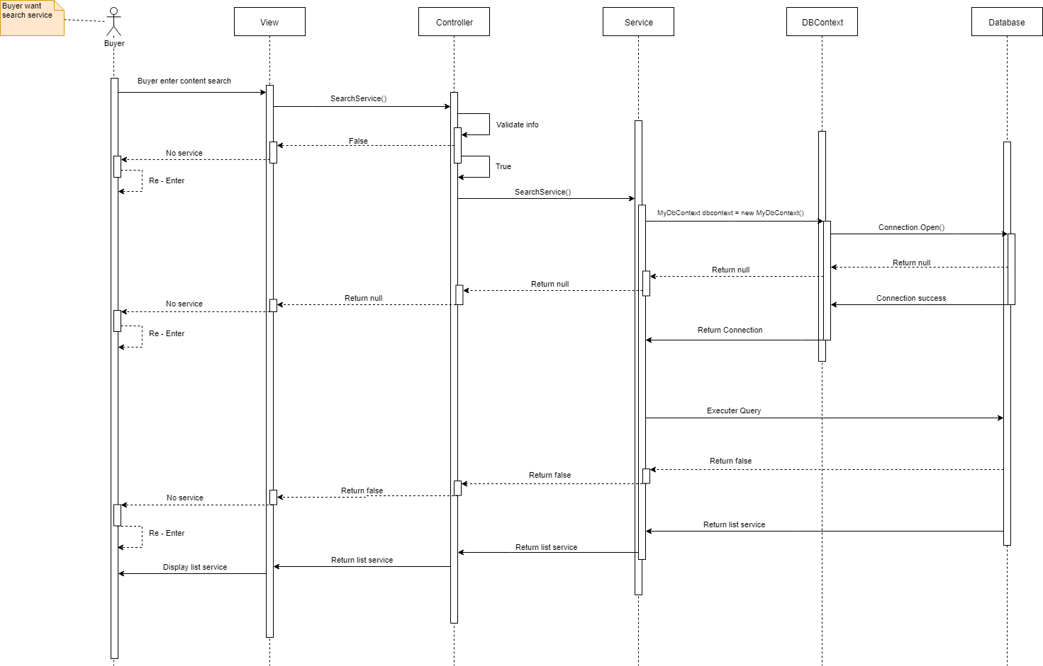

* Update offer

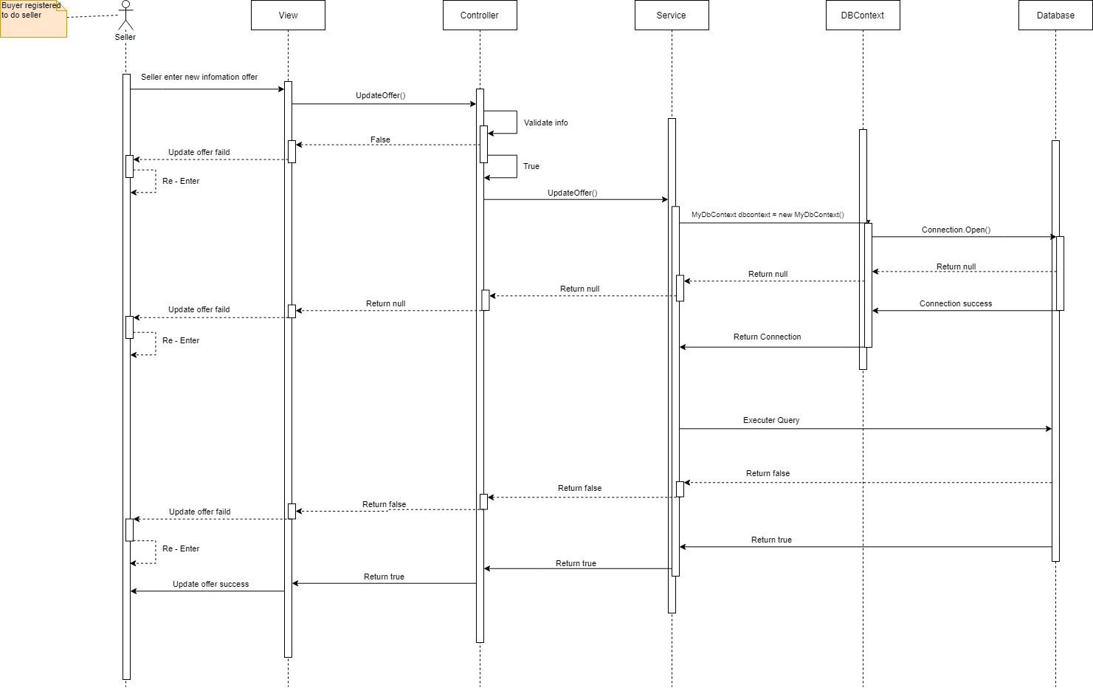

* Update request

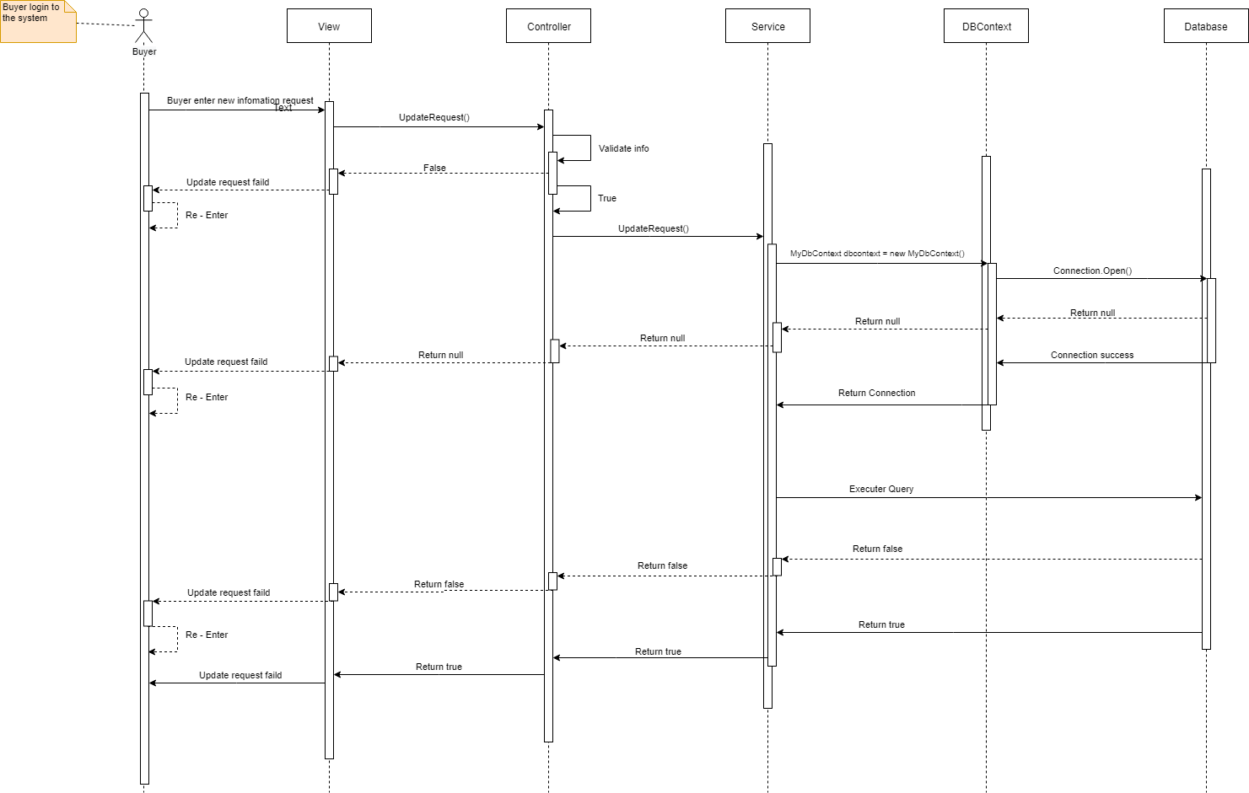

* Update service

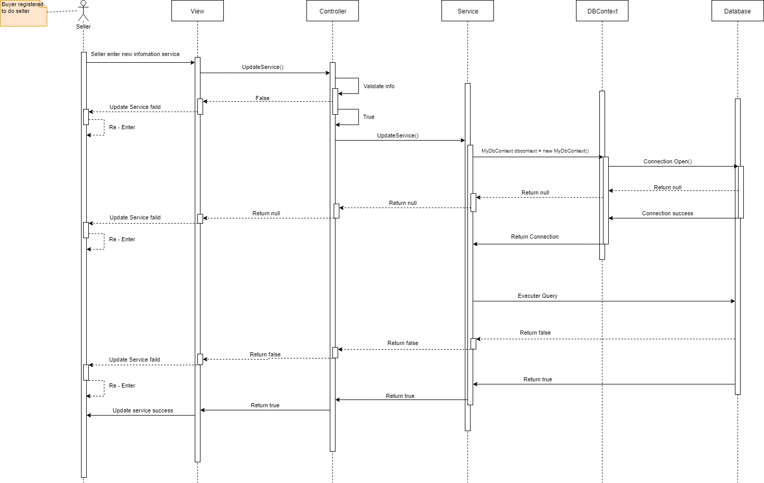

# Detailed design

## Design the theme.

* Home Page

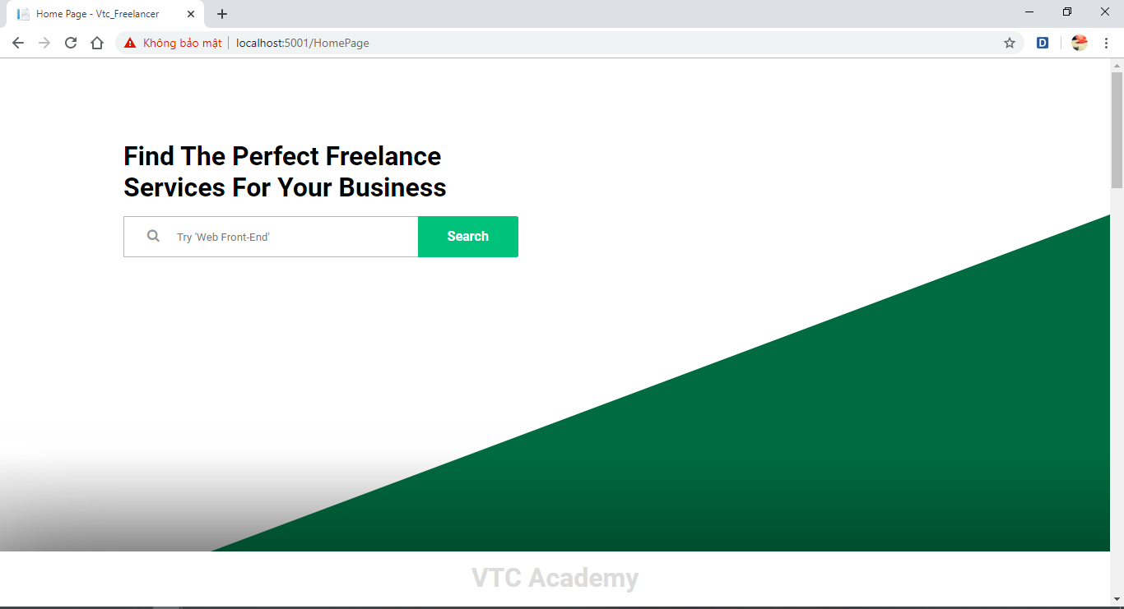

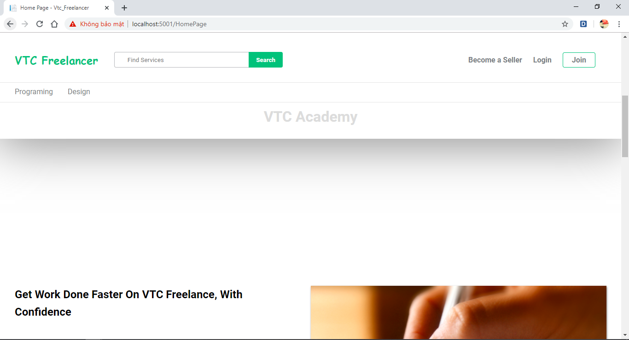

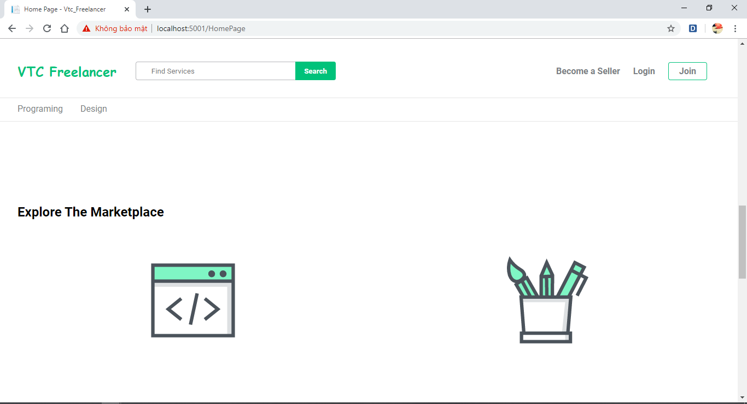

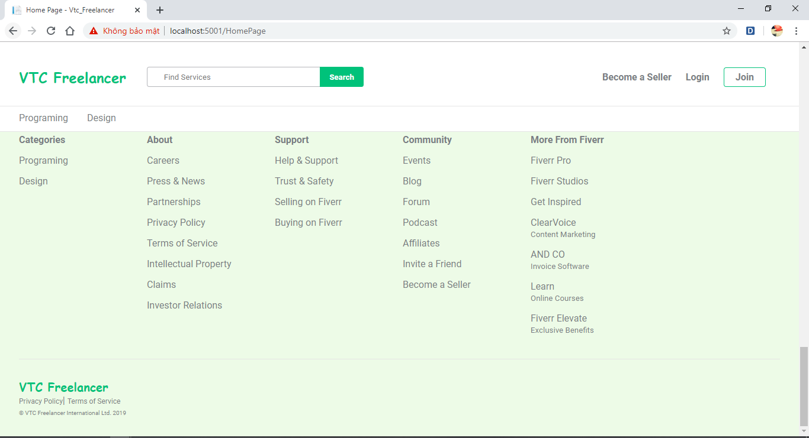

* Register

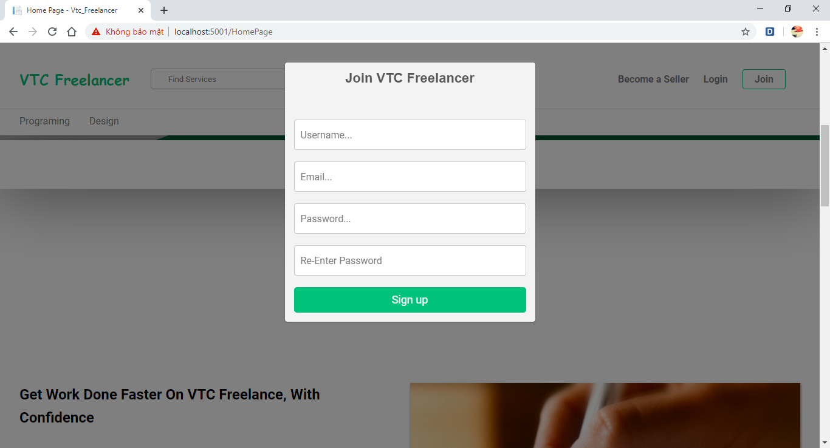

* Login

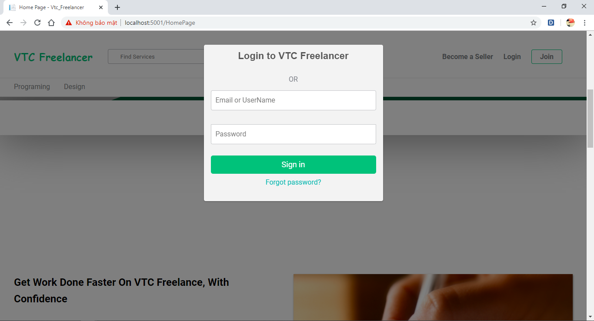

* Home page after login

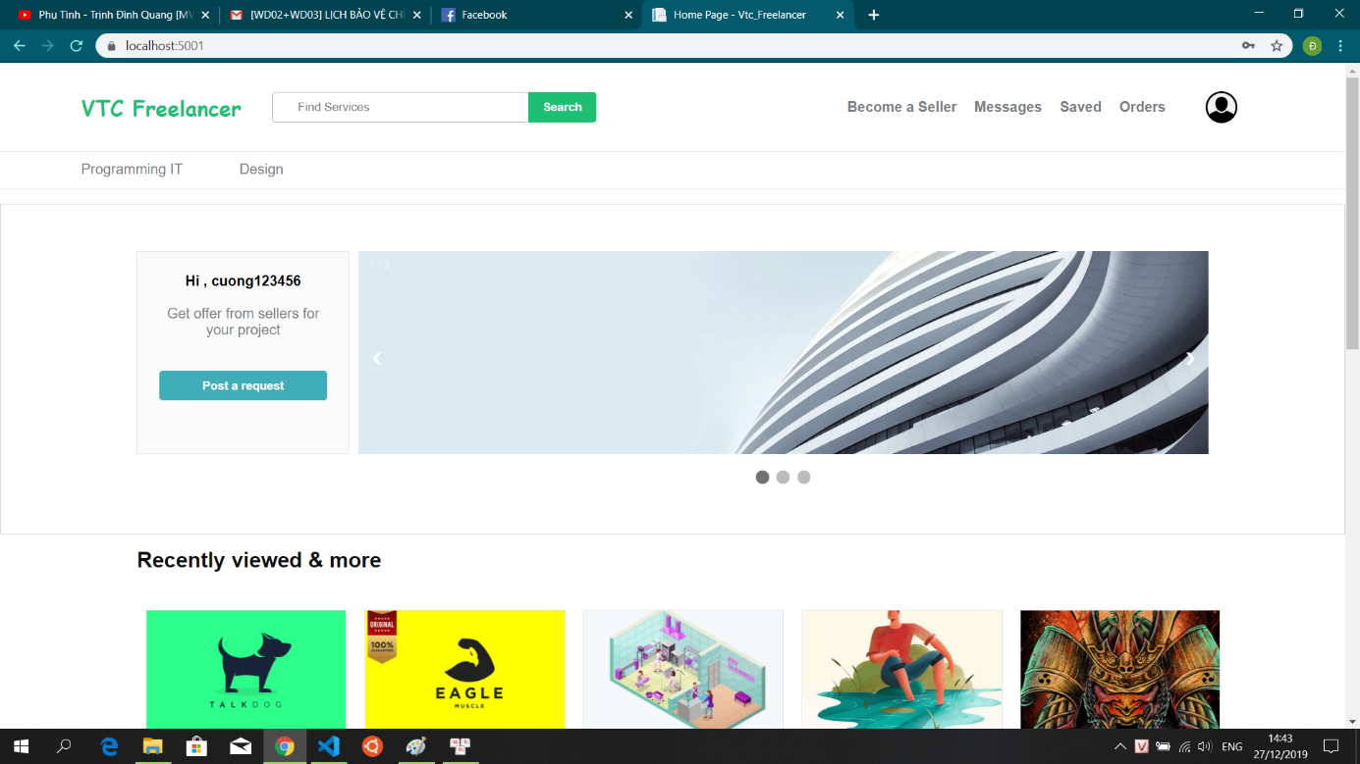

* Register seller

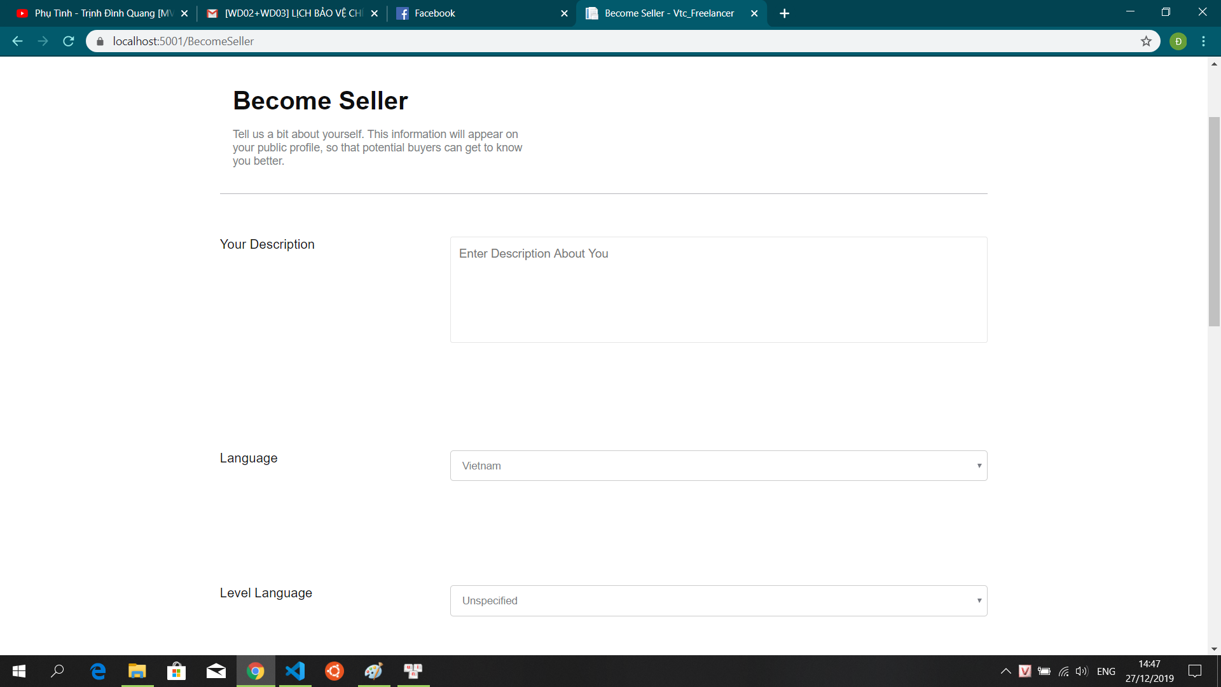

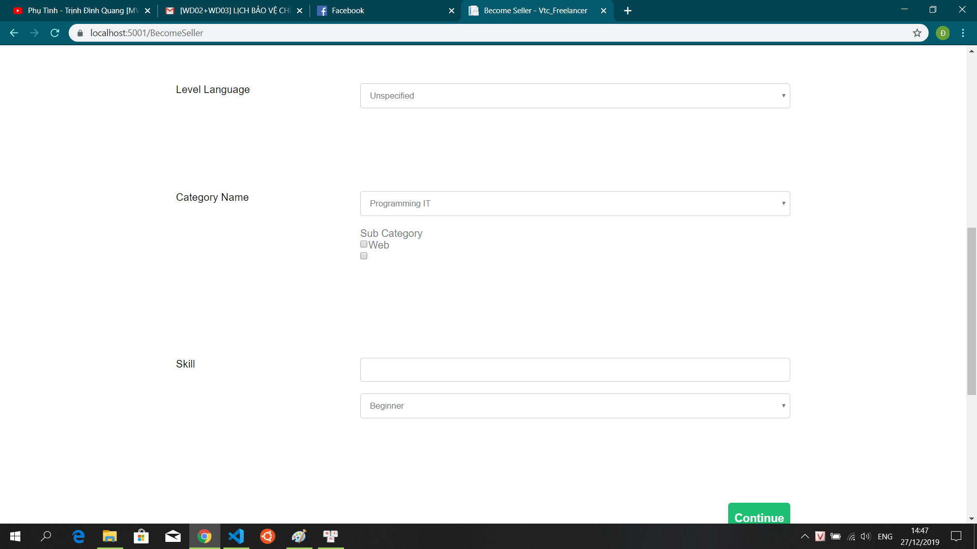

* Post request

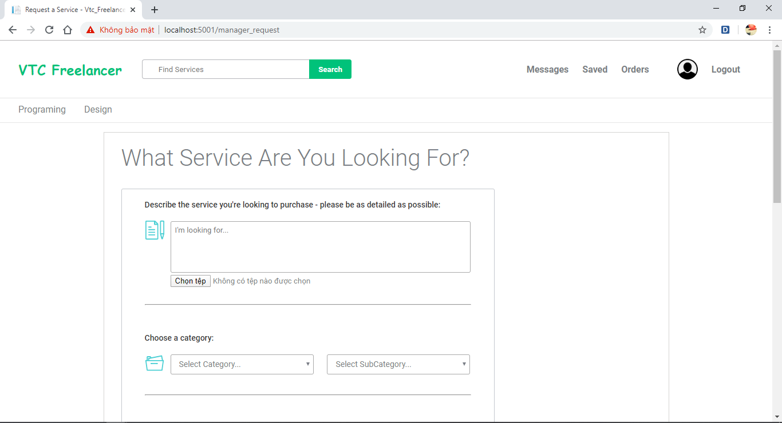

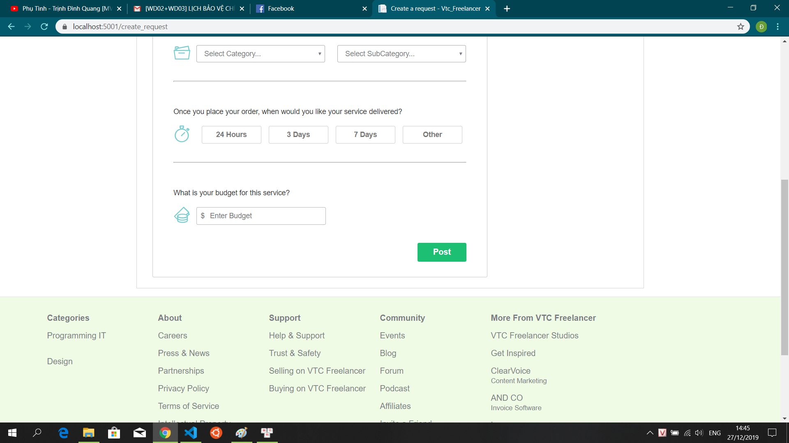

* View Order buyer

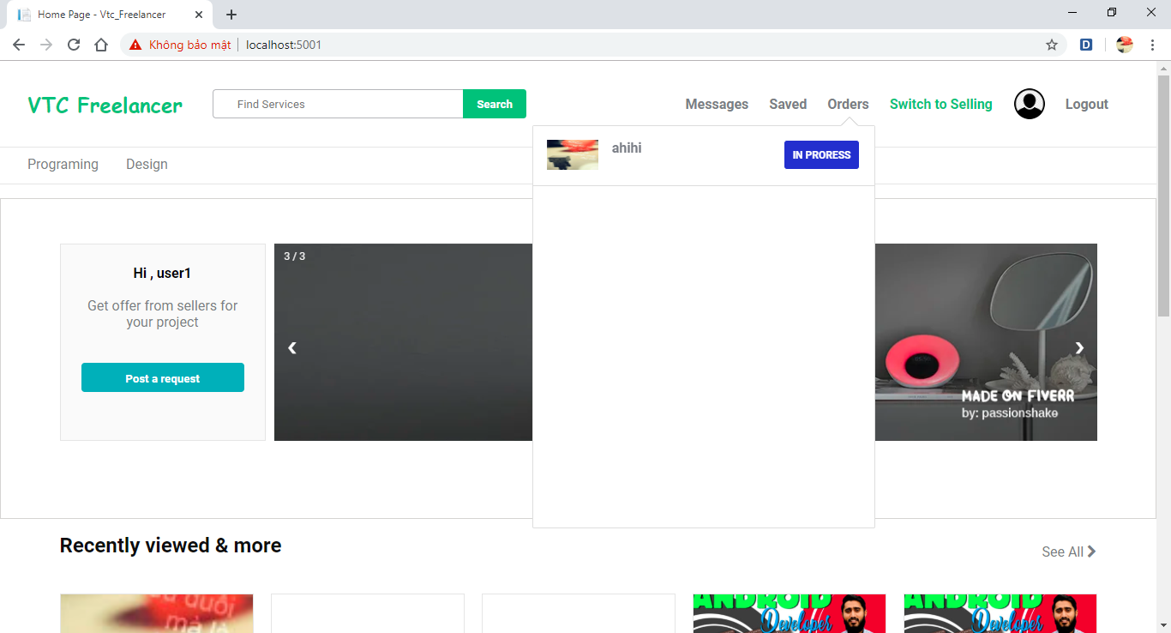

* Dashboard seller

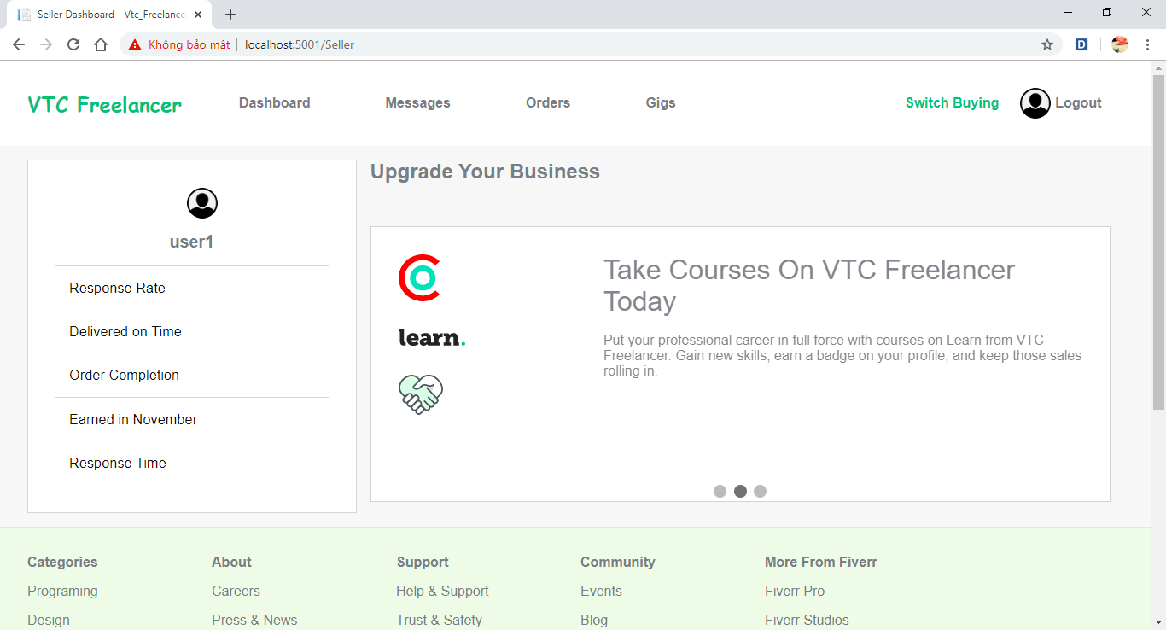

* Creater gig step 1

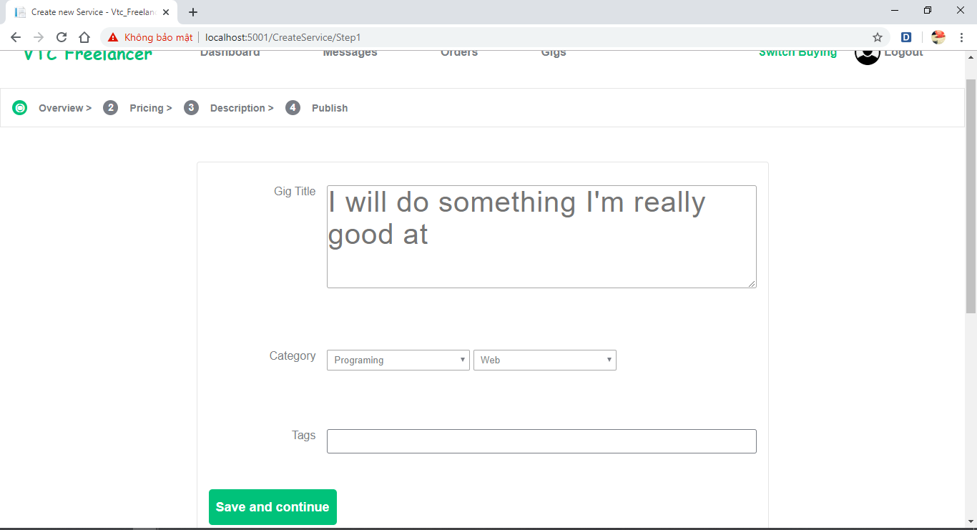

* Create gig step 2

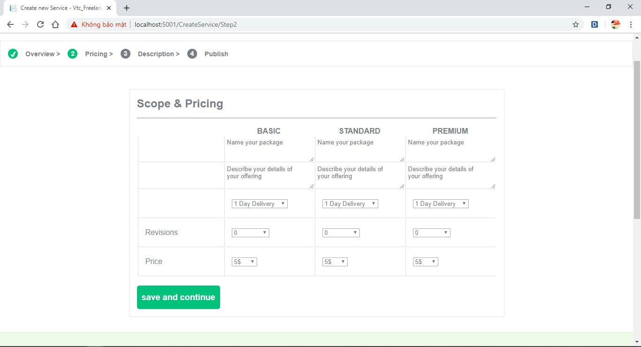

* Create gig step 3

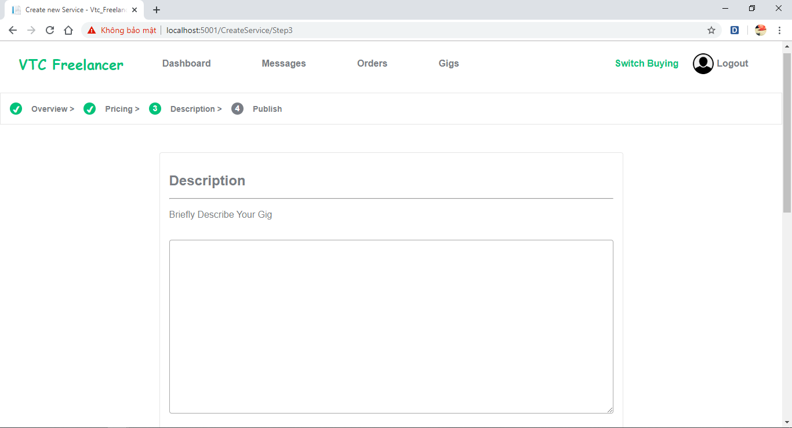

* Create gig step 4

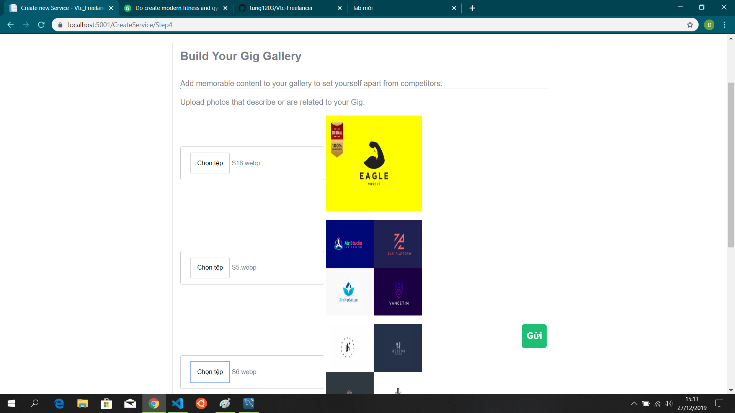

* Profile

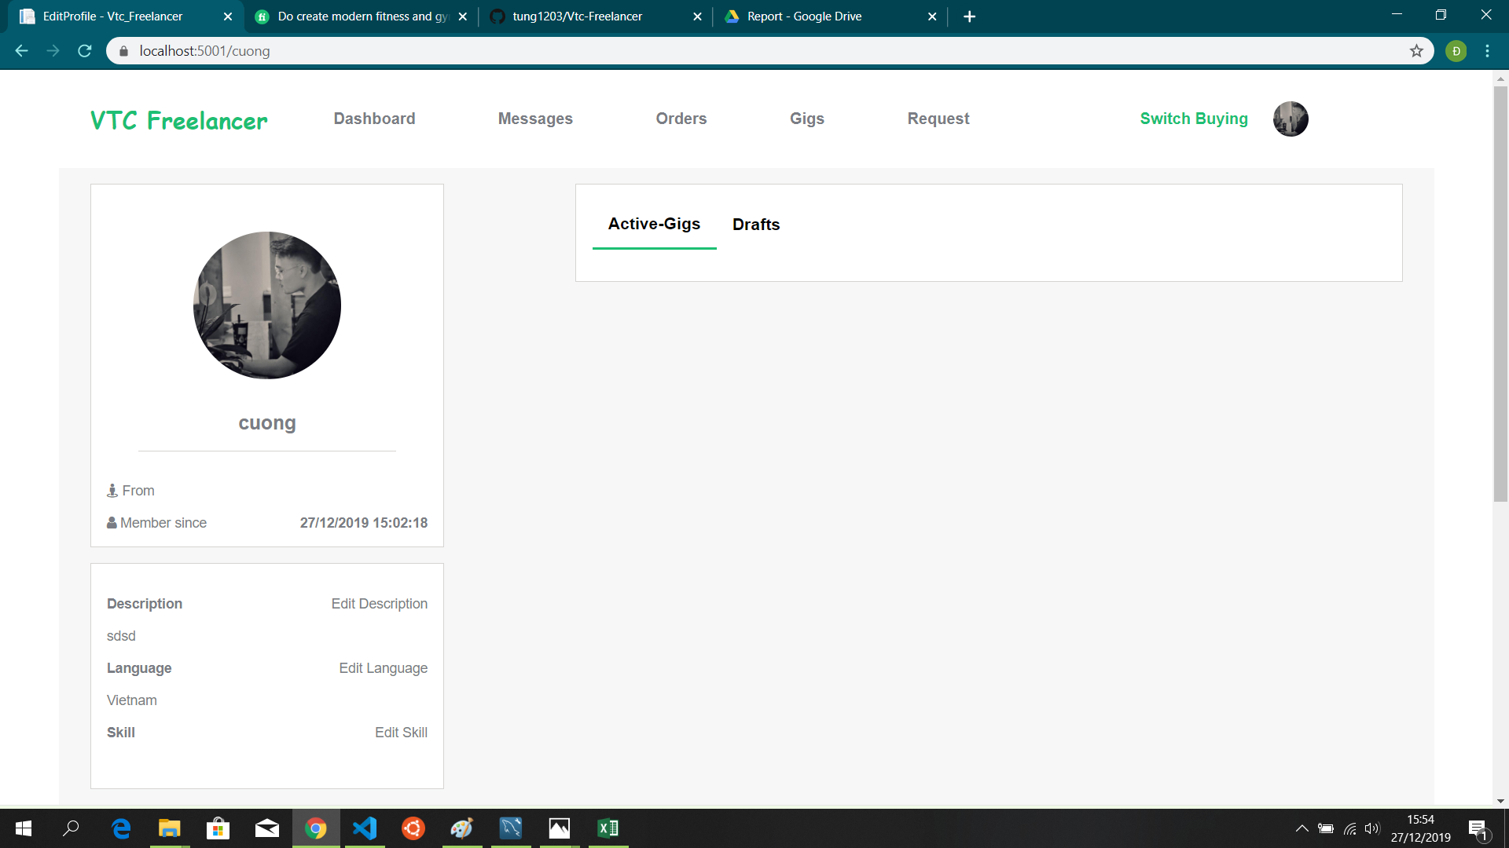

* Manager Request

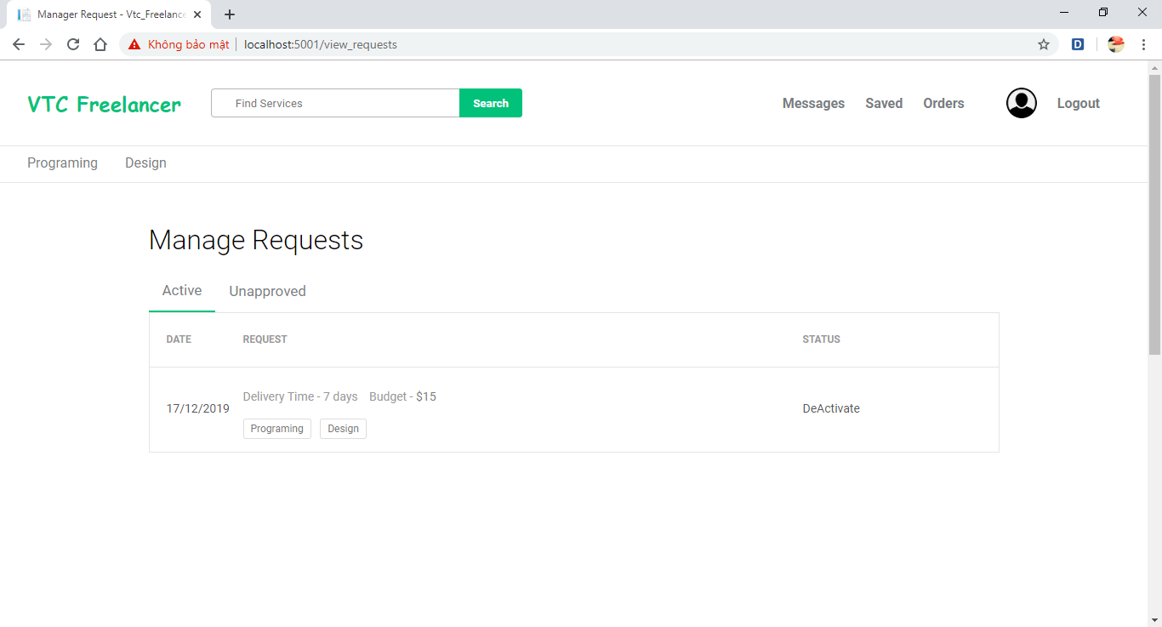

* ViewService Detaild

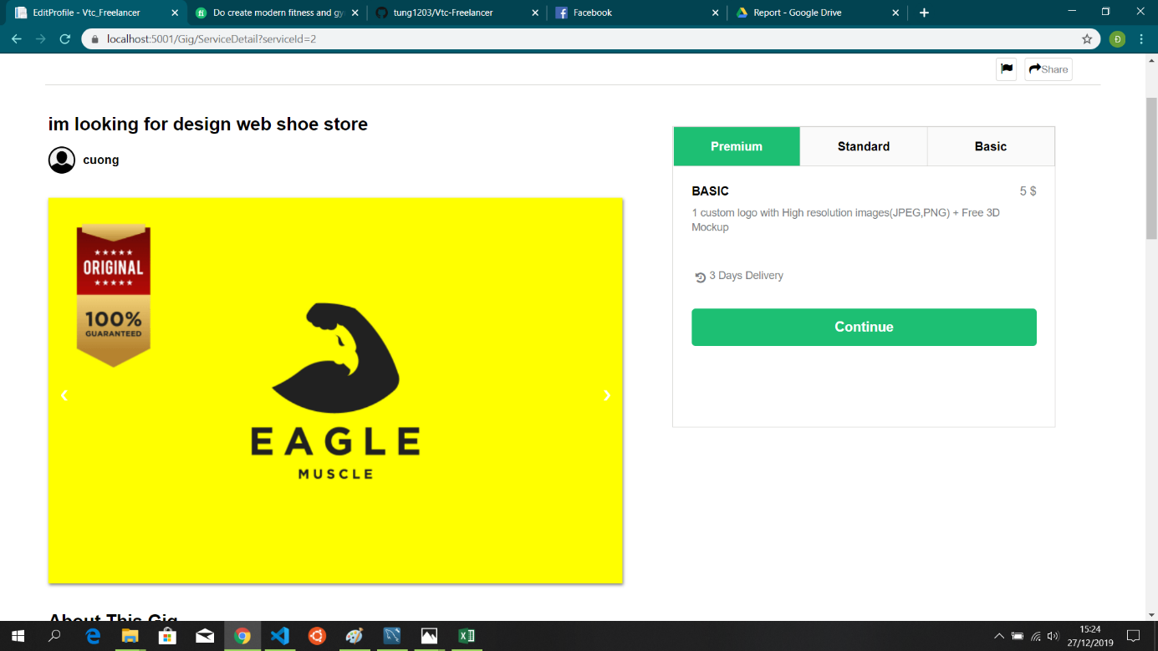

* Buyer order

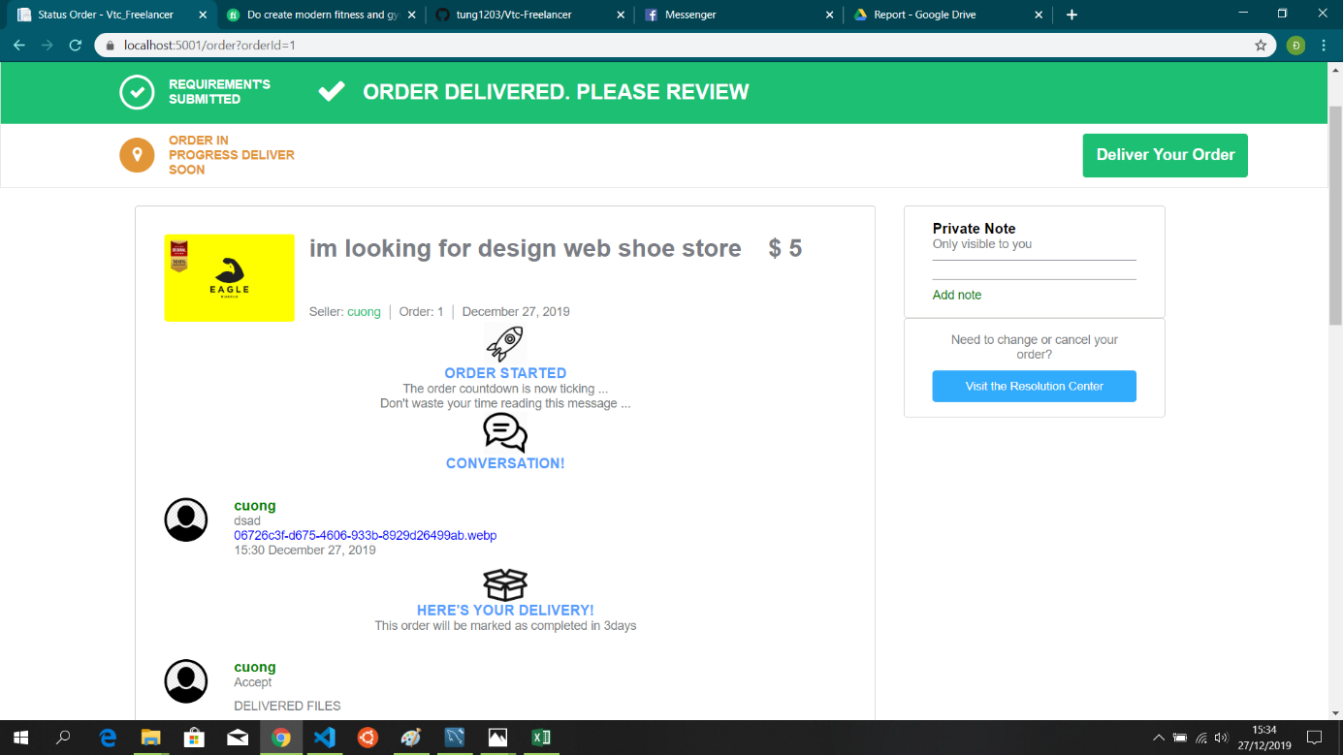

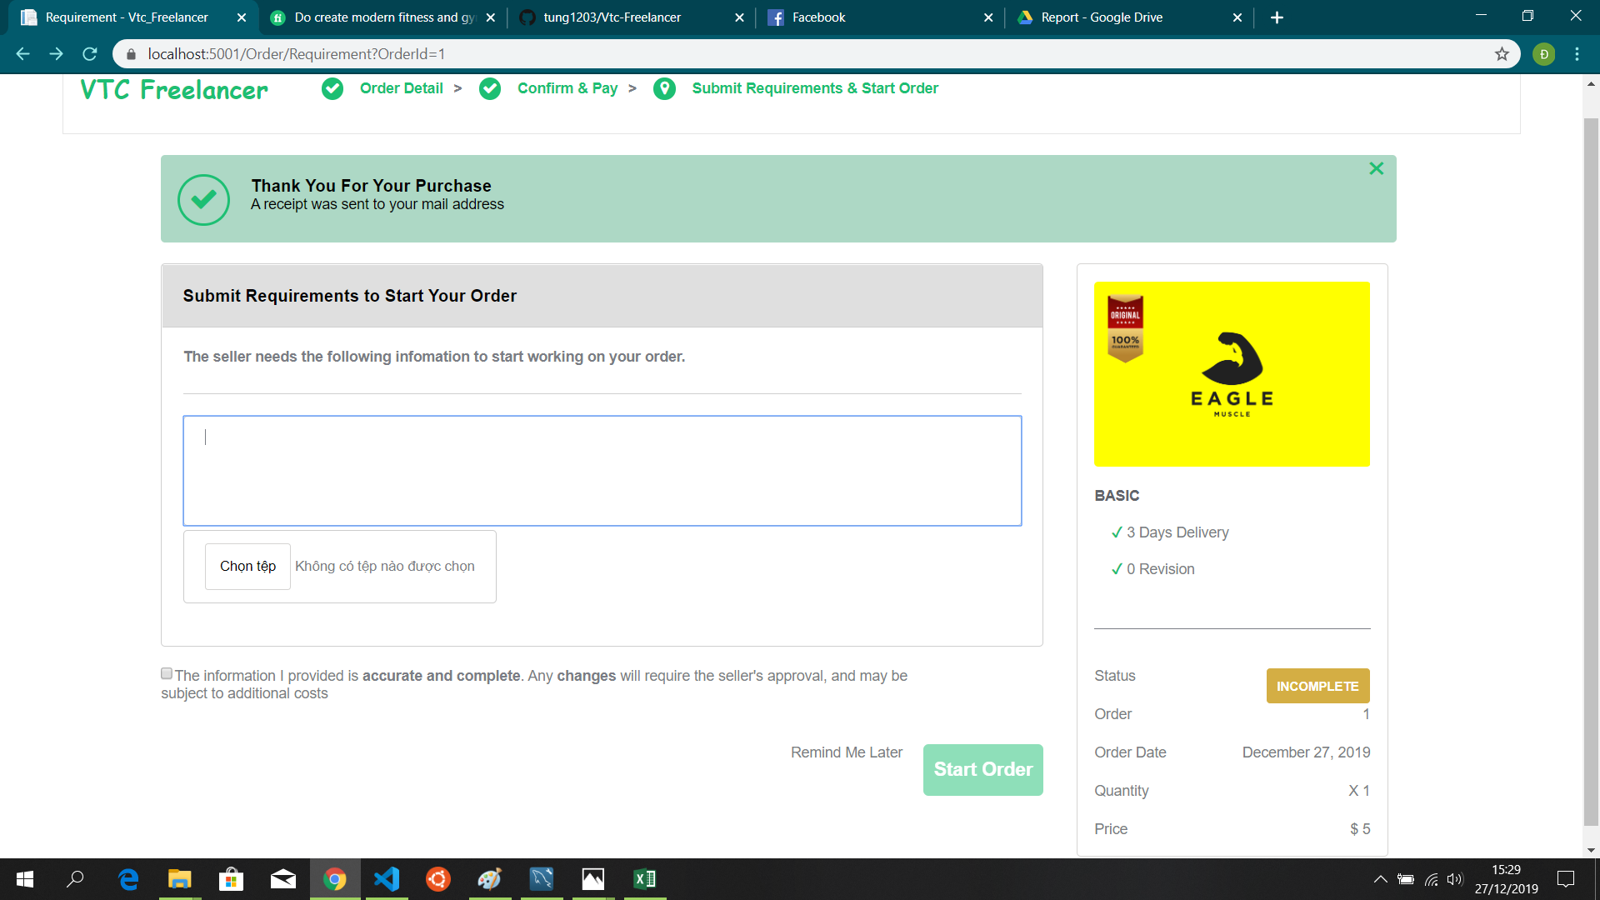

* Oder detail seller

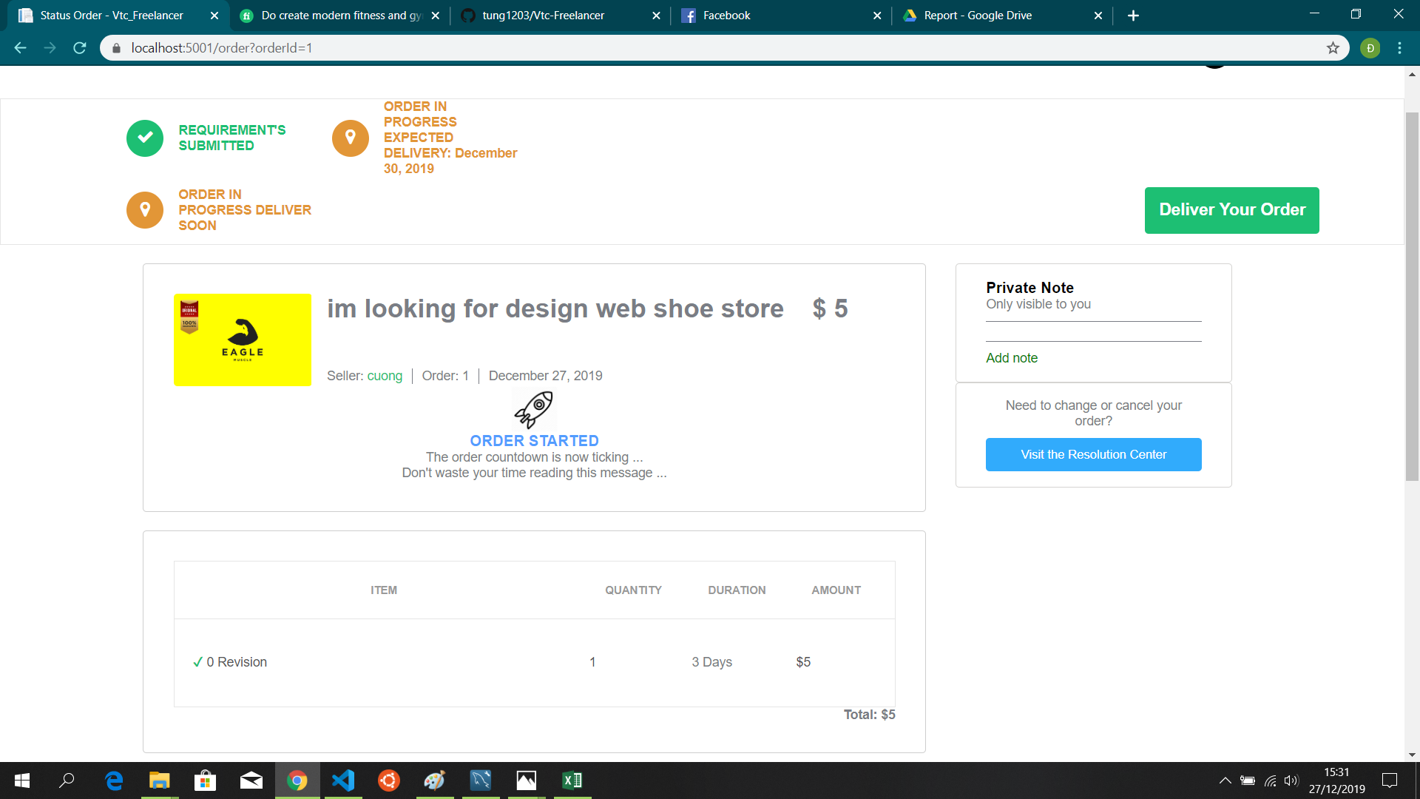

* Return Order



* Buyer take project



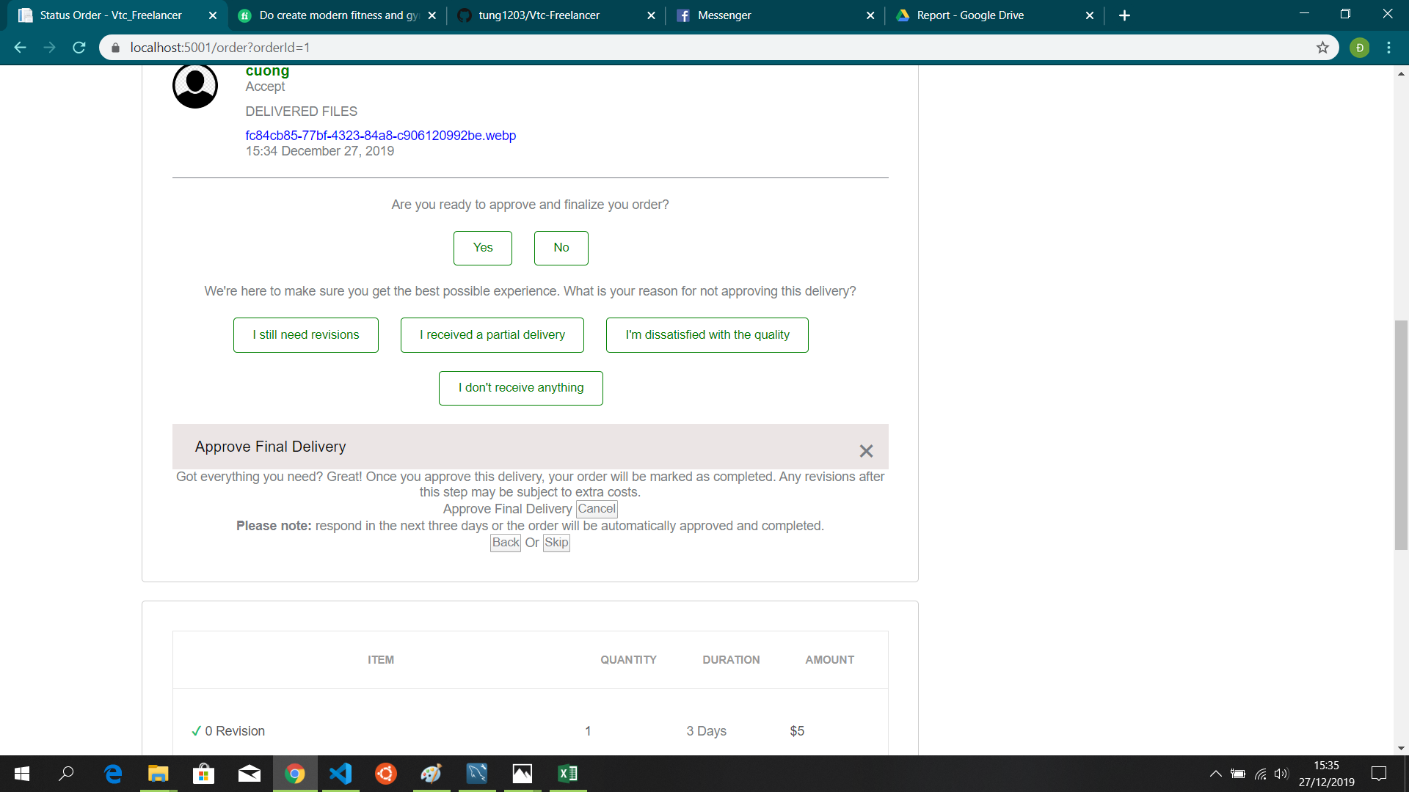

* Dashboard Admin

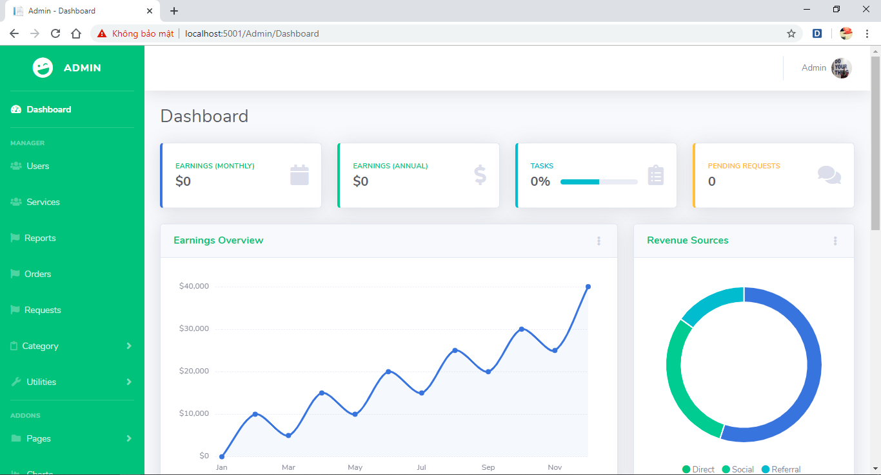

* Manager users

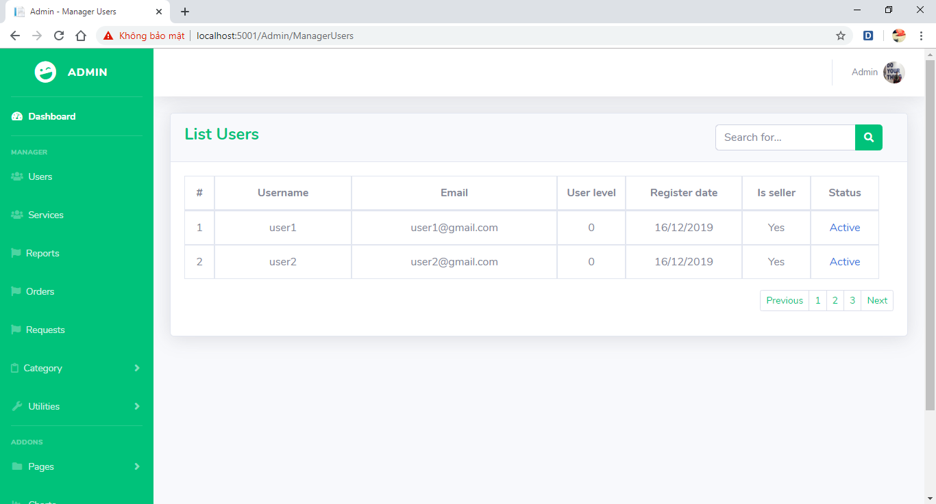

* Manager service

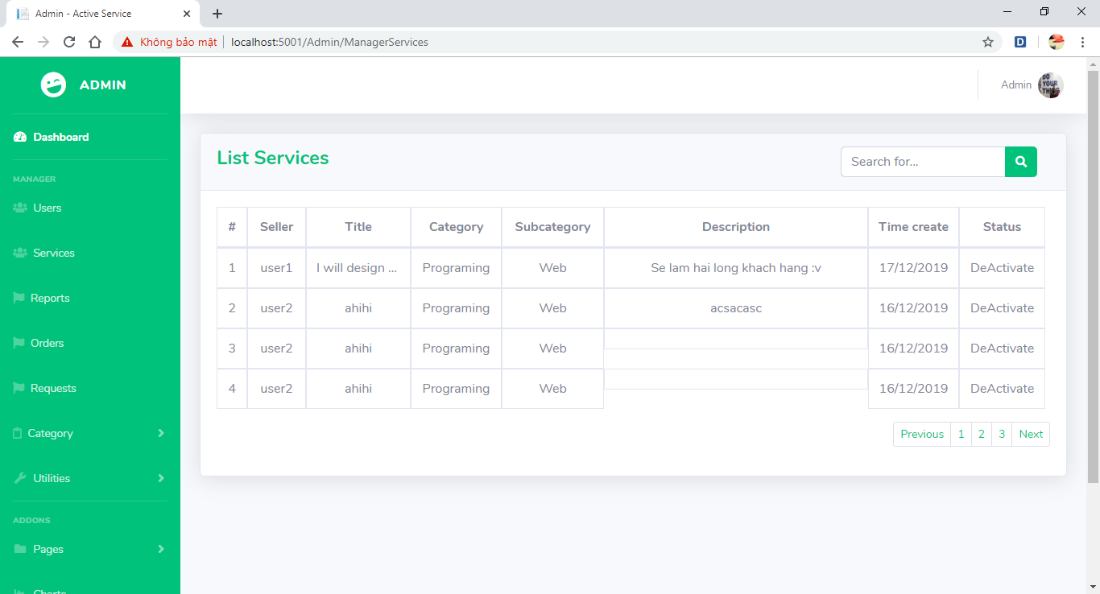

* Manager Order

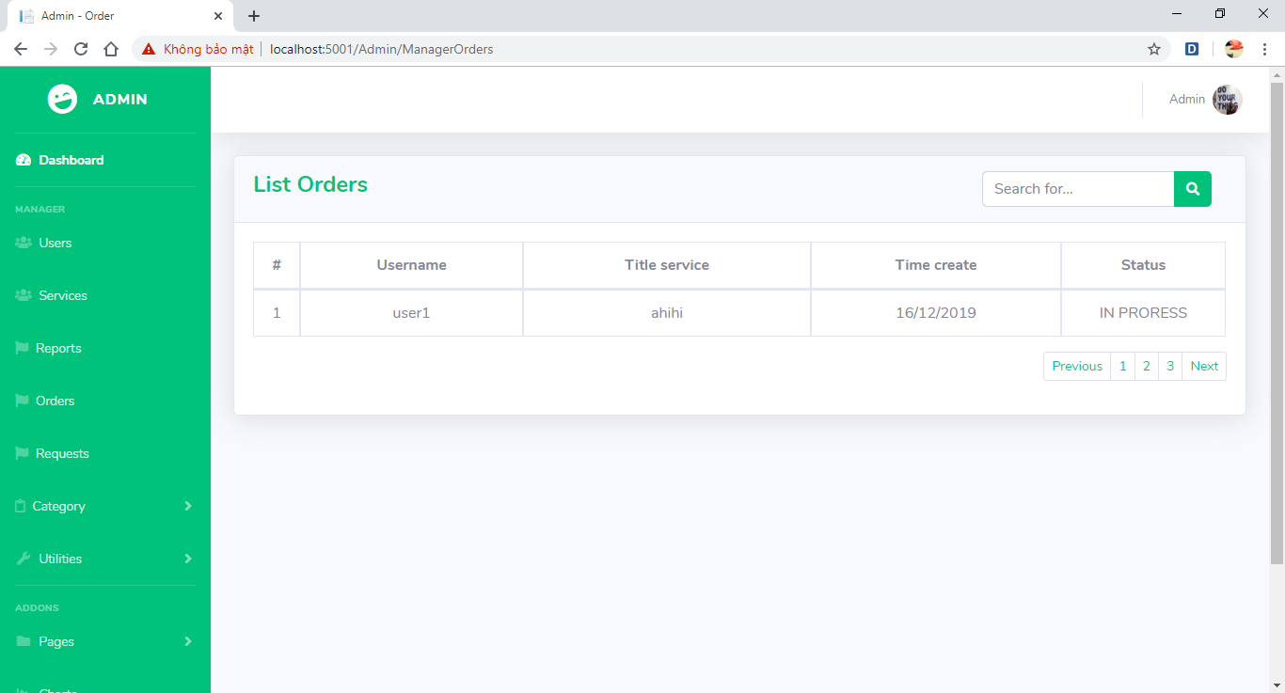

* Manager request

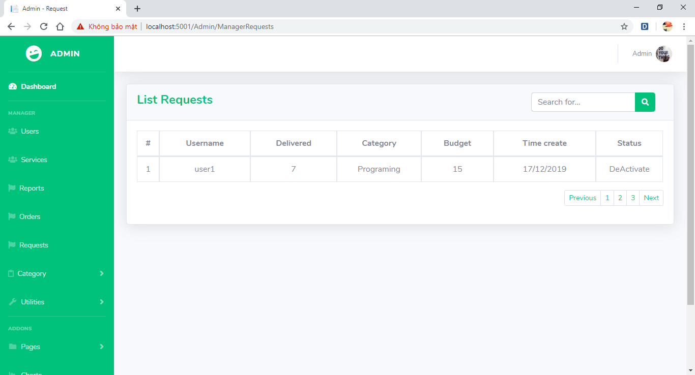

* Manager Category

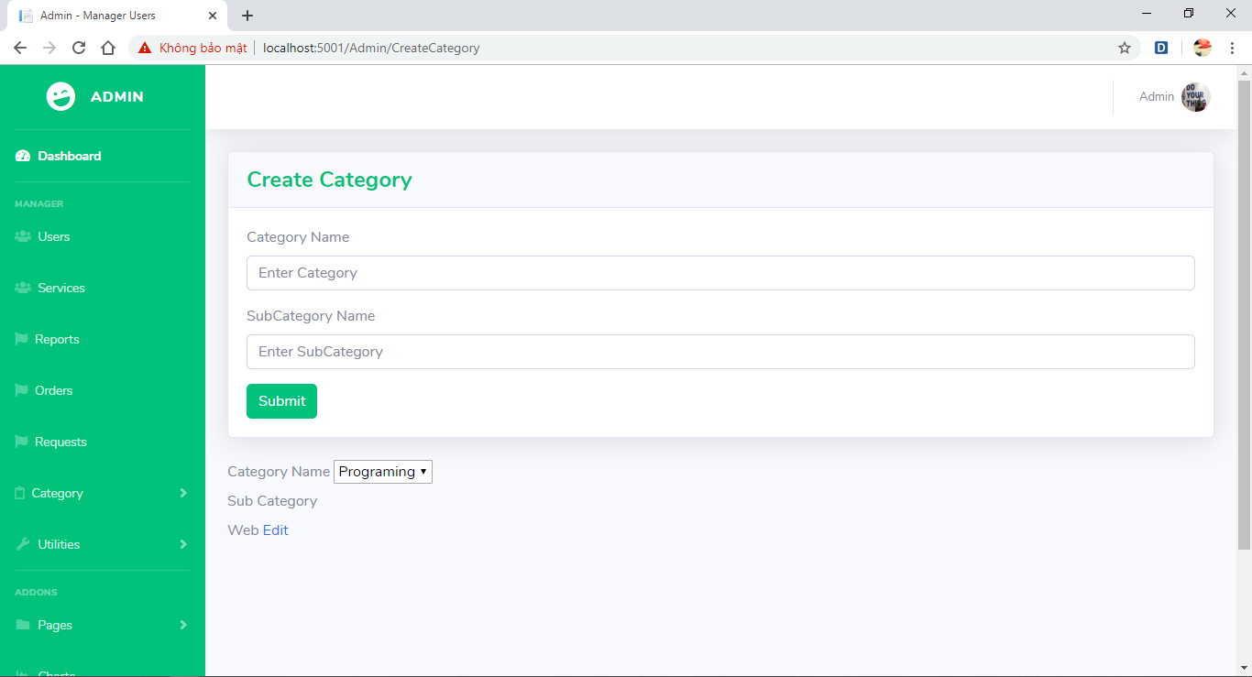

* Search

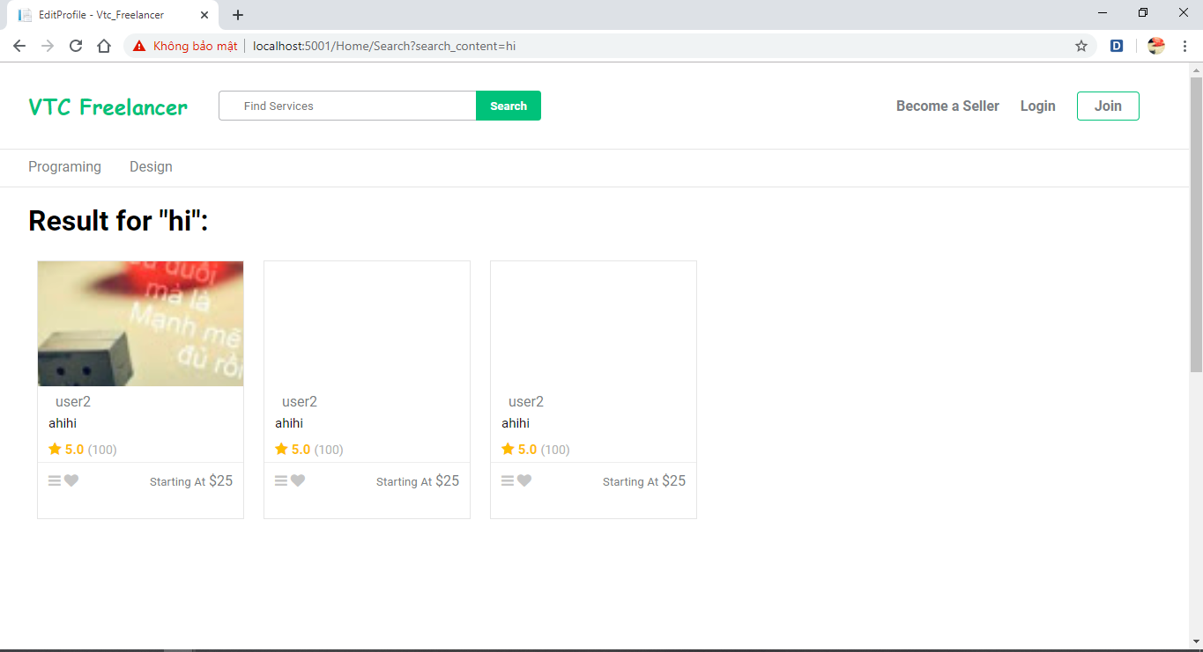

## Class Diagram

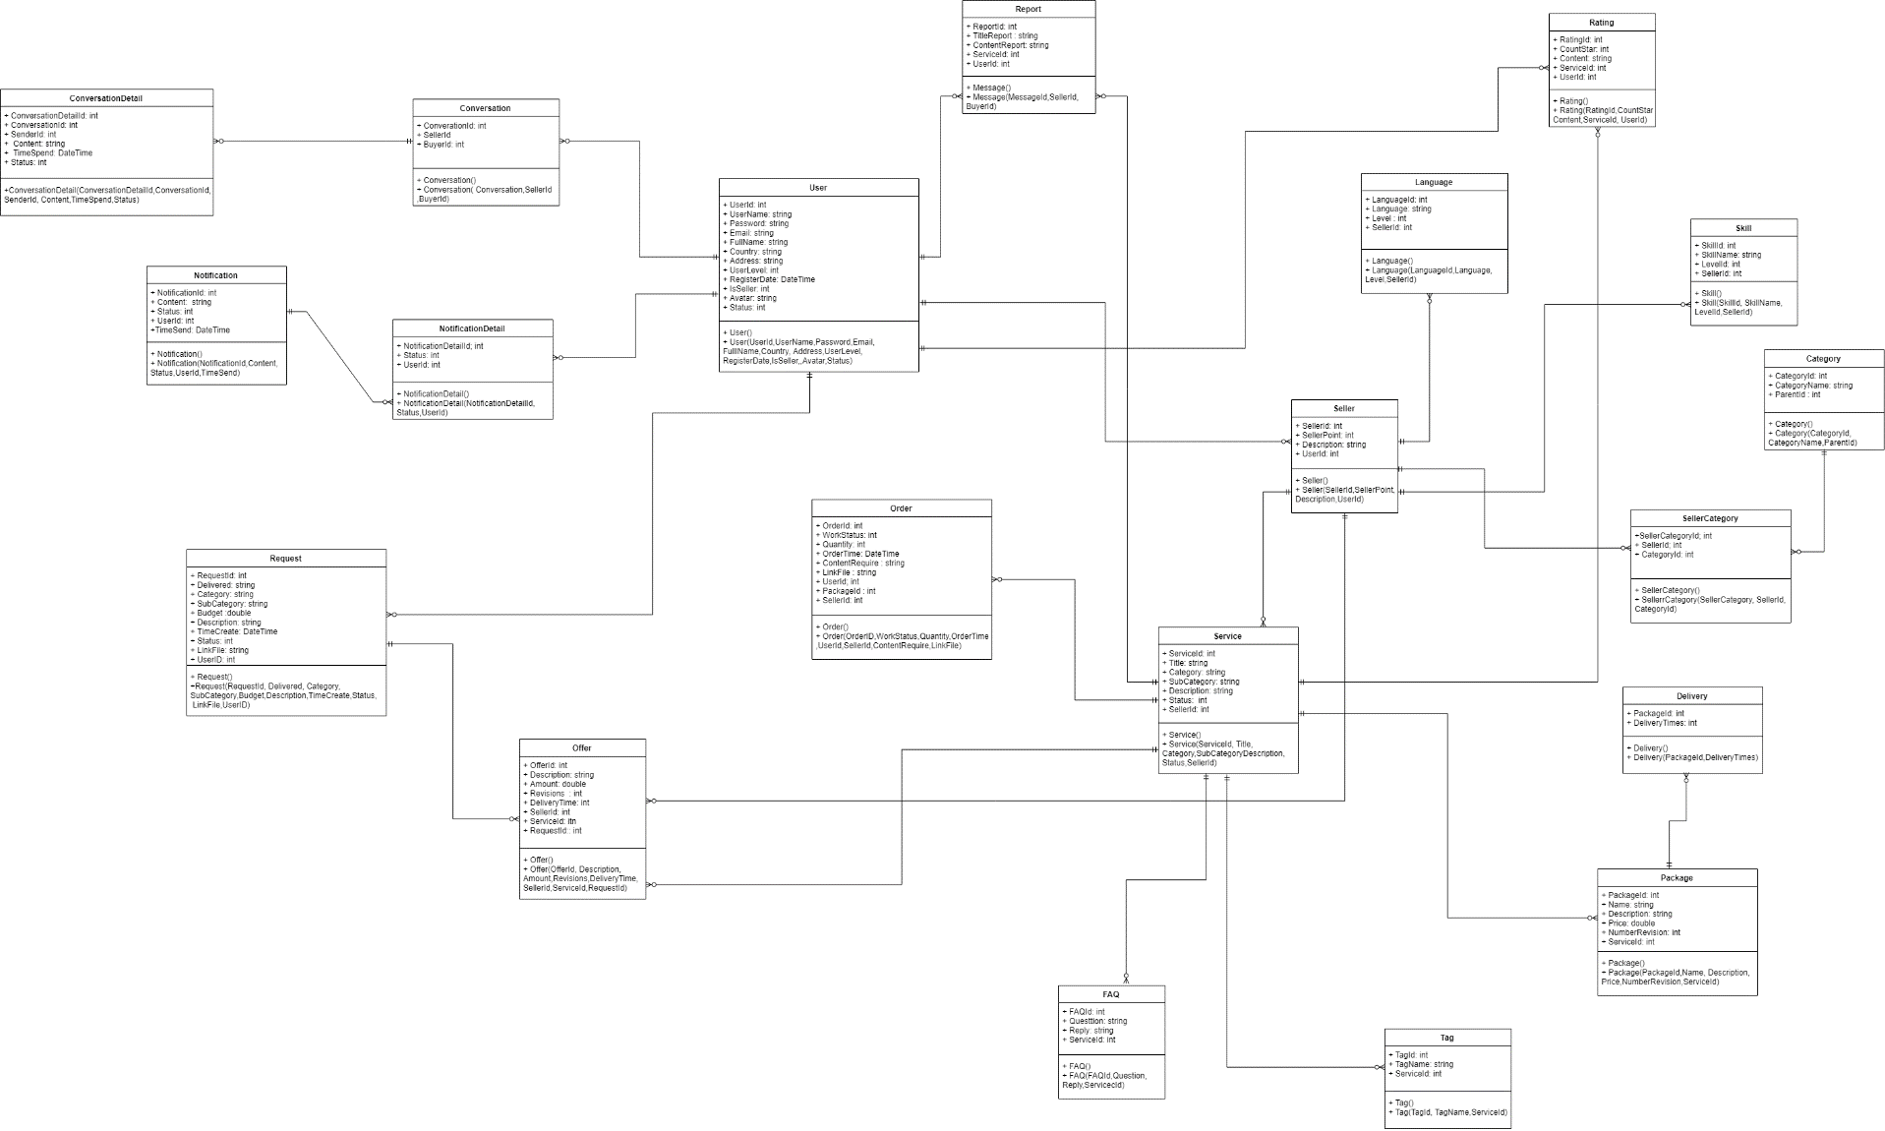

## 3. Database diagram

1. Entity Relationship Diagram

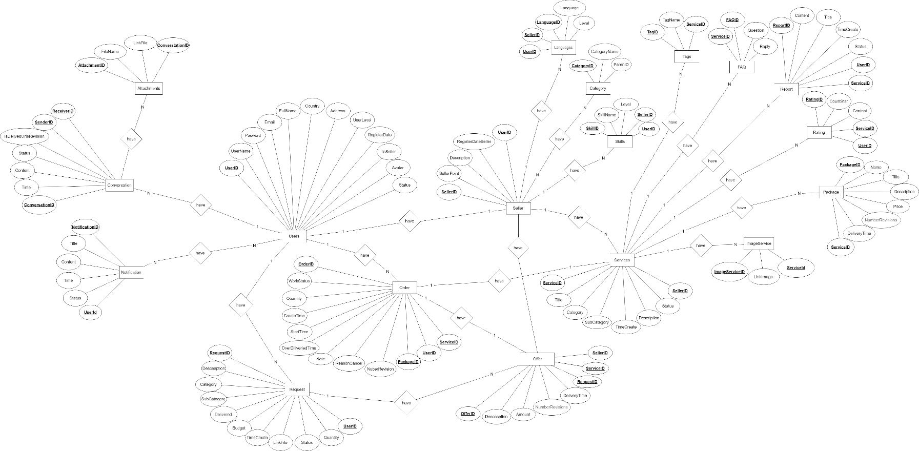

### Database detail

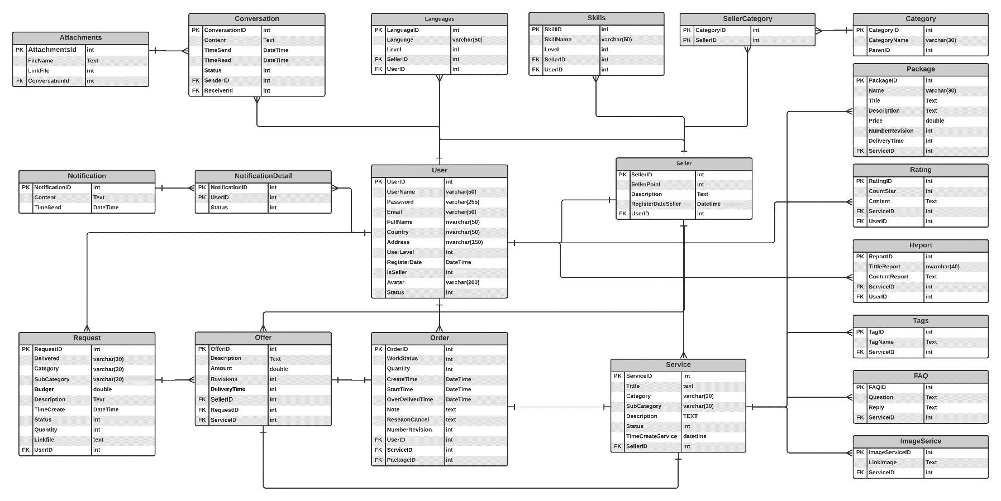

|  |  |  |  |
| --- | --- | --- | --- |
| **Users** | | | |
| **Column Name** | **Data Type** | **Constraints** | **Description** |
| **UserID** | **int** | **Primary Key, Autoincrement** |  |
| **UserName** | **varchar(50)** | **NOT NULL** |  |
| **Password** | **varchar(255)** | **NOT NULL** |  |
| **FullName** | **nvarchar(50)** | **NOT NULL** |  |
| **Email** | **varchar(50)** | **NOT NULL** | **User Email** |
| **Country** | **nvarchar(50)** |  |  |
| **Address** | **nvarchar(150)** |  |  |
| **UserLevel** | **int** | **DEFAULT 0** | **Buyer : 0 , Admin :1** |
| **RegisterDate** | **datetime** | **DEFAULT NOW()** | **Time create account** |
| **IsSeller** | **int** | **DEFAULT 0** | **Is seller 1** |
| **Avartar** | **Text** |  | **Avatar user** |
| **Status** | **int** | **DEFAULT 0** | **0 : Active 1: Inactive** |

|  |  |  |  |
| --- | --- | --- | --- |
| **Seller** | | | |
| **Column Name** | **Data Type** | **Constraints** | **Description** |
| **SellerID** | **int** | **Primary Key, Autoincrement** |  |
| **SellerPoint** | **int** |  | **Rank seller** |
| **Description** | **text** |  | **Description seller** |
| **RegisterdateSeller** | **datetime** | **DEFAULT NOW()** |  |
| **UserId** | **int** | **Foreign key** |  |

|  |  |  |  |
| --- | --- | --- | --- |
| **Service** | | | |
| **Column Name** | **Data Type** | **Constraints** | **Description** |
| **ServiceId** | **int** | **Primary Key, Autoincrement** |  |
| **Tittle** | **text** | **NOT NULL** |  |
| **Category** | **varchar(50)** | **NOT NULL** |  |
| **SubCategory** | **varchar(50)** | **NOT NULL** |  |
| **Description** | **text** |  | **Description service** |
| **Status** | **int** | **NOT NULL** | **0 : Inactive 1 : Active** |
| **Timecreateservice** | **datetime** | **DEFAULT NOW()** |  |
| **SellerId** | **int** | **Foreign key** |  |
| **Order** | | | |
| **Column Name** | **Data Type** | **Constraints** | **Description** |
| **OrderId** | **int** | **Primary Key, Autoincrement** |  |
| **WorkStatus** | **int** | **NOT NULL** |  |
| **Quantity** | **int** | **NOT NULL** |  |
| **CreateTime** | **datetime** | **DEFAULT NOW()** |  |
| **StartTime** | **datetime** | **DEFAULT NOW()** | **Order Start Time** |
| **OrverTime** | **datetime** | **DEFAULT NOW()** | **Over Time Order** |
| **Note** | **text** |  |  |
| **ReasonCancel** | **text** |  |  |
| **NumberRevision** | **int** |  |  |
| **UserId** | **int** | **Foreign key** |  |
| **ServiceId** | **int** | **Foreign key** |  |
| **PackageId** | **int** | **Foreign key** |  |

|  |  |  |  |
| --- | --- | --- | --- |
| **Offer** | | | |
| **Column Name** | **Data Type** | **Constraints** | **Description** |
| **OfferId** | **int** | **Primary Key, Autoincrement** |  |
| **Description** | **text** | **NOT NULL** | **Description offer** |
| **Amount** | **double** | **NOT NULL** | **Price** |
| **Revisions** | **int** | **NOT NULL** | **Number project corrections** |
| **DeliveryTime** | **int** | **NOT NULL** | **Require of buyer** |
| **SellerId** | **int** | **Foreign key** |  |
| **RequestId** | **int** | **Foreign key** |  |
| **PackageId** | **int** | **Foreign key** |  |

|  |  |  |  |
| --- | --- | --- | --- |
| **Request** | | | |
| **Column Name** | **Data Type** | **Constraints** | **Description** |
| **RequestId** | **int** | **Primary Key, Autoincrement** |  |
| **Delivered** | **varchar(50)** | **NOT NULL** | **Time of request** |
| **Category** | **varchar(50)** | **NOT NULL** |  |
| **SubCategory** | **varchar(50)** | **NOT NULL** |  |
| **Budget** | **double** | **NOT NULL** | **Money require project** |
| **Description** | **text** | **NOT NULL** | **Description project** |
| **TimeCreate** | **datetime** | **DEFAULD NOW()** |  |
| **Status** | **int** | **DEFAULT 1** | **1 Active 0 Inactive** |
| **Quantity** | **int** |  |  |
| **LinkFile** | **text** |  |  |
| **UserId** | **int** | **Foreign key** |  |

|  |  |  |  |
| --- | --- | --- | --- |
| **Package** | | | |
| **Column Name** | **Data Type** | **Constraints** | **Description** |
| **PackageId** | **int** | **Primary Key, Autoincrement** |  |
| **Name** | **varchar(50)** | **NOT NULL** | **Package Name** |
| **Tittle** | **text** | **NOT NULL** |  |
| **Description** | **text** | **NOT NULL** | **Description package** |
| **Price** | **double** | **NOT NULL** | **Price package** |
| **Revisions** | **int** | **NOT NULL** |  |
| **DeliveryTime** | **int** | **NOT NULL** |  |
| **ServiceId** | **int** | **Foreign key** |  |

|  |  |  |  |
| --- | --- | --- | --- |
| **Rating** | | | |
| **Column Name** | **Data Type** | **Constraints** | **Description** |
| **RatingId** | **int** | **Primary Key, Autoincrement** |  |
| **CountStart** | **int** | **NOT NULL** |  |
| **Content** | **text** | **NOT NULL** |  |
| **ServiceId** | **int** | **Foreign key** |  |
| **UserId** | **Int** | **Foreign key** |  |

|  |  |  |  |
| --- | --- | --- | --- |
| **Report** | | | |
| **Column Name** | **Data Type** | **Constraints** | **Description** |
| **ReportId** | **int** | **Primary Key, Autoincrement** |  |
| **Tittle** | **text** | **NOT NULL** |  |
| **Content** | **text** | **NOT NULL** |  |
| **ServiceId** | **int** | **Foreign key** |  |
| **UserId** | **Int** | **Foreign key** |  |

|  |  |  |  |
| --- | --- | --- | --- |
| **Tags** | | | |
| **Column Name** | **Data Type** | **Constraints** | **Description** |
| **TagID** | **int** | **Primary Key, Autoincrement** |  |
| **TagName** | **text** | **NOT NULL** |  |
| **ServiceId** | **int** | **Foreign key** |  |

|  |  |  |  |
| --- | --- | --- | --- |
| **FAQ** | | | |
| **Column Name** | **Data Type** | **Constraints** | **Description** |
| **FAQID** | **int** | **Primary Key, Autoincrement** |  |
| **Question** | **text** | **NOT NULL** |  |
| **Reply** | **text** | **NOT NULL** |  |
| **ServiceId** | **int** | **Foreign key** |  |

|  |  |  |  |
| --- | --- | --- | --- |
| **Category** | | | |
| **Column Name** | **Data Type** | **Constraints** | **Description** |
| **CategoryId** | **int** | **Primary Key, Autoincrement** |  |
| **CategoryName** | **varchar(50)** | **NOT NULL** |  |
| **ParentId** | **int** | **NOT NULL** |  |

|  |  |  |  |
| --- | --- | --- | --- |
| **SellerCategory** | | | |
| **Column Name** | **Data Type** | **Constraints** | **Description** |
| **CategoryId** | **int** | **Primary Key** |  |
| **SellerID** | **int** | **Primary Key** |  |

|  |  |  |  |
| --- | --- | --- | --- |
| **Languages** | | | |
| **Column Name** | **Data Type** | **Constraints** | **Description** |
| **LanguageId** | **int** | **Primary Key, Autoincrement** |  |
| **Language** | **text** | **NOT NULL** |  |
| **Level** | **text** | **NOT NULL** |  |
| **SellerId** | **Int** | **Foreign key** |  |
| **UserId** | **Int** | **Foreign key** |  |

|  |  |  |  |
| --- | --- | --- | --- |
| **Skills** | | | |
| **Column Name** | **Data Type** | **Constraints** | **Description** |
| **SkillsId** | **int** | **Primary Key, Autoincrement** |  |
| **SkillName** | **varchar(50)** | **NOT NULL** |  |
| **Level** | **int** | **NOT NULL** |  |
| **SellerId** | **Int** | **Foreign key** |  |
| **UserId** | **Int** | **Foreign key** |  |

|  |  |  |  |
| --- | --- | --- | --- |
| **Attachment** | | | |
| **Column Name** | **Data Type** | **Constraints** | **Description** |
| **AttachmentId** | **int** | **Primary Key, Autoincrement** |  |
| **FileName** | **Text** |  |  |
| **LinkFile** | **Text** |  |  |
| **ConversationID** | **Int** | **Foreign key** |  |

|  |  |  |  |
| --- | --- | --- | --- |
| **Notification** | | | |
| **Column Name** | **Data Type** | **Constraints** | **Description** |
| **NotificationId** | **int** | **Primary Key, Autoincrement** |  |
| **TimeSent** | **datetime** | **NOT NULL** |  |
| **Content** | **text** | **NOT NULL** |  |

|  |  |  |  |
| --- | --- | --- | --- |
| **NotificationDetail** | | | |
| **Column Name** | **Data Type** | **Constraints** | **Description** |
| **NotificationId** | **int** | **Primary Key** |  |
| **UserID** | **int** | **Primary Key** |  |
| **Status** | **int** | **DEFAULT 0** |  |

|  |  |  |  |
| --- | --- | --- | --- |
| **NotificationDetail** | | | |
| **Column Name** | **Data Type** | **Constraints** | **Description** |
| **ConversationId** | **int** | **Primary Key, Autoincrement** |  |
| **Content** | **text** | **NOT NULL** |  |
| **TimeSend** | **datetime** | **NOT NULL** |  |
| **TimeRead** | **datetime** | **NOT NULL** |  |
| **SenderId** | **Int** | **Foreign key** |  |
| **ReceiverId** | **Int** | **Foreign key** |  |

# Testing

|  |  |
| --- | --- |
| **Test Case Number** | TC01 |
| **Test Case Name** | LoginService test |
| **Test Case Description** | Check the login function in the service |
| **Preconditions** | Have database, declared login () function |
| **Test Case Input** | Login(‘boydungbg’, ‘123456’)  Login(‘admin, ‘123456’)  Login(‘boydungbg@gmail.com, ‘123456’)  Login(‘admin@gmail.com, ‘123456’)  Login(‘ád, ‘123456’)  Login(‘admsdsdsdin, ‘123456’)  Login(‘#@$@#@gmail.com, ‘123456’)  Login(‘@#!@##!@gmail.com, ‘123456’) |
| **Test Case Expected Output** | 1. Return the user who is the customer  2. Return the user who is the admin  3. Return the user who is the customer  4. Return the user who is the admin  5. Return null  6. Return null  7. Return null  8. Return null |
| **Test Case Steps** | 1. Go to the directory and test  2. Run Test |

|  |  |
| --- | --- |
| **Test Case Number** | TC02 |
| **Test Case Name** | RegisterService test |
| **Test Case Description** | Check the Register function in the service |
| **Preconditions** | Have database, declared Register() function |
| **Test Case Input** | Register(“boydungbg”, “boydungbg@gmail.com” , “123456”  Register(“admin”, “admin@gmail.com” , “123456”;  Register(“boydungbg”, “boydungbg@gmail.com” , “123456”;  Register(“boydungbg”, “boydungbg@gmail.com” , “123456”; |
| **Test Case Expected Output** | 1. Return true Register susccess.  2. Return true Register susccess.  3. Return false Register faild  4. Return false Register faild |
| **Test Case Steps** | 1. Go to the directory and test  2. Run Test |

|  |  |
| --- | --- |
| **Test Case Number** | TC03 |
| **Test Case Name** | GetUserBySellerIDService test |
| **Test Case Description** | Check the GetUserBySellerID function in the service |
| **Preconditions** | Have database, declared GetUserBySellerID () function |
| **Test Case Input** | GetUserBySellerID(1)  GetUserBySellerID(2)  GetUserBySellerID(2321)  GetUserBySellerID(2123) |
| **Test Case Expected Output** | 1. Return the user  2. Return the user  3. Return null  4. Return null |
| **Test Case Steps** | 1. Go to the directory and test  2. Run Test |

|  |  |
| --- | --- |
| **Test Case Number** | TC04 |
| **Test Case Name** | GetUserByUserNameService test |
| **Test Case Description** | Check the GetUserByUserName function in the service |
| **Preconditions** | Have database, declared GetUserByUserName () function |
| **Test Case Input** | GetUserByUserName (boydungbg)  GetUserByUserName (dung1)  GetUserByUserName (asdasd)  GetUserByUserName (asdasd) |
| **Test Case Expected Output** | 1. Return the user  2. Return the user  3. Return null  4. Return null |
| **Test Case Steps** | 1. Go to the directory and test  2. Run Test |

|  |  |
| --- | --- |
| **Test Case Number** | TC04 |
| **Test Case Name** | GetUserByUserEmailService test |
| **Test Case Description** | Check the GetUserByUserEmail function in the service |
| **Preconditions** | Have database, declared GetUserByUserEmaile() function |
| **Test Case Input** | GetUserByUserEmail (boydungbg@gamil.com)  GetUserByUserEmail (dung1@gmail.com)  GetUserByUserEmail (asdasd@gmail.com)  GetUserByUserEmail (asdas@gmail.com) |
| **Test Case Expected Output** | 1. Return the user  2. Return the user  3. Return null  4. Return null |
| **Test Case Steps** | 1. Go to the directory and test  2. Run Test |

|  |  |
| --- | --- |
| **Test Case Number** | TC06 |
| **Test Case Name** | GetListGigService test |
| **Test Case Description** | Check the GetListService function in the service |
| **Preconditions** | Have database, declared GetListService () function |
| **Test Case Input** | GetListService() |
| **Test Case Expected Output** | 1. Return list service |
| **Test Case Steps** | 1. Go to the directory and test  2. Run Test |

|  |  |
| --- | --- |
| **Test Case Number** | TC07 |
| **Test Case Name** | GetListOrderService test |
| **Test Case Description** | Check the GetListOrder function in the service |
| **Preconditions** | Have database, declared GetListOrder () function |
| **Test Case Input** | GetListOrder () |
| **Test Case Expected Output** | 1. Return list order |
| **Test Case Steps** | 1. Go to the directory and test  2. Run Test |

|  |  |
| --- | --- |
| **Test Case Number** | TC08 |
| **Test Case Name** | AddCategoryService test |
| **Test Case Description** | Check the AddCategoryService function in the service |
| **Preconditions** | Have database, declared AddCategoryService () function |
| **Test Case Input** | AddCategoryService(“Programing”, 1 “Web”)  AddCategoryService(“Design”, 1 “logo”) |
| **Test Case Expected Output** | 1. Return True addcagtegory success  2. Return True addcagtegory success |
| **Test Case Steps** | 1. Go to the directory and test  2. Run Test |

|  |  |
| --- | --- |
| **Test Case Number** | TC09 |
| **Test Case Name** | ChangeStatusUserService test |
| **Test Case Description** | Check the ChangeStatusUserService function in the service |
| **Preconditions** | Have database, declared ChangeStatusUserService () function |
| **Test Case Input** | ChangeStatusUserService (1)  ChangeStatusUserService (2)  ChangeStatusUserService (1213123)  ChangeStatusUserService (2123123) |
| **Test Case Expected Output** | 1. Return True  2. Return True  3. Return false  4. Return false |
| **Test Case Steps** | 1. Go to the directory and test  2. Run Test |
| **Test Case Number** | TC10 |
| **Test Case Name** | CreateRequestService test |
| **Test Case Description** | Check the CreateRequestService function in the service |
| **Preconditions** | Have database, declared CreateRequestService () function |
| **Test Case Input** | CreateRequestService(“lam gi do”, “Programing”, Web”, 3 day, 3000, null)  CreateRequestService(“lam gi do”, null”, Web”, 3 day, 3000, null) |
| **Test Case Expected Output** | 1. Return true  2. Return true  3. Return fales |
| **Test Case Steps** | 1. Go to the directory and test  2. Run Test |

|  |  |
| --- | --- |
| **Test Case Number** | TC11 |
| **Test Case Name** | GetUserByGigID test |
| **Test Case Description** | Check the GetUserByGigID function in the service |
| **Preconditions** | Have database, declared GetUserByGigID () function |
| **Test Case Input** | GetUserByGigID(123)  GetUserByGigID(123)  GetUserByGigID(1) |
| **Test Case Expected Output** | 1. Return null  2. Return null  3. Reture service |
| **Test Case Steps** | 1. Go to the directory and test  2. Run Test |

# Assign work to each team member

* Product backlog

|  |  |  |  |  |  |  |  |  |  |  |
| --- | --- | --- | --- | --- | --- | --- | --- | --- | --- | --- |
| **ID** | **Categories** | **Detail (Wiki URL)** | **Priority** | **Estimated value** | **Estimate the initial workload** | **New estimation of remaining work under Sprint …** | | | | |
| **S1** | **S2** | **S3** | **S4** | **S5** |
| 1 | As a user I want to register |  | 1 |  | 100 | 55 | 45 | 15 | 5 | 0 |
| 2 | As the user I want to log in |  | 1 |  | 100 | 55 | 45 | 15 | 5 | 0 |
| 3 | As Buyer I want to see all services |  | 2 |  | 100 | 55 | 45 | 15 | 5 | 0 |
| 4 | As Buyer I want to manage settings |  | 3 |  | 100 | 55 | 45 | 15 | 5 | 0 |
| 5 | As Buyer I want to find services |  | 2 |  | 100 | 55 | 45 | 15 | 5 | 0 |
| 6 | As Buyer I want to order a service |  | 1 |  | 100 | 55 | 45 | 15 | 5 | 0 |
| 7 | As Buyer I want to manage requests |  | 1 |  | 100 | 55 | 45 | 15 | 5 | 0 |
| 8 | As Buyer I want to report services |  | 3 |  | 100 | 55 | 45 | 15 | 5 | 0 |
| 9 | As Buyer I want to manage orders |  | 1 |  | 100 | 55 | 45 | 15 | 5 | 0 |
| 10 | As Seller, I want to report the buyer |  | 3 |  | 100 | 55 | 45 | 15 | 5 | 0 |
| 11 | As Seller, I want to manage offers |  | 1 |  | 100 | 55 | 45 | 15 | 5 | 0 |
| 12 | As a Seller I want to manage my services |  | 1 |  | 100 | 55 | 45 | 15 | 5 | 0 |
| 13 | As Seller, I want to manage orders |  | 1 |  | 100 | 55 | 45 | 15 | 5 | 0 |
| 14 | As Seller, I want to see statistics |  | 1 |  | 100 | 55 | 45 | 15 | 5 | 0 |
| 15 | As Seller I want to see my requests and offers. |  | 1 |  | 100 | 55 | 45 | 15 | 5 | 0 |
| 16 | As Seller I want to see my services. |  | 1 |  | 100 | 55 | 45 | 15 | 5 | 0 |
| 17 | As Seller I want to see my orders. |  | 1 |  | 100 | 55 | 45 | 15 | 5 | 0 |
| 18 | As Seller I want to manage bookings |  | 3 |  | 100 | 55 | 45 | 15 | 5 | 0 |
| 19 | As Admin, I want to manage users |  | 2 |  | 100 | 55 | 45 | 15 | 5 | 0 |
| 20 | As Admin, I want to manage categories |  | 2 |  | 100 | 55 | 45 | 15 | 5 | 0 |
| 21 | As Admin, I want to manage the services |  | 2 |  | 100 | 55 | 45 | 15 | 5 | 0 |
| 22 | As Admin, I want to manage reports |  | 2 |  | 100 | 55 | 45 | 15 | 5 | 0 |
| 23 | As Admin, I want to manage settings |  | 2 |  | 100 | 55 | 45 | 15 | 5 | 0 |
| 24 | As a User, I want to inbox |  | 2 |  | 100 | 55 | 45 | 15 | 5 | 0 |
| 25 | As a User, I want to see system notifications |  | 2 |  | 100 | 55 | 45 | 15 | 5 | 0 |
| 26 | As an Admin, I want to see statistics |  | 2 |  | 100 | 55 | 45 | 15 | 5 | 0 |
| 27 | As Admin, I want to manage the entire system |  | 2 |  | 100 | 55 | 45 | 15 | 5 | 0 |

* Sprint 1

|  |  |  |  |  |  |  |  |  |  |
| --- | --- | --- | --- | --- | --- | --- | --- | --- | --- |
| **Items in the Project Backlog** | **Sprint work** | **Person made** | **Estimate the initial workload** | **New estimates of remaining work** | | | | | |
| T2 | T3 | T4 | T5 | T6 | T7 |
| As a user I want to register | **Use Case** | Thach,Cuong | **8** | 4 | 4 | 2 | 2 | 1 | 0 |
| ERD Diagram | Linh,Dung | 8 | 4 | 4 | 2 | 2 | 1 | 0 |
| Design Database | Linh,Dung | 8 | 4 | 4 | 2 | 2 | 2 | 0 |
| As the user I want to log in | **Use Case** | Cuong | 8 | 4 | 4 | 2 | 2 | 1 | 0 |
| ERD Diagram | Dung | 8 | 4 | 4 | 2 | 2 | 1 | 0 |
| Design Database | Linh | 8 | 4 | 4 | 2 | 2 | 1 | 0 |
| As Buyer I want to see all services | **Use Case** | Thach | 8 | 4 | 4 | 2 | 2 | 1 | 0 |
| ERD Diagram | Dung | 8 | 4 | 4 | 2 | 2 | 1 | 0 |
| Design Database | Linh | 8 | 6 | 6 | 2 | 2 | 1 | 0 |
| As Buyer I want to manage settings | **Use Case** | Cuong | 8 | 6 | 6 | 2 | 2 | 1 | 0 |
| ERD Diagram | Linh | 8 | 6 | 6 | 2 | 2 | 1 | 0 |
| Design Database | Linh | 8 | 6 | 6 | 2 | 2 | 1 | 0 |
| As Buyer I want to find services | **Use Case** | Cuong,Thach | 8 | 6 | 6 | 2 | 2 | 1 | 0 |
| ERD Diagram | Dung | 8 | 6 | 6 | 2 | 2 | 1 | 0 |
| Design Database | Thach | 8 | 6 | 6 | 2 | 2 | 1 | 0 |
| As Buyer I want to order a service | **Use Case** | Thach | 8 | 6 | 6 | 2 | 2 | 1 | 0 |
| ERD Diagram | Linh,Tung | 8 | 6 | 6 | 2 | 2 | 1 | 0 |
| Design Database | Tung | 8 | 6 | 6 | 2 | 2 | 1 | 0 |
| As Buyer I want to manage requests | **Use Case** | Tung | 8 | 6 | 6 | 2 | 2 | 1 | 0 |
| ERD Diagram | Linh,Tung | 8 | 6 | 6 | 2 | 2 | 1 | 0 |
| Design Database | Tung | 8 | 6 | 6 | 2 | 2 | 1 | 0 |
| As Buyer I want to report services | **Use Case** | Thach,Cuong | 8 | 6 | 6 | 2 | 2 | 1 | 0 |
| ERD Diagram | Linh Tung | 8 | 6 | 6 | 2 | 2 | 1 | 0 |
| Design Database | Thach | 8 | 4 | 4 | 2 | 2 | 1 | 0 |
| As Buyer I want to manage orders | **Use Case** | Thach | 8 | 4 | 4 | 2 | 2 | 1 | 0 |
| ERD Diagram | Linh Dung | 8 | 4 | 4 | 2 | 2 | 1 | 0 |
| Design Database | Linh | 8 | 4 | 4 | 2 | 2 | 1 | 0 |
| As Seller, I want to report the buyer | **Use Case** | Cuong | 8 | 4 | 4 | 2 | 2 | 1 | 0 |
| ERD Diagram | Dung | 8 | 4 | 4 | 2 | 2 | 1 | 0 |
| Design Database | Thach | 8 | 4 | 4 | 2 | 2 | 1 | 0 |
| As Seller, I want to manage offers | **Use Case** | Tung,Linh | 8 | 4 | 4 | 2 | 2 | 1 | 0 |
| ERD Diagram | Linh Dung | 8 | 4 | 4 | 2 | 2 | 1 | 0 |
| Design Database | Cuong | 8 | 4 | 4 | 2 | 2 | 1 | 0 |
| As a Seller I want to manage my services | **Use Case** | Tung | 8 | 6 | 6 | 2 | 2 | 1 | 0 |
| ERD Diagram | Thach | 8 | 6 | 6 | 2 | 2 | 1 | 0 |
| Design Database | Thach | 8 | 6 | 6 | 2 | 2 | 1 | 0 |
| As Seller, I want to manage orders | **Use Case** | Cuong | 8 | 6 | 6 | 2 | 2 | 1 | 0 |
| ERD Diagram | Linh | 8 | 6 | 6 | 2 | 2 | 1 | 0 |
| Design Database | Dung | 8 | 6 | 6 | 2 | 2 | 1 | 0 |
| As Seller, I want to see statistics | **Use Case** | Tung | 8 | 4 | 4 | 2 | 2 | 1 | 0 |
| ERD Diagram | Dung | 8 | 4 | 4 | 2 | 2 | 1 | 0 |
| Design Database | Linh | 8 | 4 | 4 | 2 | 2 | 1 | 0 |
| As Seller I want to see my requests and offers. | **Use Case** | Cuong | 8 | 4 | 4 | 2 | 2 | 1 | 0 |
| ERD Diagram | Linh | 8 | 4 | 4 | 2 | 2 | 1 | 0 |
| Design Database | Thach | 8 | 4 | 4 | 2 | 2 | 1 | 0 |
| As Seller I want to see my services. | **Use Case** | Dung | 8 | 4 | 4 | 2 | 2 | 1 | 0 |
| ERD Diagram | Tung | 8 | 4 | 4 | 2 | 2 | 1 | 0 |
| Design Database | Cuong | 8 | 4 | 4 | 2 | 2 | 1 | 0 |
| As Seller I want to see my orders. | **Use Case** | Linh | 8 | 4 | 4 | 2 | 2 | 1 | 0 |
| ERD Diagram | Thach | 8 | 4 | 4 | 2 | 2 | 1 | 0 |
| Design Database | Dung | 8 | 4 | 4 | 2 | 2 | 1 | 0 |
| As Seller I want to manage bookings | **Use Case** | Tung | 8 | 4 | 4 | 2 | 2 | 1 | 0 |
| ERD Diagram | Cuong | 8 | 4 | 4 | 2 | 2 | 1 | 0 |
| Design Database | Linh | 4 | 4 | 4 | 2 | 2 | 1 | 0 |
| As Admin, I want to manage users | **Use Case** | Thach | 4 | 4 | 4 | 2 | 2 | 1 | 0 |
| ERD Diagram | Dung | 4 | 4 | 4 | 2 | 2 | 1 | 0 |
| Design Database | Tung | 4 | 4 | 4 | 2 | 2 | 1 | 0 |
| As Admin, I want to manage categories | **Use Case** | Cuong | 8 | 4 | 4 | 2 | 2 | 1 | 0 |
| ERD Diagram | Linh | 4 | 4 | 4 | 2 | 2 | 1 | 0 |
| Design Database | Thach | 4 | 4 | 4 | 2 | 2 | 1 | 0 |
| As Admin, I want to manage the services | **Use Case** | Dung | 4 | 4 | 4 | 2 | 2 | 1 | 0 |
| ERD Diagram | Tung | 4 | 4 | 4 | 2 | 2 | 1 | 0 |
| Design Database | Cuong | 4 | 4 | 4 | 2 | 2 | 1 | 0 |
| As Admin, I want to manage reports | **Use Case** | Linh | 4 | 4 | 4 | 2 | 2 | 1 | 0 |
| ERD Diagram | Thach | 4 | 4 | 4 | 2 | 2 | 1 | 0 |
| Design Database | Dung | 4 | 4 | 4 | 2 | 2 | 1 | 0 |
| As Admin, I want to manage settings | **Use Case** | Tung | 4 | 4 | 4 | 2 | 2 | 1 | 0 |
| ERD Diagram | Cuong | 4 | 4 | 4 | 2 | 2 | 1 | 0 |
| Design Database | Linh | 8 | 4 | 4 | 2 | 2 | 1 | 0 |
| As an Admin, I want to see statistics | **Use Case** | Thach | 4 | 4 | 4 | 2 | 2 | 1 | 0 |
| ERD Diagram | Dung | 4 | 4 | 4 | 2 | 2 | 1 | 0 |
| Design Database | Tung | 4 | 4 | 4 | 2 | 2 | 1 | 0 |

* Sprint 2

|  |  |  |  |  |  |  |  |  |  |
| --- | --- | --- | --- | --- | --- | --- | --- | --- | --- |
| **Items in the Project Backlog** | **Sprint work** | **Person made** | **Estimate the initial workload** | **New estimates of remaining work** | | | | | |
| T2 | T3 | T4 | T5 | T6 | T7 |
| As a user I want to register | Activity Diagram | Cả nhóm | **8** | 6 | 4 | 2 | 2 | 1 | 0 |
| Code Database | Dũng,Linh | 8 | 6 | 4 | 2 | 2 | 1 | 0 |
| GUI | Thạch,Tùng | 8 | 6 | 4 | 2 |  |  |  |
| Class Diagram | Cường | 8 | 6 | 4 | 2 | 2 | 2 | 0 |
| As the user I want to log in | Activity Diagram | Cả nhóm | 8 | 6 | 4 | 2 | 2 | 1 | 0 |
| Code Database | Dũng,Linh | 8 | 6 | 4 | 2 | 2 | 1 | 0 |
| GUI | Thạch,Tùng | 8 | 6 | 4 | 2 | 2 |  |  |
| Class Diagram | Cường | 8 | 6 | 4 | 2 | 2 | 1 | 0 |
| As Buyer I want to see all services | Activity Diagram | Cả nhóm | 8 | 3 | 4 | 2 | 2 | 1 | 0 |
| Code Database | Dũng,Linh | 8 | 3 | 4 | 2 | 2 | 1 | 0 |
| GUI | Thạch,Tùng | 8 | 3 | 4 | 2 | 2 |  |  |
| Class Diagram | Cường | 8 | 3 | 4 | 2 | 2 | 1 | 0 |
| As Buyer I want to manage settings | Activity Diagram | Cả nhóm | 4 | 3 | 4 | 2 | 2 | 1 | 0 |
| Code Database | Dũng,Linh | 4 | 3 | 4 | 2 | 2 | 1 | 0 |
| GUI | Thạch,Tùng | 4 | 3 | 4 | 2 | 2 |  |  |
| Class Diagram | Cường | 4 | 3 | 4 | 2 | 2 | 1 | 0 |
| As Buyer I want to find services | Activity Diagram | Cả nhóm | 4 | 3 | 4 | 2 | 2 | 1 | 0 |
| Code Database | Dũng,Linh | 4 | 3 | 4 | 2 | 2 | 1 | 0 |
| GUI | Thạch,Tùng | 4 | 3 | 4 | 2 | 2 |  |  |
| Class Diagram | Cường | 4 | 6 | 4 | 2 | 2 | 1 | 0 |
| As Buyer I want to order a service | Activity Diagram | Cả nhóm | 3 | 6 | 4 | 2 | 2 | 1 | 0 |
| Code Database | Dũng,Linh | 3 | 6 | 4 | 2 | 2 | 1 | 0 |
| GUI | Thạch,Tùng | 3 | 6 | 4 | 2 | 2 |  |  |
| Class Diagram | Cường | 3 | 6 | 4 | 2 | 2 | 1 | 0 |
| As Buyer I want to manage requests | Activity Diagram | Cả nhóm | 8 | 3 | 4 | 2 | 2 | 1 | 0 |
| Code Database | Dũng,Linh | 8 | 3 | 4 | 2 | 2 | 1 | 0 |
| GUI | Thạch,Tùng | 8 | 3 | 4 | 2 | 2 |  |  |
| Class Diagram | Cường | 8 | 3 | 4 | 2 | 2 | 1 | 0 |
| As Buyer I want to report services | Activity Diagram | Cả nhóm | 4 | 3 | 4 | 2 | 2 | 1 | 0 |
| Code Database | Dũng,Linh | 4 | 2 | 4 | 2 | 2 | 1 | 0 |
| GUI | Thạch,Tùng | 4 | 2 | 4 | 2 | 2 |  |  |
| Class Diagram | Cường | 4 | 2 | 4 | 2 | 2 | 1 | 0 |
| As Buyer I want to manage orders | Activity Diagram | Cả nhóm | 8 | 3 | 4 | 2 | 2 | 1 | 0 |
| Code Database | Dũng,Linh | 8 | 3 | 4 | 2 | 2 | 1 | 0 |
| GUI | Thạch,Tùng | 8 | 3 | 4 | 2 | 2 |  |  |
| Class Diagram | Cường | 8 | 3 | 4 | 2 | 2 | 1 | 0 |
| As Seller, I want to report the buyer | Activity Diagram | Cả nhóm | 4 | 3 | 4 | 2 | 2 | 1 | 0 |
| Code Database | Dũng,Linh | 4 | 3 | 4 | 2 | 2 | 1 | 0 |
| GUI | Thạch,Tùng | 4 | 3 | 4 | 2 | 2 |  |  |
| Class Diagram | Cường | 4 | 3 | 3 | 2 | 2 | 1 | 0 |
| As Seller, I want to manage offers | Activity Diagram | Cả nhóm | 8 | 6 | 4 | 2 | 2 | 1 | 0 |
| Code Database | Dũng,Linh | 8 | 6 | 4 | 2 | 2 | 1 | 0 |
| GUI | Thạch,Tùng | 8 | 6 | 4 | 2 | 2 |  |  |
| Class Diagram | Cường | 8 | 3 | 4 | 2 | 2 | 1 | 0 |
| As a Seller I want to manage my services | Activity Diagram | Cả nhóm | 8 | 3 | 3 | 2 | 2 | 1 | 0 |
| Code Database | Dũng,Linh | 8 | 3 | 4 | 2 | 2 | 1 | 0 |
| GUI | Thạch,Tùng | 8 | 3 | 4 | 2 | 2 |  |  |
| Class Diagram | Cường | 8 | 3 | 4 | 2 | 2 | 1 | 0 |
| As Seller, I want to manage orders | Activity Diagram | Cả nhóm | 8 | 6 | 4 | 2 | 2 | 1 | 0 |
| Code Database | Dũng,Linh | 8 | 6 | 4 | 2 | 2 | 1 | 0 |
| GUI | Thạch,Tùng | 8 | 6 | 4 | 2 | 2 |  |  |
| Class Diagram | Cường | 8 | 3 | 4 | 2 | 2 | 1 | 0 |
| As Seller, I want to see statistics | Activity Diagram | Cả nhóm | 4 | 3 | 4 | 2 | 2 | 1 | 0 |
| Code Database | Dũng,Linh | 4 | 3 | 4 | 2 | 2 | 1 | 0 |
| GUI | Thạch,Tùng | 4 | 3 | 4 | 2 | 2 |  |  |
| Class Diagram | Cường | 4 | 3 | 4 | 2 | 2 | 1 | 0 |
| As Seller I want to see my requests and offers. | Activity Diagram | Cả nhóm | 8 | 6 | 4 | 2 | 2 | 1 | 0 |
| Code Database | Dũng,Linh | 8 | 6 | 4 | 2 | 2 | 1 | 0 |
| GUI | Thạch,Tùng | 8 | 6 | 4 | 2 | 2 |  |  |
| Class Diagram | Cường | 8 | 6 | 4 | 2 | 2 | 1 | 0 |
| As Seller I want to see my services. | Activity Diagram | Cả nhóm | 4 | 6 | 4 | 2 | 2 | 1 | 0 |
| Code Database | Dũng,Linh | 4 | 6 | 4 | 2 | 2 | 1 | 0 |
| GUI | Thạch,Tùng | 4 | 6 | 4 | 2 | 2 |  |  |
| Class Diagram | Cường | 4 | 6 | 4 | 2 | 2 | 1 | 0 |
| As Seller I want to see my orders. | Activity Diagram | Cả nhóm | 4 | 6 | 4 | 2 | 2 | 1 | 0 |
| Code Database | Dũng,Linh | 4 | 6 | 4 | 2 | 2 | 1 | 0 |
| GUI | Thạch,Tùng | 4 | 6 | 4 | 2 | 2 |  |  |
| Class Diagram | Cường | 4 | 6 | 4 | 2 | 2 | 1 | 0 |
| As Seller I want to manage bookings | Activity Diagram | Cả nhóm | 4 | 3 | 4 | 2 | 2 | 1 | 0 |
| Code Database | Dũng,Linh | 4 | 3 | 4 | 2 | 2 | 1 | 0 |
| GUI | Thạch,Tùng | 4 | 3 | 4 | 2 | 2 |  |  |
| Class Diagram | Cường | 4 | 3 | 4 | 2 | 2 | 1 | 0 |
| As Admin, I want to manage users | Activity Diagram | Cả nhóm | 4 | 3 | 4 | 2 | 2 | 1 | 0 |
| Code Database | Dũng,Linh | 4 | 3 | 3 | 2 | 2 | 1 | 0 |
| GUI | Thạch,Tùng | 4 | 3 | 4 | 2 | 2 |  |  |
| Class Diagram | Cường | 4 | 3 | 4 | 2 | 2 | 1 | 0 |
| As Admin, I want to manage categories | Activity Diagram | Cả nhóm | 8 | 6 | 4 | 2 | 2 | 1 | 0 |
| Code Database | Dũng,Linh | 8 | 6 | 4 | 2 | 2 | 1 | 0 |
| GUI | Thạch,Tùng | 8 | 6 | 4 | 2 | 2 |  |  |
| Class Diagram | Cường | 8 | 6 | 4 | 2 | 2 | 1 | 0 |
| As Admin, I want to manage the services | Activity Diagram | Cả nhóm | 4 | 3 | 4 | 2 | 2 | 1 | 0 |
| Code Database | Dũng,Linh | 4 | 3 | 4 | 2 | 2 | 1 | 0 |
| GUI | Thạch,Tùng | 4 | 3 | 4 | 2 | 2 |  |  |
| Class Diagram | Cường | 4 | 3 | 4 | 2 | 2 | 1 | 0 |
| As Admin, I want to manage reports | Activity Diagram | Cả nhóm | 4 | 6 | 4 | 2 | 2 | 1 | 0 |
| Code Database | Dũng,Linh | 4 | 6 | 4 | 2 | 2 | 1 | 0 |
| GUI | Thạch,Tùng | 4 | 6 | 4 | 2 | 2 |  |  |
| Class Diagram | Cường | 4 | 6 | 4 | 2 | 2 | 1 | 0 |
| As Admin, I want to manage settings | Activity Diagram | Cả nhóm | 4 | 6 | 4 | 2 | 2 | 1 | 0 |
| Code Database | Dũng,Linh | 4 | 6 | 4 | 2 | 2 | 1 | 0 |
| GUI | Thạch,Tùng | 4 | 6 | 4 | 2 | 2 |  |  |
| Class Diagram | Cường | 4 | 6 | 4 | 2 | 2 | 1 | 0 |
| As an Admin, I want to see statistics | Activity Diagram | Cả nhóm | 4 | 3 | 4 | 2 | 2 | 1 | 0 |
| Code Database | Dũng,Linh | 4 | 3 | 4 | 2 | 2 | 1 | 0 |
| GUI | Thạch,Tùng | 4 | 3 | 4 | 2 | 2 |  |  |
| Class Diagram | Cường | 4 | 3 | 4 | 2 | 2 | 1 | 0 |

* Sprint 3

|  |  |  |  |  |  |  |  |  |  |
| --- | --- | --- | --- | --- | --- | --- | --- | --- | --- |
| **Hạng mục trong Project Backlog** | **Công việc trong Sprint** | **Người thực hiện** | **Ước tính khối lượng công việc ban đầu** | **Ước lượng mới về  công việc còn lại** | | | | | |
| T2 | T3 | T4 | T5 | T6 | T7 |
| Model | Tạo class model cho project | Linh, Cường | 8 | 8 | 8 | 8 | 8 | 8 | 8 |
| 8 | 8 | 8 | 8 | 8 | 8 | 8 |
| 8 | 8 | 8 | 8 | 8 | 8 | 8 |
| Là người dùng tôi muốn đăng kí | Controller | Cường,Linh | **8** | 6 | 4 | 2 | 2 | 1 | 0 |
| Service | Cường,Linh | 8 | 6 | 4 | 2 | 2 | 1 | 0 |
| View | Cường,Linh | 8 | 6 | 4 | 2 |  |  |  |
|  |  | 8 | 6 | 4 | 2 | 2 | 2 | 0 |
| Là người dùng tôi muốn đăng nhập | Controller | Cường,Linh | 8 | 6 | 4 | 2 | 2 | 1 | 0 |
| Service | Cường,Linh | 8 | 6 | 4 | 2 | 2 | 1 | 0 |
| View | Cường,Linh | 8 | 6 | 4 | 2 | 2 |  |  |
|  |  | 8 | 6 | 4 | 2 | 2 | 1 | 0 |
| Là Buyer tôi muốn xem tất cả dịch vụ | Controller | Tùng,Thạch | 8 | 3 | 4 | 2 | 2 | 1 | 0 |
| Service | Tùng,Thạch | 8 | 3 | 4 | 2 | 2 | 1 | 0 |
| View | Tùng,Thạch | 8 | 3 | 4 | 2 | 2 |  |  |
|  |  | 8 | 3 | 4 | 2 | 2 | 1 | 0 |
| Là Buyer tôi muốn quản lý cài đặt | Controller | Thạch | 4 | 3 | 4 | 2 | 2 | 1 | 0 |
| Service | Thạch | 4 | 3 | 4 | 2 | 2 | 1 | 0 |
| View | Thạch | 4 | 3 | 4 | 2 | 2 |  |  |
|  |  | 4 | 3 | 4 | 2 | 2 | 1 | 0 |
| Là Buyer tôi muốn tìm kiếm dịch vụ | Controller | Linh | 4 | 3 | 4 | 2 | 2 | 1 | 0 |
| Service | Linh | 4 | 3 | 4 | 2 | 2 | 1 | 0 |
| View | Linh | 4 | 3 | 4 | 2 | 2 |  |  |
|  |  | 4 | 6 | 4 | 2 | 2 | 1 | 0 |
| Là Buyer tôi muốn order một dịch vụ | Controller | Dũng,Linh | 3 | 6 | 4 | 2 | 2 | 1 | 0 |
| Service | Dũng,Linh | 3 | 6 | 4 | 2 | 2 | 1 | 0 |
| View | Dũng,Linh | 3 | 6 | 4 | 2 | 2 |  |  |
|  |  | 3 | 6 | 4 | 2 | 2 | 1 | 0 |
| Là Buyer tôi muốn quản lý các yêu cầu | Controller | Linh | 8 | 3 | 4 | 2 | 2 | 1 | 0 |
| Service | Linh | 8 | 3 | 4 | 2 | 2 | 1 | 0 |
| View | Linh | 8 | 3 | 4 | 2 | 2 |  |  |
|  |  | 8 | 3 | 4 | 2 | 2 | 1 | 0 |
| Là Buyer tôi muốn báo cáo dịch vụ | Controller | Linh | 4 | 3 | 4 | 2 | 2 | 1 | 0 |
| Service | Linh | 4 | 2 | 4 | 2 | 2 | 1 | 0 |
| View | Linh | 4 | 2 | 4 | 2 | 2 |  |  |
|  |  | 4 | 2 | 4 | 2 | 2 | 1 | 0 |
| Là Buyer tôi muốn quản lý các order | Controller | Linh | 8 | 3 | 4 | 2 | 2 | 1 | 0 |
| Service | Linh | 8 | 3 | 4 | 2 | 2 | 1 | 0 |
| View | Linh | 8 | 3 | 4 | 2 | 2 |  |  |
|  |  | 8 | 3 | 4 | 2 | 2 | 1 | 0 |
| Là Seller tôi muốn báo cáo buyer | Controller | Linh | 4 | 3 | 4 | 2 | 2 | 1 | 0 |
| Service | Linh | 4 | 3 | 4 | 2 | 2 | 1 | 0 |
| View | Linh | 4 | 3 | 4 | 2 | 2 |  |  |
|  |  | 4 | 3 | 3 | 2 | 2 | 1 | 0 |
| Là Seller tôi muốn quản lý các offer | Controller | Linh | 8 | 6 | 4 | 2 | 2 | 1 | 0 |
| Service | Linh | 8 | 6 | 4 | 2 | 2 | 1 | 0 |
| View | Linh | 8 | 6 | 4 | 2 | 2 |  |  |
|  |  | 8 | 3 | 4 | 2 | 2 | 1 | 0 |
| Là Seller tôi muốn quản lý các dịch vụ của tôi | Controller | Dũng,Thạch | 8 | 3 | 3 | 2 | 2 | 1 | 0 |
| Service | Dũng,Thạch | 8 | 3 | 4 | 2 | 2 | 1 | 0 |
| View | Dũng,Thạch | 8 | 3 | 4 | 2 | 2 |  |  |
|  |  | 8 | 3 | 4 | 2 | 2 | 1 | 0 |
| Là Seller tôi muốn quản lý các order | Controller | Dũng,Linh | 8 | 6 | 4 | 2 | 2 | 1 | 0 |
| Service | Dũng,Linh | 8 | 6 | 4 | 2 | 2 | 1 | 0 |
| View | Dũng,Linh | 8 | 6 | 4 | 2 | 2 |  |  |
|  |  | 8 | 3 | 4 | 2 | 2 | 1 | 0 |
| Là Seller tôi muốn xem thống kế | Controller | Dũng,Thạch | 4 | 3 | 4 | 2 | 2 | 1 | 0 |
| Service | Dũng,Thạch | 4 | 3 | 4 | 2 | 2 | 1 | 0 |
| View | Dũng,Thạch | 4 | 3 | 4 | 2 | 2 |  |  |
|  |  | 4 | 3 | 4 | 2 | 2 | 1 | 0 |
| Là Seller tôi muốn xem các request và offer của tôi. | Controller | Tùng,Thạch | 8 | 6 | 4 | 2 | 2 | 1 | 0 |
| Service | Tùng,Thạch | 8 | 6 | 4 | 2 | 2 | 1 | 0 |
| View | Tùng,Thạch | 8 | 6 | 4 | 2 | 2 |  |  |
|  | Tùng,Thạch | 8 | 6 | 4 | 2 | 2 | 1 | 0 |
| Là Seller tôi muốn xem các dịch vụ của tôi. | Controller | Tùng,Thạch | 4 | 6 | 4 | 2 | 2 | 1 | 0 |
| Service | Tùng,Thạch | 4 | 6 | 4 | 2 | 2 | 1 | 0 |
| View | Tùng,Thạch | 4 | 6 | 4 | 2 | 2 |  |  |
|  |  | 4 | 6 | 4 | 2 | 2 | 1 | 0 |
| Là Seller tôi muốn xem các order của tôi. | Controller | Linh,Dũng | 4 | 6 | 4 | 2 | 2 | 1 | 0 |
| Service | Linh,Dũng | 4 | 6 | 4 | 2 | 2 | 1 | 0 |
| View | Linh,Dũng | 4 | 6 | 4 | 2 | 2 |  |  |
|  |  | 4 | 6 | 4 | 2 | 2 | 1 | 0 |
| Là Seller tôi muôn quản lý cái đặt | Controller | Cường | 4 | 3 | 4 | 2 | 2 | 1 | 0 |
| Service | Cường | 4 | 3 | 4 | 2 | 2 | 1 | 0 |
| View | Cường | 4 | 3 | 4 | 2 | 2 |  |  |
|  |  | 4 | 3 | 4 | 2 | 2 | 1 | 0 |
| Là Admin tôi muốn quản lý các user | Controller | Linh,Cường | 4 | 3 | 4 | 2 | 2 | 1 | 0 |
| Service | Linh,Cường | 4 | 3 | 3 | 2 | 2 | 1 | 0 |
| View | Linh,Cường | 4 | 3 | 4 | 2 | 2 |  |  |
|  |  | 4 | 3 | 4 | 2 | 2 | 1 | 0 |
| Là Admin tôi muốn quản lý các category | Controller | Cường | 8 | 6 | 4 | 2 | 2 | 1 | 0 |
| Service | Cường | 8 | 6 | 4 | 2 | 2 | 1 | 0 |
| View | Cường | 8 | 6 | 4 | 2 | 2 |  |  |
|  |  | 8 | 6 | 4 | 2 | 2 | 1 | 0 |
| Là Admin tôi muốn quản lý các dịch vụ | Controller | Dũng,Linh | 4 | 3 | 4 | 2 | 2 | 1 | 0 |
| Service | Dũng,Linh | 4 | 3 | 4 | 2 | 2 | 1 | 0 |
| View | Dũng,Linh | 4 | 3 | 4 | 2 | 2 |  |  |
|  | Dũng,Linh | 4 | 3 | 4 | 2 | 2 | 1 | 0 |
| Là Admin tôi muốn quản lý các báo cáo | Controller | Dũng,Linh | 4 | 6 | 4 | 2 | 2 | 1 | 0 |
| Service | Dũng,Linh | 4 | 6 | 4 | 2 | 2 | 1 | 0 |
| View | Dũng,Linh | 4 | 6 | 4 | 2 | 2 |  |  |
|  | Dũng,Linh | 4 | 6 | 4 | 2 | 2 | 1 | 0 |
| Là Admin tôi muốn quản lý cài đặt | Controller | Tùng | 4 | 6 | 4 | 2 | 2 | 1 | 0 |
| Service | Tùng | 4 | 6 | 4 | 2 | 2 | 1 | 0 |
| View | Tùng | 4 | 6 | 4 | 2 | 2 |  |  |
|  |  | 4 | 6 | 4 | 2 | 2 | 1 | 0 |
| Là Admin tôi muốn xem thống kê | Controller | Tùng | 4 | 3 | 4 | 2 | 2 | 1 | 0 |
| Service | Tùng | 4 | 3 | 4 | 2 | 2 | 1 | 0 |
| View | Tùng | 4 | 3 | 4 | 2 | 2 |  |  |
|  |  | 4 | 3 | 4 | 2 | 2 | 1 | 0 |

* Sprint 4

|  |  |  |  |  |  |  |  |  |  |
| --- | --- | --- | --- | --- | --- | --- | --- | --- | --- |
| **Items in the Project Backlog** | **Sprint work** | **Person made** | **Estimate the initial workload** | **New estimates of remaining work** | | | | | |
| T2 | T3 | T4 | T5 | T6 | T7 |
| As the user I want to log in | Controller | Cường,Linh | 12 | 12 | 4 | 2 | 2 | 1 | 0 |
| Service | Cường,Linh | 12 | 8 | 4 | 2 | 2 | 1 | 0 |
| View | Cường,Linh | 12 | 12 | 4 | 2 | 2 | 0 | 0 |
|  |  |  |  |  |  |  |  |  |
| As Buyer I want to see all services | Controller | Tùng,Thạch | 12 | 12 | 4 | 2 | 2 | 1 | 0 |
| Service | Tùng,Thạch | 12 | 8 | 4 | 2 | 2 | 1 | 0 |
| View | Tùng,Thạch | 12 | 8 | 4 | 2 | 2 | 0 | 0 |
|  |  |  |  |  |  |  |  |  |
| As Buyer I want to manage settings | Controller | Thạch | 12 | 8 | 4 | 2 | 2 | 1 | 0 |
| Service | Thạch | 12 | 8 | 4 | 2 | 2 | 1 | 0 |
| View | Thạch | 12 | 8 | 4 | 2 | 2 | 0 | 0 |
|  |  |  |  |  |  |  |  |  |
| As Buyer I want to find services | Controller | Linh | 12 | 12 | 4 | 2 | 2 | 1 | 0 |
| Service | Linh | 12 | 12 | 4 | 2 | 2 | 1 | 0 |
| View | Linh | 12 | 12 | 4 | 2 | 2 | 0 | 0 |
|  |  |  |  |  |  |  |  |  |
| As Buyer I want to order a service | Controller | Dũng,Linh | 12 | 12 | 4 | 2 | 2 | 1 | 0 |
| Service | Dũng,Linh | 12 | 12 | 4 | 2 | 2 | 1 | 0 |
| View | Dũng,Linh | 12 | 12 | 4 | 2 | 2 | 0 | 0 |
|  |  |  |  |  |  |  |  |  |
| As Buyer I want to manage requests | Controller | Linh | 12 | 12 | 4 | 2 | 2 | 1 | 0 |
| Service | Linh | 12 | 12 | 4 | 2 | 2 | 1 | 0 |
| View | Linh | 12 | 12 | 4 | 2 | 2 | 0 | 0 |
|  |  |  |  |  |  |  |  |  |
| As Buyer I want to report services | Controller | Linh | 8 | 8 | 4 | 2 | 2 | 1 | 0 |
| Service | Linh | 8 | 8 | 4 | 2 | 2 | 1 | 0 |
| View | Linh | 8 | 8 | 4 | 2 | 2 | 0 | 0 |
|  |  |  |  |  |  |  |  |  |
| As Buyer I want to manage orders | Controller | Linh | 12 | 12 | 4 | 2 | 2 | 1 | 0 |
| Service | Linh | 12 | 12 | 4 | 2 | 2 | 1 | 0 |
| View | Linh | 12 | 12 | 4 | 2 | 2 |  |  |
|  |  |  |  |  |  |  |  |  |
| As Seller, I want to report the buyer | Controller | Linh | 8 | 8 | 4 | 2 | 2 | 1 | 0 |
| Service | Linh | 8 | 8 | 4 | 2 | 2 | 1 | 0 |
| View | Linh | 8 | 8 | 4 | 2 | 2 | 0 | 0 |
|  |  |  |  |  |  |  |  |  |
| As Seller, I want to manage offers | Controller | Linh | 12 | 8 | 4 | 2 | 2 | 1 | 0 |
| Service | Linh | 12 | 8 | 4 | 2 | 2 | 1 | 0 |
| View | Linh | 12 | 12 | 4 | 2 | 2 | 0 | 0 |
|  |  |  |  |  |  |  |  |  |
| As a Seller I want to manage my services | Controller | Dũng,Thạch | 12 | 8 | 3 | 2 | 2 | 1 | 0 |
| Service | Dũng,Thạch | 12 | 12 | 4 | 2 | 2 | 1 | 0 |
| View | Dũng,Thạch | 12 | 12 | 4 | 2 | 2 | 0 | 0 |
|  |  |  |  |  |  |  |  |  |
| As Seller, I want to manage orders | Controller | Dũng,Linh | 12 | 8 | 4 | 2 | 2 | 1 | 0 |
| Service | Dũng,Linh | 12 | 8 | 4 | 2 | 2 | 1 | 0 |
| View | Dũng,Linh | 12 | 8 | 4 | 2 | 2 | 0 |  |
|  |  |  |  |  |  |  |  | 0 |
| As Seller, I want to see statistics | Controller | Dũng,Thạch | 12 | 8 | 4 | 2 | 2 | 1 | 0 |
| Service | Dũng,Thạch | 12 | 8 | 4 | 2 | 2 | 1 | 0 |
| View | Dũng,Thạch | 12 | 8 | 4 | 2 | 2 |  |  |
|  |  |  |  |  |  |  |  |  |
| As Seller I want to see my requests and offers. | Controller | Tùng,Thạch | 12 | 8 | 4 | 2 | 2 | 1 | 0 |
| Service | Tùng,Thạch | 12 | 8 | 4 | 2 | 2 | 1 | 0 |
| View | Tùng,Thạch | 12 | 12 | 4 | 2 | 2 | 0 | 0 |
|  |  |  | 8 |  |  |  |  |  |
| As Seller I want to see my services. | Controller | Tùng,Thạch | 8 | 6 | 4 | 2 | 2 | 1 | 0 |
| Service | Tùng,Thạch | 8 | 6 | 4 | 2 | 2 | 1 | 0 |
| View | Tùng,Thạch | 8 | 6 | 4 | 2 | 2 | 0 | 0 |
|  |  |  |  |  |  |  |  |  |
| As Seller I want to see my orders. | Controller | Linh,Dũng | 8 | 6 | 4 | 2 | 2 | 1 | 0 |
| Service | Linh,Dũng | 8 | 6 | 4 | 2 | 2 | 1 | 0 |
| View | Linh,Dũng | 8 | 6 | 4 | 2 | 2 | 0 | 0 |
|  |  |  |  |  |  |  |  |  |
| As Seller I want to manage settings | Controller | Cường | 8 | 4 | 4 | 2 | 2 | 1 | 0 |
| Service | Cường | 8 | 4 | 4 | 2 | 2 | 1 | 0 |
| View | Cường | 8 | 8 | 4 | 2 | 2 | 0 |  |
|  |  |  |  |  |  |  |  | 0 |
| As Admin, I want to manage users | Controller | Linh,Cường | 8 | 4 | 4 | 2 | 2 | 1 | 0 |
| Service | Linh,Cường | 8 | 4 | 3 | 2 | 2 | 1 | 0 |
| View | Linh,Cường | 8 | 4 | 4 | 2 | 2 | 0 | 0 |
|  |  |  |  |  |  |  |  |  |
| As Admin, I want to manage categories | Controller | Cường | 12 | 6 | 4 | 2 | 2 | 1 | 0 |
| Service | Cường | 12 | 6 | 4 | 2 | 2 | 1 | 0 |
| View | Cường | 12 | 6 | 4 | 2 | 2 | 0 | 0 |
|  |  |  |  |  |  |  |  |  |
| As Admin, I want to manage the services | Controller | Dũng,Linh | 8 | 3 | 4 | 2 | 2 | 1 | 0 |
| Service | Dũng,Linh | 8 | 3 | 4 | 2 | 2 | 1 | 0 |
| View | Dũng,Linh | 8 | 3 | 4 | 2 | 2 | 0 | 0 |
|  | Dũng,Linh | 8 | 3 | 4 | 2 | 2 | 1 | 0 |
| As Admin, I want to manage reports | Controller | Dũng,Linh | 8 | 6 | 4 | 2 | 2 | 1 | 0 |
| Service | Dũng,Linh | 8 | 6 | 4 | 2 | 2 | 1 | 0 |
| View | Dũng,Linh | 8 | 6 | 4 | 2 | 2 | 0 | 0 |
|  |  |  |  |  |  |  |  |  |
| As Admin, I want to manage settings | Controller | Tùng | 8 | 6 | 4 | 2 | 2 | 1 | 0 |
| Service | Tùng | 8 | 6 | 4 | 2 | 2 | 1 | 0 |
| View | Tùng | 8 | 6 | 4 | 2 | 2 |  |  |
|  |  |  |  |  |  |  |  |  |
| As an Admin, I want to see statistics | Controller | Tùng | 8 | 3 | 4 | 2 | 2 | 1 | 0 |
| Service | Tùng | 8 | 3 | 4 | 2 | 2 | 1 | 0 |
| View | Tùng | 8 | 3 | 4 | 2 | 2 | 0 | 0 |
|  |  |  |  |  |  |  |  |  |

* Sprint 5

|  |  |  |  |  |  |  |  |  |  |
| --- | --- | --- | --- | --- | --- | --- | --- | --- | --- |
| **Items in the Project Backlog** | **Sprint work** | **Person made** | **Estimate the initial workload** | **New estimates of remaining work** | | | | | |
| T2 | T3 | T4 | T5 | T6 | T7 |
| As the user I want to log in | Sequence Diagram | Cả nhóm | 12 | 8 | 4 | 2 | 2 | 1 | 0 |
| Testing | Dũng | 12 | 8 | 4 | 2 | 2 | 1 | 0 |
|  |  |  |  |  |  |  |  |  |
|  |  |  |  |  |  |  |  |  |
| As Buyer I want to see all services | Sequence Diagram | Cả nhóm | 12 | 8 | 4 | 2 | 2 | 1 | 0 |
| Testing | Dũng | 12 | 8 | 4 | 2 | 2 | 1 | 0 |
|  |  |  |  |  |  |  |  |  |
|  |  |  |  |  |  |  |  |  |
| As Buyer I want to manage settings | Sequence Diagram | Cả nhóm | 12 | 8 | 4 | 2 | 2 | 1 | 0 |
| Testing | Dũng | 12 | 8 | 4 | 2 | 2 | 1 | 0 |
|  |  |  |  |  |  |  |  |  |
|  |  |  |  |  |  |  |  |  |
| As Buyer I want to find services | Sequence Diagram | Cả nhóm | 12 | 8 | 4 | 2 | 2 | 1 | 0 |
| Testing | Dũng | 12 | 8 | 4 | 2 | 2 | 1 | 0 |
|  |  |  |  |  |  |  |  |  |
|  |  |  |  |  |  |  |  |  |
| As Buyer I want to order a service | Sequence Diagram | Cả nhóm | 12 | 8 | 4 | 2 | 2 | 1 | 0 |
| Testing | Dũng | 12 | 8 | 4 | 2 | 2 | 1 | 0 |
|  |  |  |  |  |  |  |  |  |
|  |  |  |  |  |  |  |  |  |
| As Buyer I want to manage requests | Sequence Diagram | Cả nhóm | 12 | 8 | 4 | 2 | 2 | 1 | 0 |
| Testing | Dũng | 12 | 8 | 4 | 2 | 2 | 1 | 0 |
|  |  |  |  |  |  |  |  |  |
|  |  |  |  |  |  |  |  |  |
| As Buyer I want to report services | Sequence Diagram | Cả nhóm | 12 | 8 | 4 | 2 | 2 | 1 | 0 |
| Testing | Dũng | 12 | 8 | 4 | 2 | 2 | 1 | 0 |
|  |  |  |  |  |  |  |  |  |
|  |  |  |  |  |  |  |  |  |
| As Buyer I want to manage orders | Sequence Diagram | Cả nhóm | 12 | 8 | 4 | 2 | 2 | 1 | 0 |
| Testing | Dũng | 12 | 8 | 4 | 2 | 2 | 1 | 0 |
|  |  |  |  |  |  |  |  |  |
|  |  |  |  |  |  |  |  |  |
| As Seller, I want to report the buyer | Sequence Diagram | Cả nhóm | 12 | 8 | 4 | 2 | 2 | 1 | 0 |
| Testing | Dũng | 12 | 8 | 4 | 2 | 2 | 1 | 0 |
|  |  |  |  |  |  |  |  |  |
|  |  |  |  |  |  |  |  |  |
| As Seller, I want to manage offers | Sequence Diagram | Cả nhóm | 12 | 8 | 4 | 2 | 2 | 1 | 0 |
| Testing | Dũng | 12 | 8 | 4 | 2 | 2 | 1 | 0 |
|  |  |  |  |  |  |  |  |  |
|  |  |  |  |  |  |  |  |  |
| As a Seller I want to manage my services | Sequence Diagram | Cả nhóm | 12 | 8 | 4 | 2 | 2 | 1 | 0 |
| Testing | Dũng | 12 | 8 | 4 | 2 | 2 | 1 | 0 |
|  |  |  |  |  |  |  |  |  |
|  |  |  |  |  |  |  |  |  |
| As Seller, I want to manage orders | Sequence Diagram | Cả nhóm | 12 | 8 | 4 | 2 | 2 | 1 | 0 |
| Testing | Dũng | 12 | 8 | 4 | 2 | 2 | 1 | 0 |
|  |  |  |  |  |  |  |  |  |
|  |  |  |  |  |  |  |  |  |
| As Seller, I want to see statistics | Sequence Diagram | Cả nhóm | 12 | 8 | 4 | 2 | 2 | 1 | 0 |
| Testing | Dũng | 12 | 8 | 4 | 2 | 2 | 1 | 0 |
|  |  |  |  |  |  |  |  |  |
|  |  |  |  |  |  |  |  |  |
| As Seller I want to see my requests and offers. | Sequence Diagram | Cả nhóm | 12 | 12 | 4 | 2 | 2 | 1 | 0 |
| Testing | Dũng | 12 | 8 | 4 | 2 | 2 | 1 | 0 |
|  |  |  |  |  |  |  |  |  |
|  |  |  |  |  |  |  |  |  |
| As Seller I want to see my services. | Sequence Diagram | Cả nhóm | 12 | 12 | 4 | 2 | 2 | 1 | 0 |
| Testing | Dũng | 12 | 8 | 4 | 2 | 2 | 1 | 0 |
|  |  |  |  |  |  |  |  |  |
|  |  |  |  |  |  |  |  |  |
| As Seller I want to see my orders. | Sequence Diagram | Cả nhóm | 12 | 12 | 4 | 2 | 2 | 1 | 0 |
| Testing | Dũng | 12 | 8 | 4 | 2 | 2 | 1 | 0 |
|  |  |  |  |  |  |  |  |  |
|  |  |  |  |  |  |  |  |  |
| As Seller I want to see my orders. | Sequence Diagram | Cả nhóm | 12 | 12 | 4 | 2 | 2 | 1 | 0 |
| Testing | Dũng | 12 | 8 | 4 | 2 | 2 | 1 | 0 |
|  |  |  |  |  |  |  |  |  |
|  |  |  |  |  |  |  |  |  |
| As Admin, I want to manage users | Sequence Diagram | Cả nhóm | 12 | 12 | 4 | 2 | 2 | 1 | 0 |
| Testing | Dũng | 12 | 8 | 4 | 2 | 2 | 1 | 0 |
|  |  |  |  |  |  |  |  |  |
|  |  |  |  |  |  |  |  |  |
| As Admin, I want to manage categories | Sequence Diagram | Cả nhóm | 12 | 12 | 4 | 2 | 2 | 1 | 0 |
| Testing | Dũng | 12 | 8 | 4 | 2 | 2 | 1 | 0 |
|  |  |  |  |  |  |  |  |  |
|  |  |  |  |  |  |  |  |  |
| As Admin, I want to manage the services | Sequence Diagram | Cả nhóm | 12 | 12 | 4 | 2 | 2 | 1 | 0 |
| Testing | Dũng | 12 | 8 | 4 | 2 | 2 | 1 | 0 |
|  |  |  |  |  |  |  |  |  |
|  |  |  |  |  |  |  |  |  |
| As Admin, I want to manage reports | Sequence Diagram | Cả nhóm | 12 | 12 | 4 | 2 | 2 | 1 | 0 |
| Testing | Dũng | 12 | 8 | 4 | 2 | 2 | 1 | 0 |
|  |  |  |  |  |  |  |  |  |
|  |  |  |  |  |  |  |  |  |
| As Admin, I want to manage settings | Sequence Diagram | Cả nhóm | 12 | 12 | 4 | 2 | 2 | 1 | 0 |
| Testing | Dũng | 12 | 8 | 4 | 2 | 2 | 1 | 0 |
|  |  |  |  |  |  |  |  |  |
|  |  |  |  |  |  |  |  |  |
| As an Admin, I want to see statistics | Sequence Diagram | Cả nhóm | 12 | 12 | 4 | 2 | 2 | 1 | 0 |
| Testing | Dũng | 12 | 8 | 4 | 2 | 2 | 1 | 0 |
|  |  |  |  |  |  |  |  |  |
|  |  |  |  |  |  |  |  |  |
|  |  |  |  | 0 | 0 | 0 | 0 | 0 | 0 |
|  |  |  |  | 0 | 0 | 0 | 0 | 0 | 0 |
|  |  |  |  | 0 | 0 | 0 | 0 | 0 | 0 |
|  |  |  |  | 0 | 0 | 0 | 0 | 0 | 0 |
|  |  |  |  | 0 | 0 | 0 | 0 | 0 | 0 |

* Logs

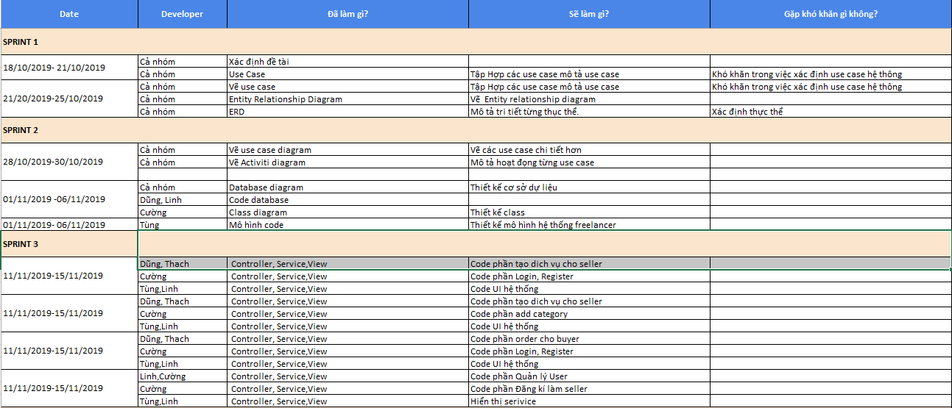

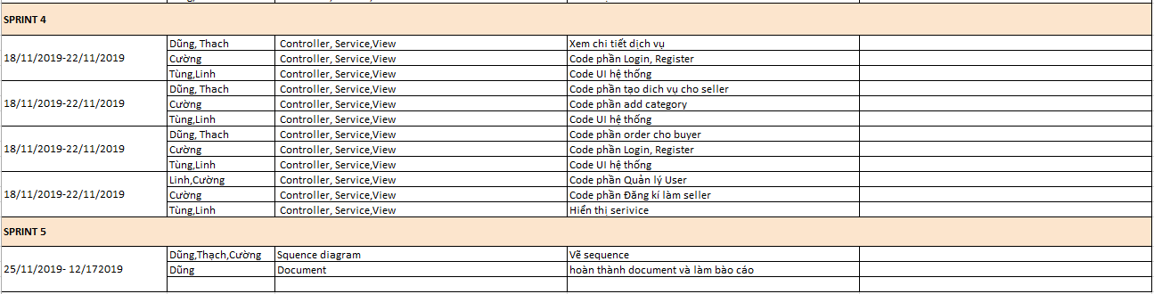

* Project-info

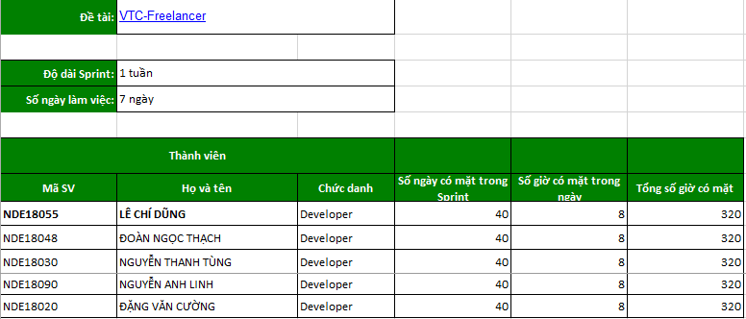

# Installation Instructions

## Deployment Diagram

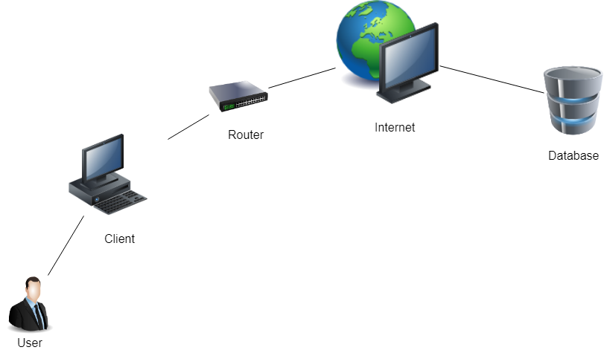

1. Installation steps

• Environment settings

- Download and install the .NET Core environment accordingly

https://www.microsoft.com/net/download

- Download and install MySql by following the link: https://dev.mysql.com/downloads/mysql/ select the version according to the operating system of the machine

• Database installation

- During the installation process, the superuser root is generated with a temporary random password. PLEASE SAVE THIS PASSWORD !!!. For the latest MySQL, passwords are also sent to the notifications.

- Open cmd with windows, terminal with mac

- Launch MySql: sudo /usr/local/mysql/support-files/mysql.server start

- First login to mysql: mysql -u root -p

Enter password: // enter the initial password for the installation

- Change password by command: ALTER USER 'root' @ 'localhost' IDENTIFIED BY 'NewPassword';

- run the command: quit;

- Open cmd (Windows) in the application directory -> copy the command "mysql -u root -p <vtc-freelancer.sql" -> enter the password of MySql just changed

- open the application folder, open the dbcontext.cs file

server = localhost; user id =admin ; password = 123456; port = 3306; database =vtc-freelancer; SslMode = None -> Change password = your password and server = localhost ip address of your machine (Example: 127.0.0.1 )

- Run app “Dotnet run file vtc-freelancer.dll”

- Open localhost:5001

3. Open the folder:

- Download the file Vtc-freelancer project -> extract it -> select the Vtc-Freelancer file

# Appendix

## References

* <https://www.fiverr.com/>
* [https://stackoverflow.com](https://stackoverflow.com/)
* <https://www.w3schools.com/>

1. Some other issues

* Result
* Learn the process of making a web site
* Analysis of problem solving in a login way
* Linit
* Haven't solved the whole problem
* Still limited in knowledge
* Not good teamwork

# Document format

***Bìa báo cáo:***

*Bìa báo cáo được in mầu xanh.*

*Với định dạng như trang đầu tiên của tài liệu này.*

***Khổ giấy***

*Báo cáo được trình bày trên khổ giấy khổ A4 (210 mm x 297 mm)*

***Lề trên***

*Bên trái: Logo của VTC Academy*

*Bên phải: Tên Project*

*Font chữ: Time New Roman*

*Font size: 13pt*

***Lề dưới***

*Bên trái: Tên lớp – Tên nhóm*

*Bên phải: Số trang*

*Font chữ: Time New Roman*

*Font size: 13pt*

***Nội dung tài liệu:***

*Báo cáo được trình bày theo chiều dài của trang giấy khổ A4 (định hướng bản in theo chiều dài)*

*Font chữ: Time New Roman*

*Font size: 13pt*

*Tối thiểu 20 trang*

***Định lề trang văn bản (đối với khổ giấy A4)***

*Lề trên: cách mép trên từ 20 - 25 mm;*

*Lề dưới: cách mép dưới từ 20 - 25 mm;*

*Lề trái: cách mép trái từ 30 - 35 mm;*

*Lề phải: cách mép phải từ 15 - 20 mm*